Supporting Information

Thermal and Mechanical Behavior of Plasma-synthesized Nanometer Scale Aluminum Fluoride Passivation Layers
Mohsen Motezaker¹, Andrew H. Jones², David R. Boris³, Scott G. Walton³, and Patrick E. Hopkins^{1,2,4,5}
¹Department of Mechanical and Aerospace Engineering, University of Virginia, Charlottesville, Virginia 22904, USA
²Laser Thermal, Charlottesville, Virginia 22902, USA
³ U.S. Naval Research Laboratory, Plasma Physics Division, Washington, District of Columbia 20375, USA
⁴Department of Materials and Science Engineering, University of Virginia, Charlottesville, Virginia 22904, USA
⁵Department of Physics, University of Virginia, Charlottesville, Virginia 22904, USA

- Thickness measurements using LAPPS ellipsometer and TEM

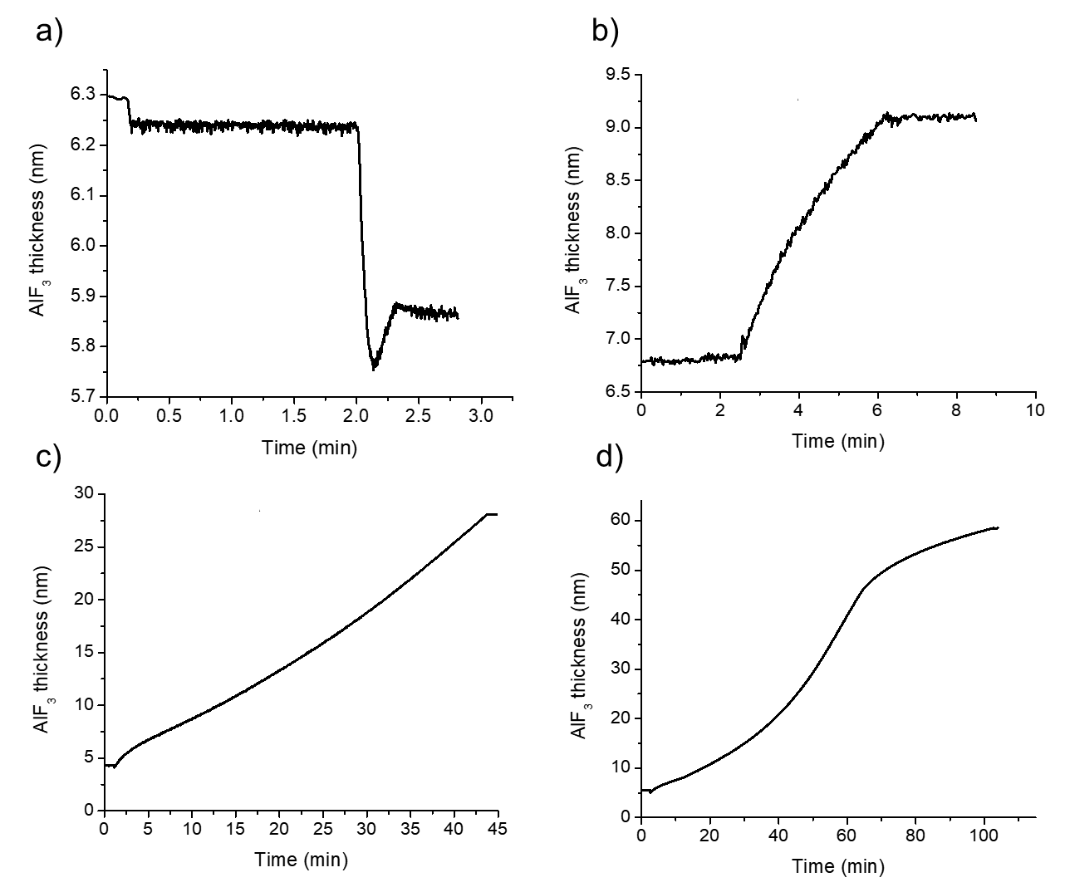

Figure S1: In situ ellipsometry data of thickness v. time for the (a) 0.3 minute (b) 3.7 minute (c) 42 minute and (d) 100 minute cases corresponding to final ellipsometer measured thicknesses of 6 nm, 9nm, 28 nm and 58 nm, respectively. The initial drop in thickness is thought to correspond to the removal of adsorbed material removal upon plasma ignition and the transformation from oxide to fluoride during the early stages of growth.

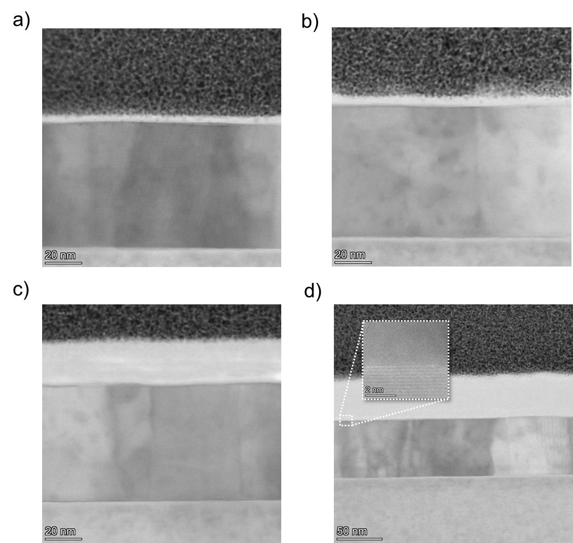
Figure S2: Cross-sectional TEM images of (a) 4.1 nm, (b) 5.9 nm, (c) 24.5 nm, and (d) 48.1 nm AlF₃ layers, corresponding to 0.3, 3.7, 42, and 100-minute fluorination times. The images reveal polycrystalline grain boundaries in the underlying aluminum, while the AlF₃ layers appear featureless with no visible microdefects such as pores or cracks. The inset in (d) provides a magnified view showing the periodic lattice fringes of the aluminum in contrast to the amorphous structure of the AlF₃ layer. The upper platinum layer was deposited to mitigate damage from the gallium ion beam during thinning.

Table S1: Comparison of in-situ ellipsometry and cross-sectional TEM thickness measurements for AlF₃ layers grown under different fluorination times.
Fluorination Time (minutes) | In-situ Ellipsometry (nm) | TEM Measured Thickness (nm)
0.3 | 6 | 4.1
3.7 | 9 | 5.9
25.5 | 14 | 11.2
42 | 28 | 24.5
70 | 35 | 30.3
100 | 58 | 48.1

- TEM - EDX mapping and line scan of AlF₃:
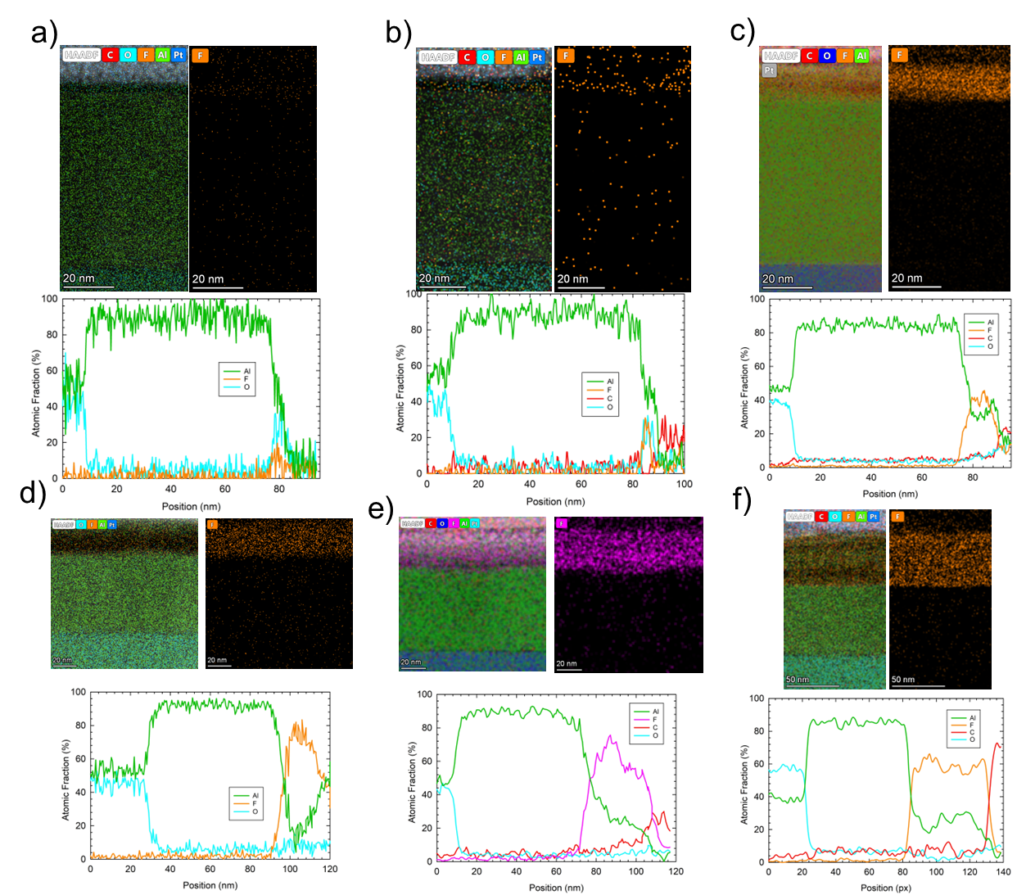
Figure S3: TEM - EDX mapping and line scan of a) 4.1 nm film, (b) 5.9 nm film, (c) 11.2 nm film, and (d) 24.5 nm film, (e) 30.3 nm film, (f) 48.1 nm film. For the line scans, zero on the abscissa corresponds to the sapphire substrate located at the bottom of the images. These cross-sectional measurements confirm the compositional trends observed in the SEM/EDX analysis (Fig. 2a): thicker AlF₃ layers exhibit lower aluminum content and higher fluorine content, stabilizing above ~20 nm.

- TDTR data and model fit used to extract effective conductance (G)

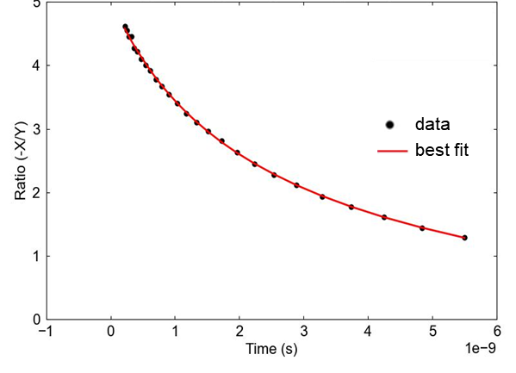
Figure S4: Theoretical fit of the experimental TDTR data for the 5.9 nm film. The plot illustrates the best-fit thermal model applied to the ratio of in-phase and out-of-phase signals, yielding an effective thermal conductance of 50.2 MW m⁻² K⁻¹ with R2 = 0.54%.

- Dielectric functions
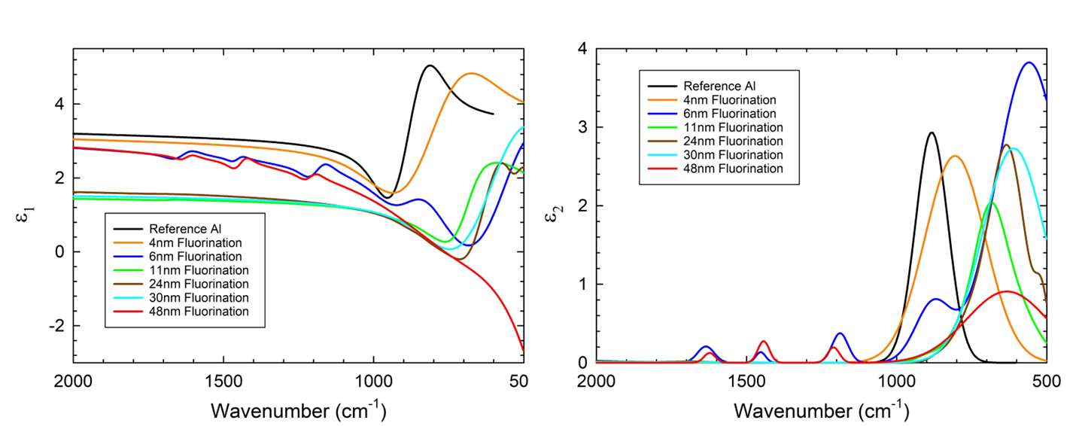

Figure S5: The real (ε₁) and imaginary (ε₂) parts of the dielectric function.

