Supporting Information: Unveiling Phonon Contributions to Thermal Conductivity and the Applicability of the Wiedemann–Franz Law in Ruthenium and Tungsten Thin Films

Md. Rafiqul Islam¹, Pravin Karna², Niraj Bhatt², Sandip Thakur², Helge Heinrich³, Daniel M. Hirt¹, Saman Zare¹, Christopher Jezewski⁴, Rinus T.P. Lee⁵, Kandabara Tapily⁵, John T.Gaskins⁶, Colin D. Landon⁷, Sean W. King⁸, Ashutosh Giri², and Patrick E. Hopkins*^{1,9,10}

¹Department of Mechanical and Aerospace Engineering, University of Virginia, Charlottesville, Virginia 22904, USA
²Department of Mechanical Industrial and Systems Engineering, University of Rhode Island, Kingston, RI 02881, USA
³Nanoscale Materials Characterization Facility, University of Virginia, Charlottesville, Virginia 22904, USA
⁴Components Research, Intel Corporation, Hillsboro, Oregon 97124, USA
⁵TEL Technology Center, America, Albany NY 12203, USA
⁶Laser Thermal, Charlottesville, Virginia 22902, USA
⁷Logic Technology Development, Intel Corporation, Hillsboro, Oregon 97124, USA
⁸Supplier, Technology, and Industry Development, Intel Corporation, Hillsboro, Oregon 97124, USA
⁹Department of Materials Science and Engineering, University of Virginia, Charlottesville, Virginia 22904, USA
¹⁰Department of Physics, University of Virginia, Charlottesville, Virginia 22904, USA

Contents
Section S1. Scanning transmission electron microscopy (STEM) of Ru and W films (Page 3)
Section S2. First principles-calculation to obtain the thermal conductivity and electron-phonon coupling factor of Ru and W films (Page 12)
Section S3: Methodology and lattice thermal conductivity using machine-learning (Page 15)
Section 4: Spectral Energy Density (SED) Calculations (Page 18)
Section S5: TDTR thickness, sensitivity, uncertainty, and data analysis (Page 23)
Section S6: SSTR sensitivity, uncertainty, and data analysis (Page 27)
Section S7. Lorenz number of ruthenium and tungsten thin films (Page 33)
Section S8: Beam offset technique (Page 34)
Section S9. Two temperature model (TTM) and electron-phonon coupling factor (Page 36)
Section S10. Effective electron relaxation time determination with an infrared ellipsometer (Page 43)
Table S1: The atomic fraction of oxygen and silicon from EDX analysis on Ru films (Page 5)
Table S2: Table S2: The atomic fraction of oxygen from EDX analysis on W films (Page 8)
Table S3: The average roughness of Ru and W films (Page 10)
Table S4: Individual contributions to the total scattering rate for Ru and W thin films (Page 15)
Table S5. Parameters used in sensitivity analysis and thermal model of Ru and W films (Page 27)
Table S6: Comparison of SSTR, and TDTR measured in-plane thermal conductivities (Page 30)
Table S7: The temperature rise and reduction in thermal conductivity in Ru and W films (Page 33)
Table S8: Comparison of Lorenz number and phonon contributions in Ru (Page 33)
Table S9: Comparison of Lorenz number and phonon contributions in W films (Page 34)
Table S10. Parameters utilized for the two-temperature model calculations in this work (Page 40)

S1. Scanning transmission electron microscopy (STEM) characterization of Ru and W films

We use physical vapor deposition (PVD) to synthesize a series of Ru films with thicknesses ranging from 5 nm to 100 nm on 100 nm SiO₂/Si substrates. Similarly, we deposit W films with thicknesses between 3 nm and 101 nm on 3 nm Ta/100 nm SiO₂/Si substrates using the PVD technique. To study the role of experimental parameters on different properties, we synthesize W films through two distinct approaches: one focused on reducing resistivity (labeled as W_{R}) and the other on modifying grain size (assigned as W_{G}). We then characterize the microstructure, chemical composition, and crystallography of selected Ru and W films using scanning transmission electron microscopy (STEM).

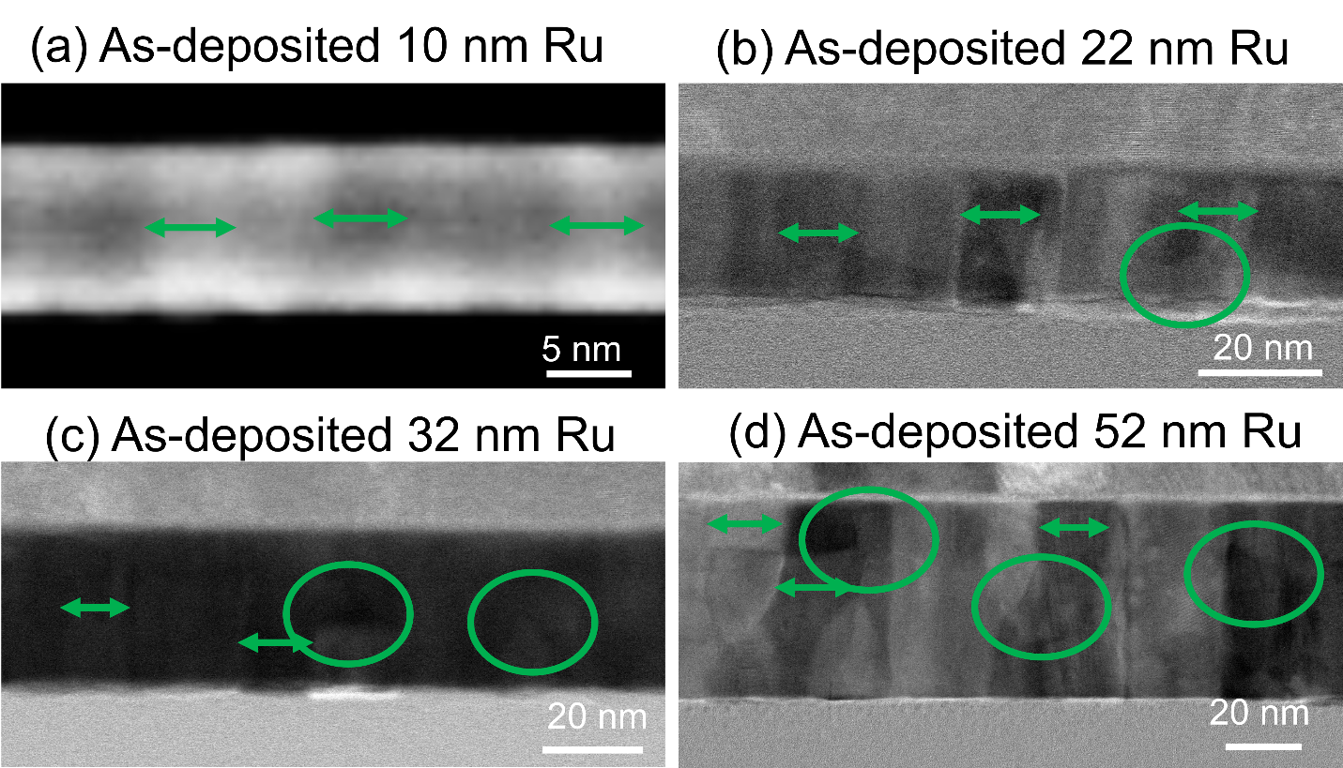

Figure S1: STEM micrographs for PVD grown as-deposited (a) ~10 nm, (b) ~22 nm, (c) ~32 nm and (d) ~52 Ru films. The green arrows indicate grain size and green circle indicates the presence of irregular or equiaxed grains.

Figure S1 illustrates the mixed grain morphology of as-deposited Ru films, where columnar grains are predominant, while some grains, highlighted by circles, display irregular or equiaxed shapes. Additionally, several grains transform from an equiaxed structure near the interface to a columnar form as they grow vertically. Our chemical composition analysis using STEM-EDX confirms that both as-deposited and annealed Ru do not contain significant impurities. Figure S3 and Table S1 show the presence of silicon in the EDX signal, which originates from the underlying 100 nm SiO₂ layer. Moreover, the Cu peak observed in the EDX spectrum arises from the Cu grid.

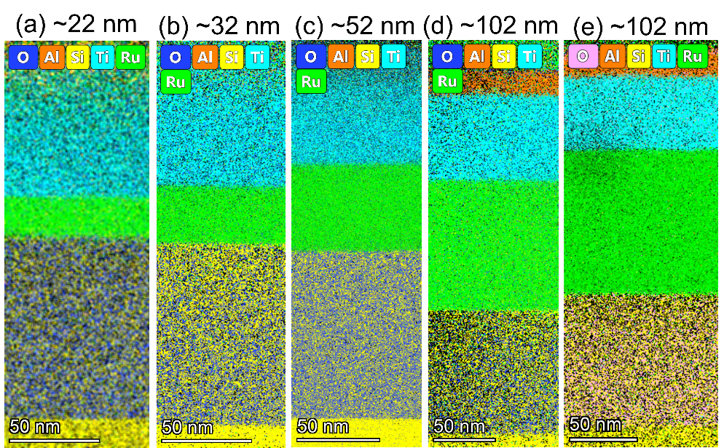

Figure S2: STEM-EDX mapping for PVD grown as-deposited (a) ~32 nm, (b) ~52 nm, (d) ~102 Ru films and annealed (e) ~102 nm films. These films do not contain noticeable impurity.

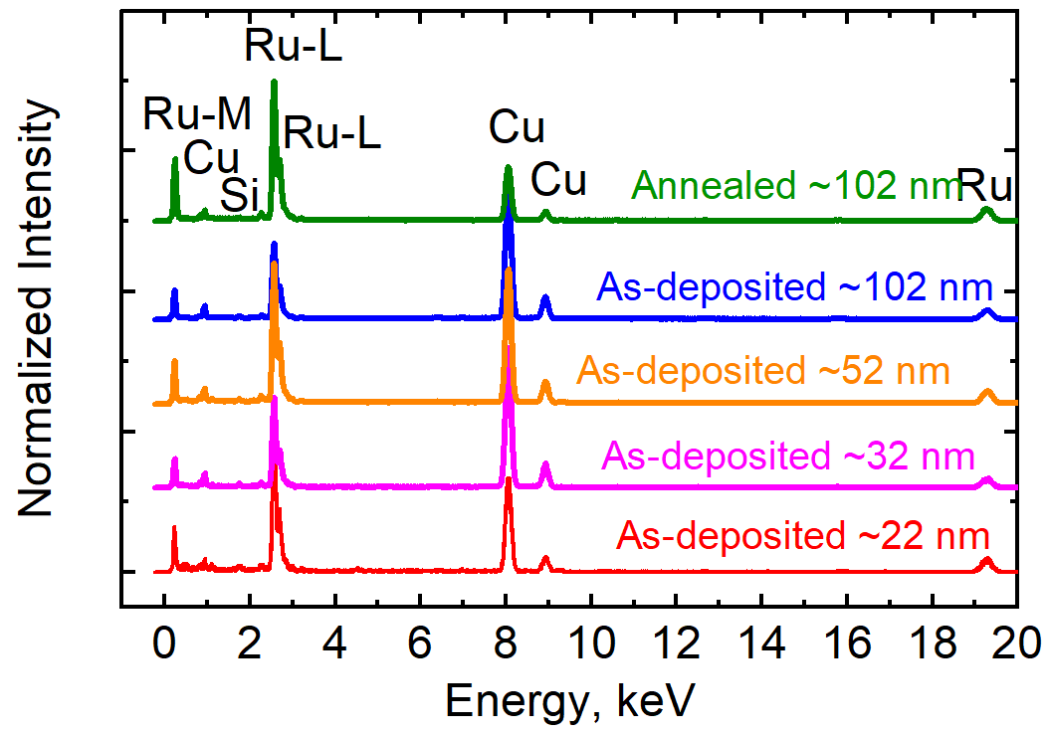

Figure S3: STEM-EDX spectra for PVD grown ~22 nm, ~32 nm, ~52 nm, ~102nm as-deposited Ru films and ~102 nm annealed Ru films. Silicon in the EDX signal originates from the underlying 100 nm SiO2 layer.
Table S1: The atomic fraction of oxygen and silicon from EDX analysis on as-deposited and annealed Ru films

As-deposited Ru films, nm | Oxygen atomic fraction  (%) | Silicon atomic fraction  (%) | Annealed Ru films, nm | Oxygen atomic fraction  (%) | Silicon atomic fraction  (%)
~22 | 0.0 | 3.9±0.02
~32 | 0.0 | 3.1±0.03
~52 | 0.0 | 2.4± 0.03
~102 | 0.0 | 5.2±0.06 | ~102 | 2.2±0.01 | 0.9±0.03

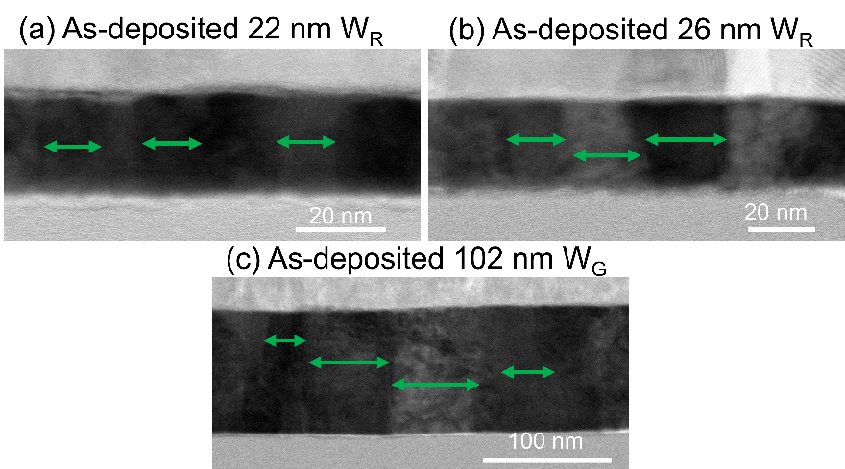

Figure S4: STEM micrographs for PVD grown as-deposited (a) ~22 nm W_{R} , (b) ~32 nm W_{R} and (c) ~102 nm W_{G} films. The green arrows indicate the grain size, which increases with thickness. The grains in the tungsten films are columnar.

We also analyze the grain size and thickness of tungsten films (W_{R} and W_{G}). As shown in Figure S4, the grain sizes of W_{R} films remain within a similar range. However, the grain size of the ~102 nm film is notably larger compared to the thinner films. The chemical composition of these films is further verified through STEM-EDX analysis, as presented in Figures S5 and S6 and summarized in Table S2. Oxygen is detected in the films, primarily originating from the transfer process of the prepared thin samples from the FIB to the STEM chamber. Additionally, a 1–2 nm layer of native tungsten oxide may have formed on the W surface. The presence of carbon (C) and molybdenum (Mo) in the EDX spectrum is attributed to the FIB-SEM and STEM characterization processes. Carbon is intentionally deposited on W films to achieve a clean surface, facilitating the identification of the top surface layer in FIB-SEM and STEM imaging. The Mo peak observed in the EDX spectrum arises from the Mo grid. In summary, EDX analysis confirms that the Ru and W films are free from general impurities, although W films contain a small amount of oxygen

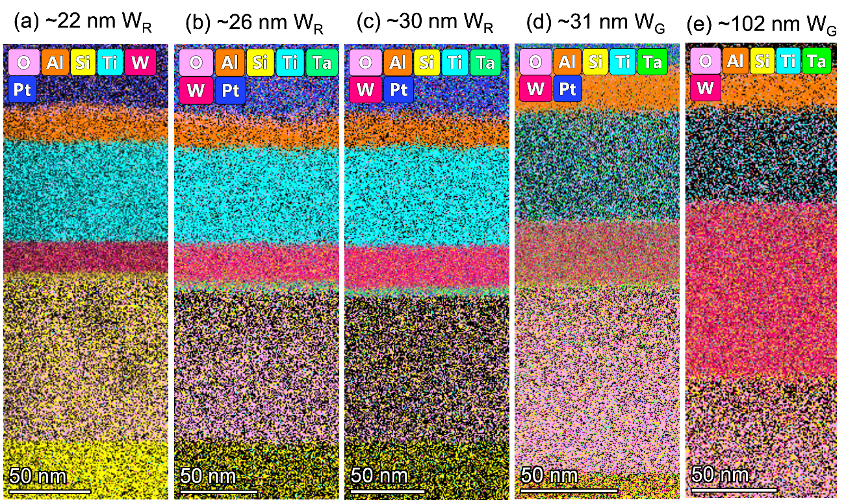
Figure S5: STEM-EDX mapping for PVD grown as-deposited (a) ~22 nm W_{R}, (b) ~26 nm W_{R}, (c) ~30 nm W_{R}, (d) ~ 31W_{G} and (e) ~102 nm W_{G} films. These films do not contain noticeable impurity.

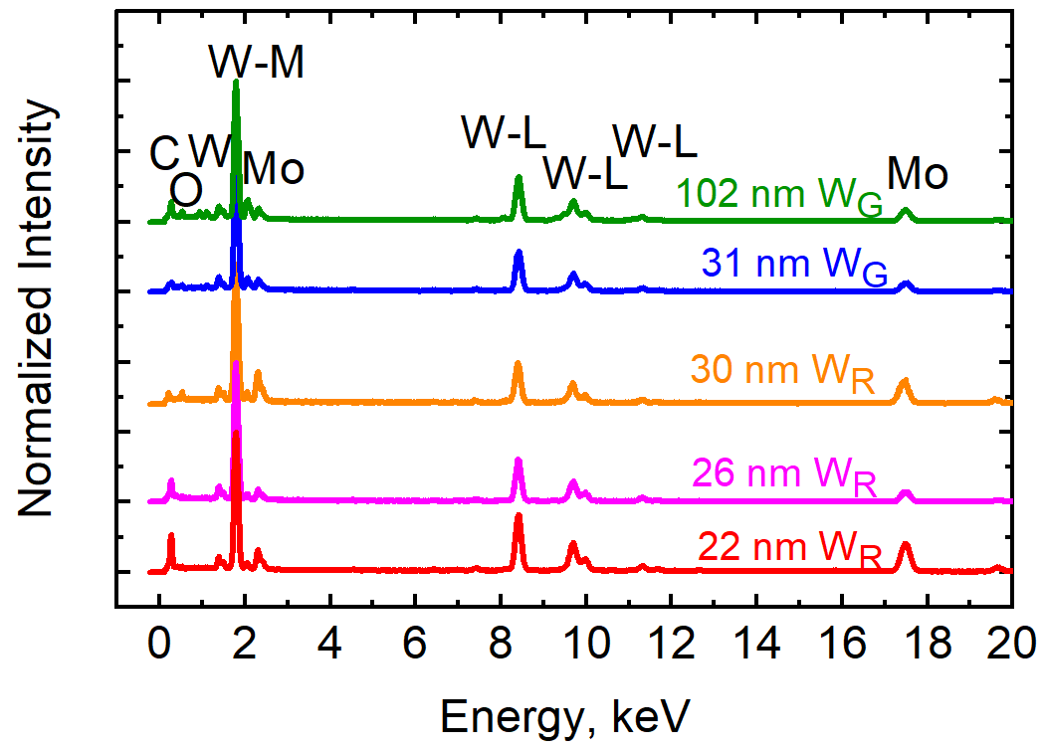
Figure S6: STEM-EDX spectra for PVD grown as-deposited ~22 nm W_{R} , ~26 nm W_{R} , ~30 nm W_{R} , ~ 31 nm W_{G} and ~102 nm W_{G} films. The detected oxygen originates from the transfer process of the prepared thin samples from the FIB to the STEM chamber. Additionally, a 1–2 nm layer of native tungsten oxide may have formed on the W surface. The detection of carbon (C) and molybdenum (Mo) in the EDX spectrum is associated with the FIB-SEM and TEM characterization process.

Table S2: The atomic fraction of oxygen from EDX analysis on as-deposited tungsten films

As-deposited W_{R} films, nm | Oxygen atomic fraction  (%) | As-deposited W_{G} films, nm | Oxygen atomic fraction  (%)
~22 | 4.1±0.04
~26 | 6.3±0.21
~30 | 4.7±0.07 | ~31 | 4.4±0.21
 |  | ~102 | 5.7±0.27

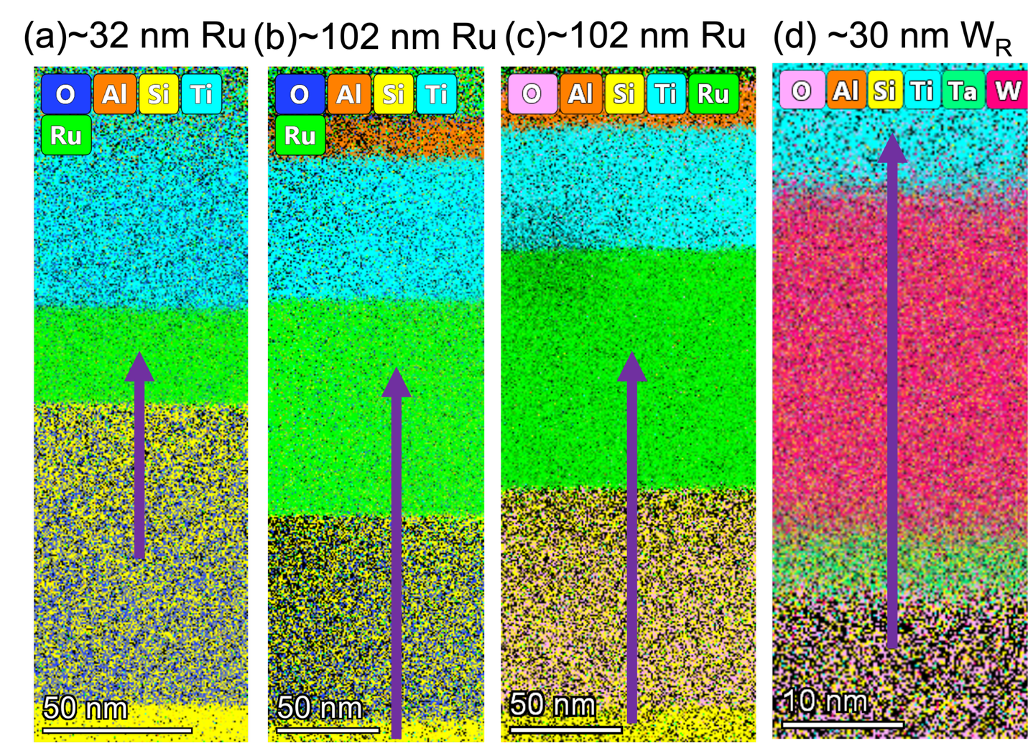

Figure S07: STEM-EDX elemental mapping of PVD-grown thin films: (a) ~32 nm Ru, (b) ~102 nm Ru (as-deposited), (c) ~102 nm Ru (annealed), and (d) ~30 nm W_{R} as-deposited film. The arrows indicate the scan direction used for the line EDX analysis. These maps are used to examine interfacial integrity and assess any elemental intermixing across the film/substrate interface.

Our EDX analysis confirms there is no significant intermixing between the metal films and the SiO₂/Si substrates. Figure S07 shows the STEM-EDX elemental mapping of the PVD grown films. The arrows indicate the scan direction used for the line EDX analysis, from the bottom (SiO₂) to the top metal layer (Ru or W). Figure S08 presents the EDX line spectra for Ru and W, showing atomic fraction across the film cross-sections. For both as-deposited and annealed Ru films grown on SiO₂/Si (Figure S08 a-c), the line scan indicates the formation of a thin (1-2 nm) Ru oxide layer at the interface. This is attributed to Ru bonding with oxygen on the SiO₂ surface. Notably, there is a sharp drop in the Si signal, suggesting the absence of Si at the interface and confirming that Ru does not intermix with the SiO₂/Si substrate.

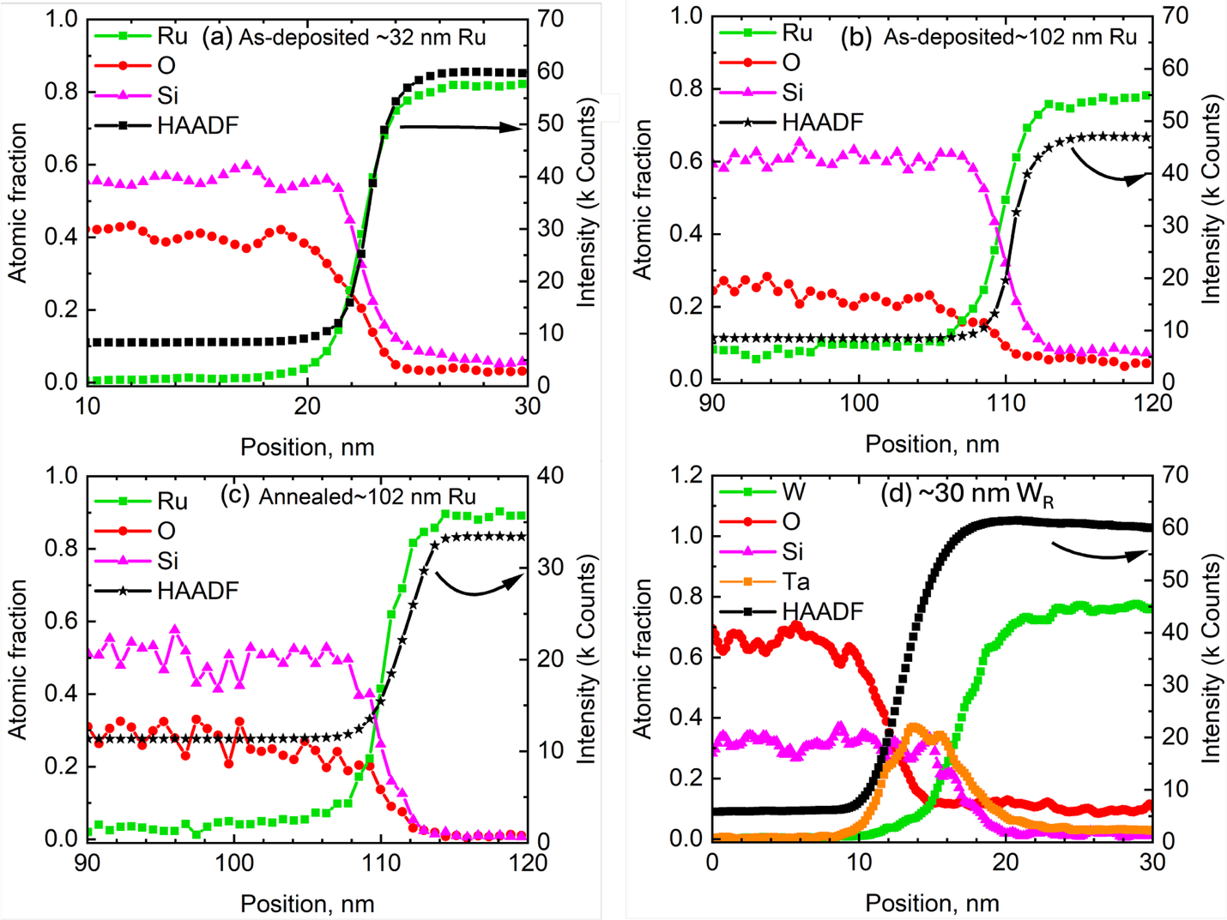

Figure S08: EDX line scans showing atomic fraction and intensity profiles for a PVD-grown (a) as-deposited ~32 nm Ru, (b) as-deposited ~102 nm Ru, (c) annealed ~102 nm Ru and (d) ~30 nm W_{R} film on a SiO₂/Si substrate. Unlike Ru films there is a ~3 nm Ta adhesion layer between W and SiO₂/Si substrate. The black curve represents the high-angle annular dark-field (HAADF) signal, which provides atomic number contrast and highlights the sharp compositional transitions across the interface. The abrupt changes in atomic fractions of Ru, W, Ta, Si, and O confirm well-defined interfaces and minimal intermixing between the metal film and the SiO₂/Si substrate. Although the Ta layer appears thicker in EDX (~5 to 6 nm), this overestimation arises from secondary signal spreading during EDX collection.

Similarly, W films deposited on 3 nm Ta/SiO₂/Si show no evidence of W-Si intermixing (Figure S08 d). The Ta layer acts as a diffusion barrier, preventing W from interacting with the underlying Si. However, a minor 1 to 2 nm intermixing between W and Ta is observed, which is expected. Overall, our EDX analyses confirm that there is no significant intermixing between the metal films and the SiO₂/Si substrates.

We measure the surface roughness of Ru and W films using a Zygo NewView 7300 interference microscope, with additional measurement details provided elsewhere.^{[1]} Briefly, we employ three-dimensional white-light interferometry, a non-contact profilometry technique. The microscope features a 20× Mirau interference objective, a 150 µm piezoelectric vertical turret, a digital black-and-white camera (640 × 480 pixels), and Zygo's proprietary image analysis software. The field of view is 350 × 260 µm, and the system provides an axial resolution of ~0.1 nm with a repeatability of <0.3 nm. The average roughness of the Ru and W films remains nearly identical across thicknesses and is very low (~≤ 1 nm), as summarized in Table S3.

Table S3: The average roughness of Ru and W films

Ru film,  nm | Average roughness,  nm | W films,  nm | Average roughness,  nm
As-deposited ~52 nm | 0.98±0.14 | As-deposited  26 nm W_{R} | 0.58±0.02
As-deposited ~102 nm | 0.67±0.05 | As-deposited  30 nm W_{R} | 0.62±0.07
Annealed ~52 nm | 0.89±0.12 | As-deposited  50 nm W_{G} | 0.41±0.05
Annealed ~102 nm | 1.02±0.09 | As-deposited 101 nm W_{G} | 0.46±0.01

We also determine the thickness of the Al and Ti transducers using STEM, as shown in Figure S09. We utilize these transducers to perform the steady-state and time-domain thermoreflectance measurements.

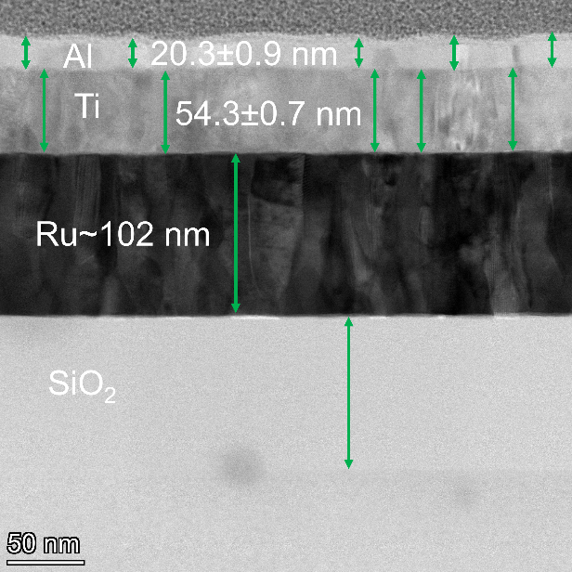

Figure S09: STEM image of Al/ Ti coated 102 nm annealed Ru film.
We perform X-ray diffraction (XRD) characterization to confirm the crystallinity of Ru and W films. The XRD patterns for both materials exhibit sharp, well-defined peaks corresponding to their expected crystal structures, indicating comparable crystalline quality and grain structure. The XRD data are shown below:
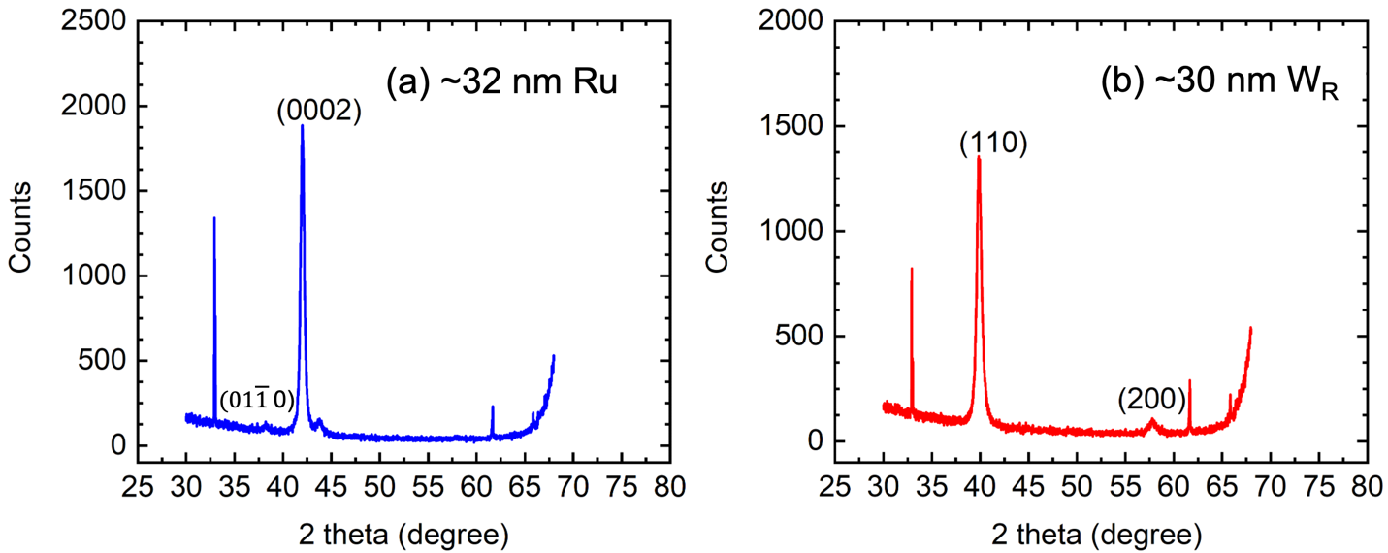
Figure S10: X-ray diffraction (XRD) patterns of (a) ~32 nm Ru and (b) ~30 nm W films deposited on SiO₂/Si substrate. The Ru film shows characteristic peaks corresponding to the (0110) and (0002) planes of the hexagonal close-packed structure,^{[2]} while the W film shows (110) and (200) peaks indicative of a body-centered cubic structure.^{[3]} The sharp and well-defined peaks in both patterns suggest comparable crystalline quality.

S2: First principles-calculation to obtain the thermal conductivity and electron-phonon coupling factor of Ru and W films

We obtain the electron-thermal conductivity and electron-phonon coupling factor of Ru and W films through First principles calculations. The details of our calculations can be found in our previous work. ^{[4,5]} The interpolation of the electron-phonon matrix elements, phonon modes, and band energies from an initial coarse grid (10 × 10 × 10 and 5 × 5 × 5) to a uniform fine grid (80 × 80 × 80 and 35 × 35 × 35) for electron and phonon wave vector grids is achieved using Electron phonon Wannier (EPW) package which is incorporated within the Quantum Espresso software. We use norm-conserving pseudopotential for both Ru and W which is obtained from the PS Library.

We calculate the Eliashberg spectral function ${ α}^{2}F\left(ω\right)$ at room temperature for Ru and W using density functional perturbation theory calculation. A corresponding mass enhancement parameter, $λ$, is also calculated which is 0.52 and 0.29 for Ru and W respectively. The calculated values of $λ$ matches well with prior literature.^{[6]} We calculate the average mean free path of Ru and W from the calculated electron-phonon scattering rates which are ~ 15.5 nm for W and ~6 nm for Ru. The calculated Fermi velocity as obtained from the Fermi surface is ~6$×$10⁵ m s⁻¹ for Ru and ~9.4 $×$10⁵ m s⁻¹ for W.

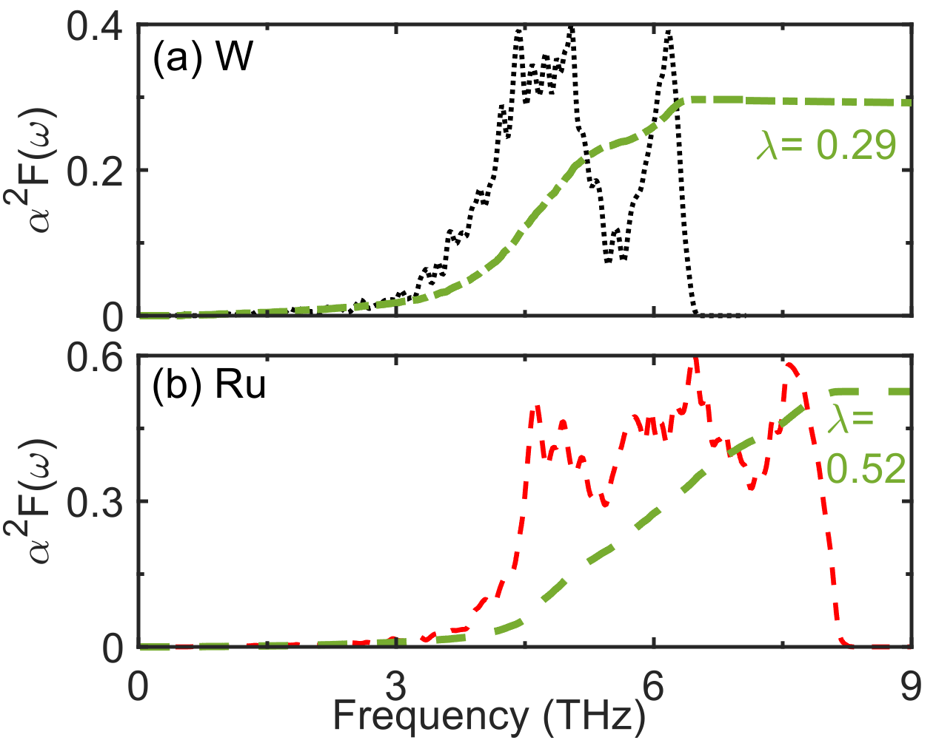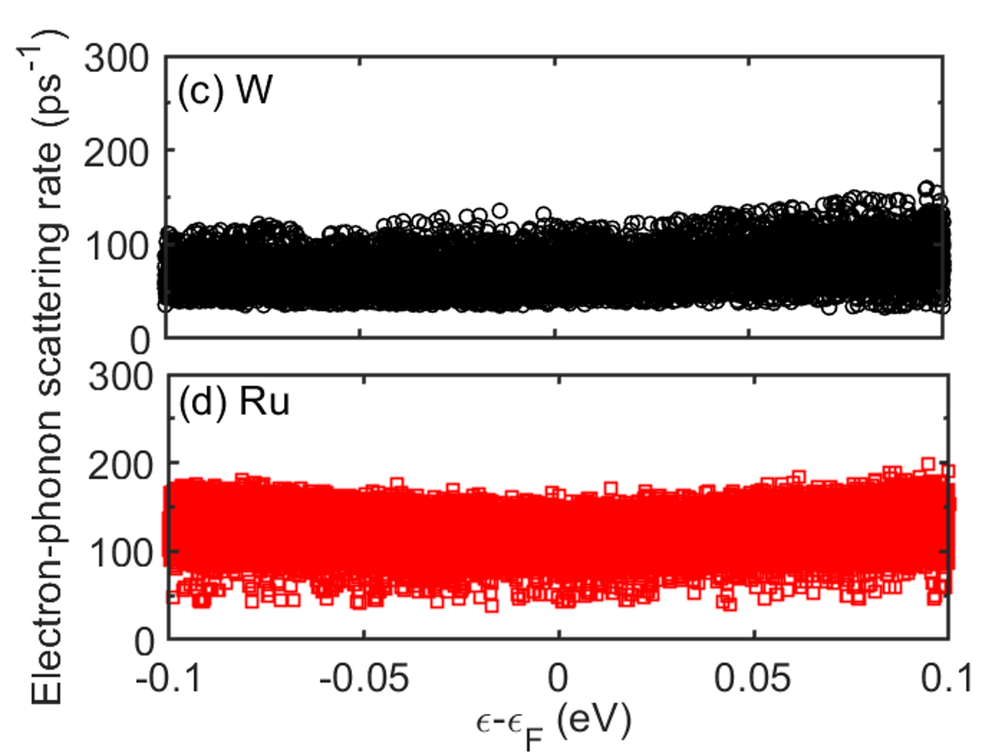

Figure S11: Calculated Elishberg spectral function for (a) W and (b) Ru. The dashed lines represent the corresponding mass enhancement parameter. Calculated electron-phonon scattering rates for (c) W and (d) Ru.

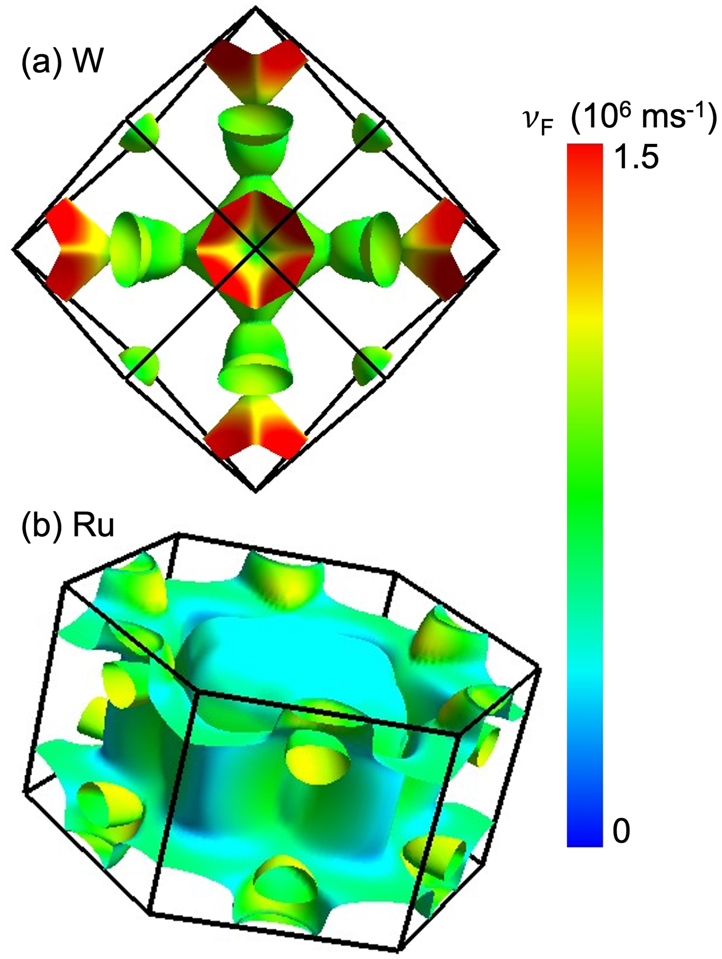

Figure S12: Calculated Fermi surface for (a) W and (b) Ru. The color on the Fermi surfaces are representative of the Fermi velocities of the electrons on the Fermi surface.

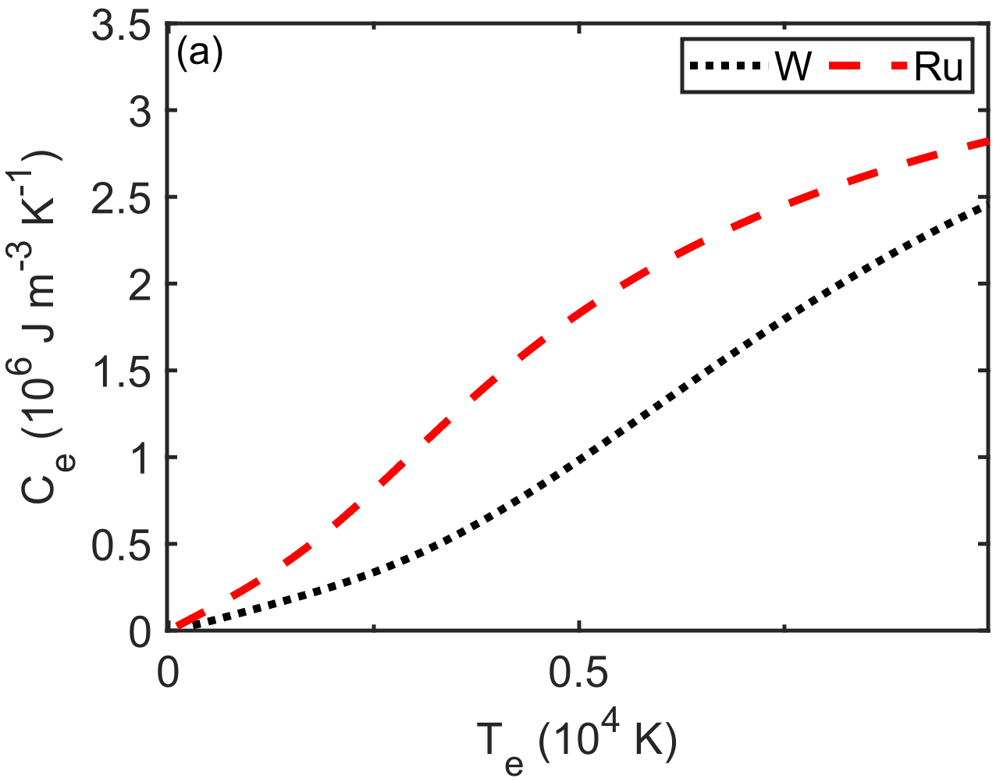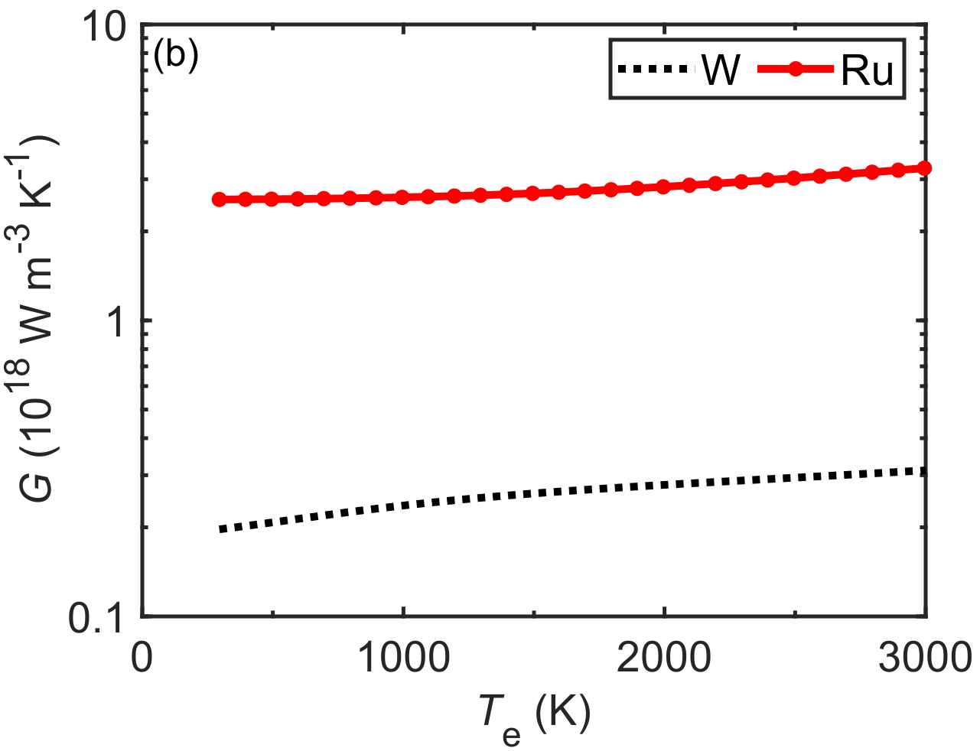
Figure S13: (a) Electronic temperature-dependent electronic heat capacity for W and Ru. (b) Electronic temperature-dependent volumetric electron–phonon coupling factor for W and Ru.

We calculate the electronic heat capacity of the metals using,

$C_{e}\left(T_{e}\right)=\int_{-∞}^{∞}{\frac{∂f(ε, μ, T_{e})}{∂T_{e}}} g\left(ε\right)εdε$, (S01)

where $g\left(ε\right)$ denotes the eDOS at the energy level $ε$, $μ$ is the chemical potential at $T_{e}$, and $f(ε, μ, T_{e})$ denotes fermi distribution function, defined as $f\left(ε, μ, T_{e}\right)=\{exp⁡[(ε-μ)/k_{B}T_{e}] +1\}$⁻¹.
We also calculate the volumetric rate of e-p coupling, which is given as,
$G=πℏk_{B}λ⟨ω^{2}⟩\int_{0}^{∞}{\frac{{\left(D\left(ε\right)\right)}^{2}}{D(ε_{F})}\left[-\frac{∂f}{∂ε}\right]dε,}$ (S02)

where $⟨ω^{2}⟩$ represents the second moment of the phonon spectrum and $D\left(ε\right)$ is the eDOS. At room temperature, the calculated $G$ is ~2$×$10¹⁷ W m⁻³ K⁻¹ for W and ~2.5$×$10¹⁸ W m⁻³ K⁻¹ for Ru which matches closely with previous calculations.^{[6]} From the calculated $C_{e}$, $v_{F}$ and $Λ$, we calculate the thermal conductivity as detailed in our previous works.^{[4–6]} The calculated electronic thermal conductivity for W and Ru is 135 W m⁻¹ K⁻¹ and 97 W m⁻¹ K⁻¹ , respectively.

The electron-electron (e-e) scattering rate scales with $({Ε-E_{F})}^{2}$ , leading to a higher scattering rate for hot electrons and for states away from the Fermi level. However, near the Fermi level and at room temperature, electron–electron scattering remains negligible compared to electron–phonon (e–ph) scattering. The electron-electron scattering lifetime can be calculated as a function of energy using the random phase approximation of the Fermi liquid theory given by the expression^{[7]}
$τ_{e-e}=τ_{0}\left[\frac{ϵ_{F}}{δϵ}\right]$ (S03)
Here, $ϵ_{F}$ denotes the Fermi energy, and $τ_{0}$ represents the proportionality constant calculated using the Lindhard dielectric function^{[8]}

$τ_{0}=\frac{128}{π^{2}√3}\frac{1}{ω_{p}}$ ( S04)

where $ω_{p}$ is the plasma frequency. We measure $ω_{p}$ to be 6.05 eV for Ru and 5.99 eV for W using IR-VASE, discussed in Section S10 of the Supporting Information. Figure S14 a-b show the electron lifetimes for Ru and W, respectively. The electron lifetimes obtained by including both electron-electron and electron-phonon scattering (red symbols) reveal that the contribution of electron-electron interactions is negligible near the Fermi energy. The near equivalence of these lifetimes with those computed from electron-phonon scattering alone indicates that electron-phonon interactions predominantly determine the electron lifetime in this energy regime. These findings comply with our prior work on noble metals.^{[9]}

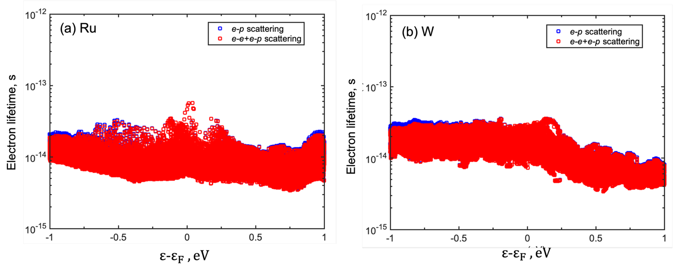Figure S14: Lifetimes of electrons predicted by including both electron-phonon (e-p) and electron-electron (e-e) scattering for (a) Ru and (b) W. For comparison, the lifetimes computed by considering only electron-phonon (blue symbol) scattering are also shown. The combined electron-electron and electron-phonon scattering results (red symbols) indicate that electron-electron interactions have a negligible impact on the total electron lifetime near the Fermi energy. The close agreement between the combined and electron-phonon-only lifetimes suggests that electron-phonon scattering is the dominant mechanism governing electron lifetimes in this energy range.

At room temperature, thermal and electrical transport in metals is primarily governed by electrons within a narrow energy window around the Fermi level.^{[10]} Therefore, we choose $τ_{e-e}$​ at $ε$-$ε_{F}$ ≈±0.1 eV as representative for room-temperature transport. The corresponding value of $τ_{e-e}$ is $1.55{10}^{-11}$ s for Ru and is $1.73{10}^{-11}$ s for W and is included in our total scattering time model to account for electron-electron interactions.

We introduce the effect of boundary scattering on the total scattering rate of the electrons is given as,^{[11,12]}
$\frac{1}{τ_{tot}}=\frac{v_{F}}{Λ_{e-p}}+\frac{v_{F}}{d}$ + $\frac{v_{F}}{D}+$ $\frac{v_{F}}{Λ_{defect}}$ $+\frac{1}{τ_{e-e}}$ (S05)
$τ_{tot}$ represents the total scattering time which includes electron-phonon scattering rate as well as the boundary scattering of the electrons. In this formulation, d denotes the thickness of the thin film, D is the grain-size, $Λ_{defect}=\frac{a}{\sqrt{c}}$ represents the effective mean free path associated with point defect scattering, where a is the lattice constant and c is the defect concentration. ^{[13]} In this work, we assume a point defect concentration of 0.2% in both Ru and W thin films. ^{[14,15]} We present the calculated values of each term for ~32 nm Ru and ~30 nm W films in the table below:

Table S4: Individual contributions to the total scattering rate for Ru and W thin films, showing dominant and minor scattering mechanisms near the Fermi level

Films | $\frac{v_{F}}{Λ_{e-p}}$, s⁻¹ | $\frac{v_{F}}{d}$, s⁻¹ | $\frac{v_{F}}{D}$, s⁻¹ | $\frac{v_{F}}{Λ_{defect}}$ , s⁻¹ | $\frac{1}{τ_{e-e}}$, s⁻¹
~32 nm Ru | $$1.0{10}^{14}$$ | $$1.9{10}^{13}$$ | $$2.7{10}^{13}$$ | $$9.9{10}^{13}$$ | $$6.5{10}^{10}$$
~30 nm W_{R} | $$6.1{10}^{13}$$ | 2.7${10}^{13}$ | $$4.4{10}^{13}$$ | $$1.4{10}^{14}$$ | $$5.8{10}^{10}$$

This table confirms that electron-electron scattering contributes minimally compared to other mechanisms.

﻿﻿S3: Methodology and lattice thermal conductivity results using machine-learned potential
- Training Data:
We develop a precise interatomic potential using a diverse training dataset produced by ab-initio molecular dynamics. During simulations at finite temperature, snapshots of the MD trajectory are taken, encompassing a range from various pressures at ambient temperatures. These snapshots offered atomic coordinates, forces, energies, and cell parameters, enabling thorough exploration of the configurational space. The diversity of the data is essential as the accuracy of the machine-learned potential heavily depends on the quality and diversity of the training data. The Quantum Espresso package is used for all ab-initio MD simulations.^{[16]} The exchange-correlation interactions are described using the PBE functional. The plane wave expansion uses an energy cut-off of ~ 60 Ry, while the self-consistent field energy convergence is set to 10⁻⁶ a.u. The Monkhorst-Pack mesh samples the Brillouin zone over a 4×4×4 grid. To accommodate the partial occupancy of electrons, we employ Fermi-Dirac smearing, with a smearing width of 0.02 Ry for Brillouin-zone integration in Ru. The cell parameters are allowed to relax in all ab-initio MD simulations, utilizing the isobaric-isothermal setup. We maintain each simulation at zero pressure using the Parrinello-Rahman barostat,^{[17]} while temperature is kept constant through the rescaling technique. A time step of 2 fs and the Verlet algorithm are utilized in all DFT-MD simulations. The training dataset includes snapshots of the trajectory from isothermal-isobaric simulations at ambient temperature. First, a 2x2x2 supercell with a hexagonal close-packed (hcp) lattice containing 16 atoms is relaxed at 0 bar, and the equilibrium lattice constant is determined. The equilibrium lattice constant is then uniformly compressed and expanded, and the atoms are equally perturbed in random directions to conduct subsequent isothermal-isobaric simulations at ambient temperature. The equilibrium lattice parameters are compressed and expanded by percentages ranging from ±0.5% to ±4%. Random atomic perturbations of up to 0.04 Å are applied. We conduct a 2 ps simulation for each perturbed configuration, resulting in 5, 000 data frames generated by ab-initio simulations. A set of 1, 000 data frames, not included in the training dataset, is used as a validation dataset to evaluate the model’s accuracy.

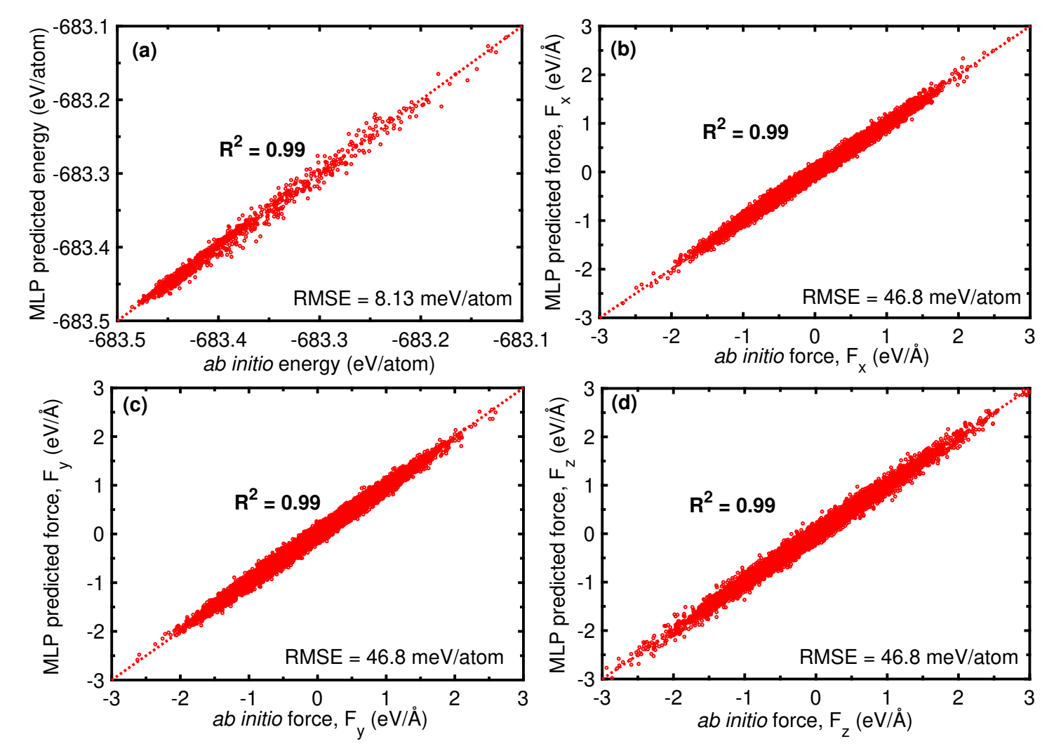
﻿Figure S15: Validation plots comparing (a) energies and (b-d) forces from our MLP and ab initio MD for ruthenium at ambient temperature. The low RMSE as well as R-squared values close to unity revealed perfect x=y agreement of MLP-predicted vs ab initio energies and forces indicate the accuracy of our MLP.

- Training procedure
﻿
We accurately map the energy space of an atom’s position using the deep learning framework DEEPMD to create a DeepPot-SE neural model through dataset training. We employ DEEPMD integrated with the popular Tensorflow^{[18]} deep learning framework for training and testing the machine-learned interatomic potential, as well as the widely used molecular dynamics package LAMMPS ^{[19]} for MD simulations. A cutoff radius of 6Å is established, and the descriptors decay from 0.5Å to 6Å to eliminate the discontinuity introduced by the cutoff. The neural architecture comprises two neural networks: one to convert atomic coordinates to descriptors and the other to map descriptors to their corresponding atomic energies. The former network is referred to as the embedding network, while the latter is known as the fitting network. The embedding network consists of three hidden layers with sizes of (25, 50, 100) following a Res-Net-like architecture. ^{[20]} The fitting network comprises three hidden layers, each with 240 neurons. Adam stochastic gradient descent approach is utilized for cost function optimization. The learning rate varies from 10⁻³to 10⁻⁸ with an exponential decay over 2, 000, 000 steps. The pre-factors of energies and forces are set as $P_{e}^{start}$ = 0.01, $P_{f}^{start}$=1, 000, $P_{e}^{limit}$==1, and $P_{f}^{limit}$= 1, respectively.

We utilize a test dataset of 1000 frames to assess the trained potential’s accuracy. The test indicated an energy accuracy of 8.13×10⁻³ eV/atom and a force accuracy of 46.87×10⁻³ eV/Å , demonstrating the accuracy of the ML Potential as shown in Figure S15. We carry out all MD simulations using the large-scale atomic/molecular massively parallel simulator (LAMMPS) and the DEEPMD package. A timestep of 1.0 fs is utilized, and the velocity-verlet algorithm is ﻿implemented. Temperature and pressure is controlled using the Nose-Hoover thermostat and barostat, with damping parameters set at 0.1 ps and 1 ps for the thermostat and barostat, respectively. We apply periodic boundary conditions in all three directions.

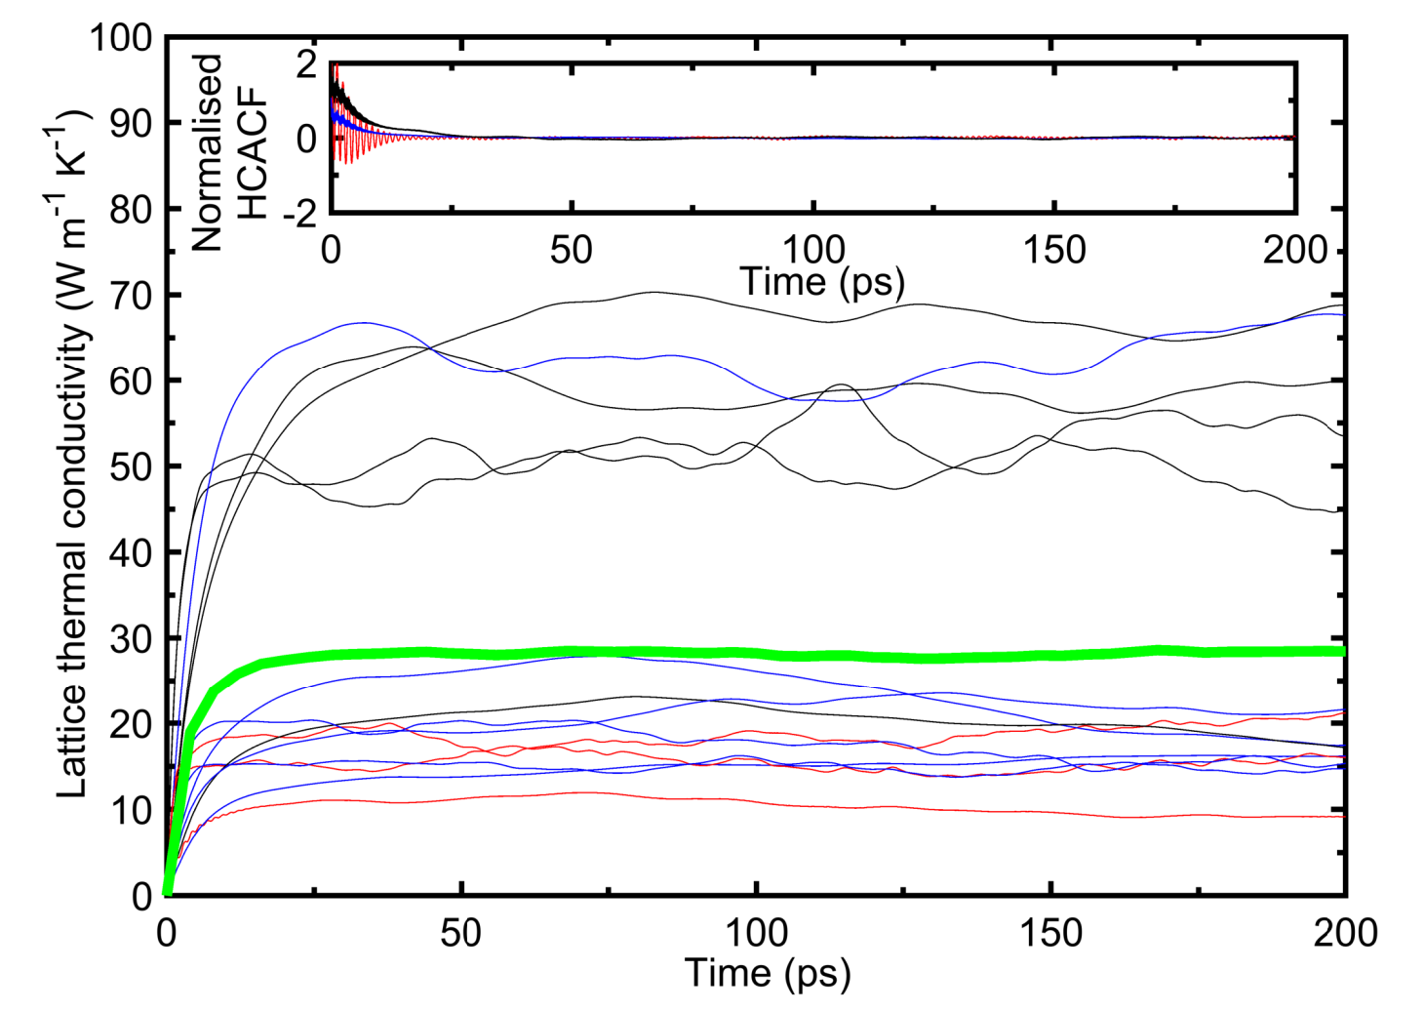
﻿Figure S16. Green-Kubo predicted thermal conductivities for average five different runs as a function of the integration time for ruthenium at ambient conditions. The thick green lines denote the average predicted thermal conductivities at room temperature. We average out the thermal conductivity by taking mean thermal conductivity from 50 ps to 200 ps. (inset) A fully decayed normalized heat current autocorrelation function (HCACF) as a function of the integration time

- Calculating phonon thermal conductivity

We determine the phonon thermal conductivity of Ru using the Machine-learned potential and the EMD method based on the Green-Kubo formula. The lattice thermal conductivity associated with the heat current autocorrelation function (HCACF) can be expressed as

$κ=\frac{1}{VK_{b}T^{2}}\int_{0}^{∞}{{<J}_{x,y,z}(0)}J_{x,y,z} \left(t\right)>dt$ (S06)

﻿where K_{b} ,T ,V and t are the Boltzmann constant, temperature, volume, and time respectively, and ⟨J_{x, y, z}(0) J_{x,y,z}(t)⟩ is the heat current auto-correlation (HCACF) component along x,yor z-directions.

﻿First, the lattice undergoes minimization using the conjugate gradient approach, followed by relaxation under the NPT ensemble for 50 ps at a target temperature and pressure of 0 bar. Subsequently, the system undergoes relaxation under the NVT ensemble for 50 ps. Lastly, the system is relaxed under the NVE ensemble for 10 ns, and data on heat current is collected to calculate the phonon thermal conductivity using the equation mentioned above. For calculating the lattice thermal conductivity for Ru at ambient, we use the well-known green-kubo formalism. The total correlation time period ranging from 50 ps to 200 ps is used to achieve converged heat current autocorrelation function (HCACF) for all our simulations. We use a sampling interval of 10 fs while collecting the data to calculate the HCACF at ambient temperature. Finally, the heat current autocorrelation function is integrated to get the converged thermal conductivity for Ru. We perform ∼5 independent simulations at room temperature with different initial conditions as shown in Figure S16. The phonon thermal conductivity reported is estimated by taking the mean value of all the simulations. We obtain a lattice thermal thermal conductivity of 27.4 ±3 Wm⁻¹K⁻¹ at room temperature using our MLP. The uncertainties quantified by standard deviation range less than 12% in all our simulations.

S4: Spectral Energy Density (SED) Calculations
We perform MD simulations using the SED formalism to analyze the atomic-scale dynamics of the material. In this approach, we apply a Fourier transform to the atomic velocities to calculate the average kinetic energy per unit cell as a function of wave vector (q) and frequency (ω), which is expressed as,^{[21,22]}
$Φ\left(q,ω\right)=\frac{1}{4πτN_{T}}\sum_{α}^{3}{\sum_{b}^{B}{m_{b}{\left|\int_{0}^{τ}{\sum_{n_{x,y,z} }^{N_{T}}{{\dot{u}}_{α}\left(\begin{matrix}n_{x,y,z} \\ b\end{matrix};t\right)×exp\left[iq⋅r\left(\begin{matrix}n_{x,y,z} \\ 0\end{matrix}\right)-iωt\right]dt}}\right|}^{2}}}$(S07)
Here τ is the total simulation time, α represents the Cartesian direction, and $n_{x,y,z}$ denotes a unit cell. $N_{T}$ is the total number of unit cells in the crystal, $b$ represents the atomic index in a given unit cell, $B$ is the atomic number in the unit cell, and $m_{b}$ is the mass of atom $b$ in the unit cell. ${\dot{u}}_{α}$ denotes the velocity in the α-direction at time t, and r represents the equilibrium position of each unit cell.
For the SED calculations, we construct a computational domain by replicating the unit cell to form a supercell of dimensions of 4 $×$ 100 $×$4. The system is first equilibrated using the Nos\'e-Hoover thermostat and barostat (i.e. the NPT ensemble)^{[23]} for 2 ns with a timestep of 0.5 fs, maintaining a constant number of particles, pressure, and temperature at 0 bar. This is followed by an additional 2 ns equilibration under the NVT ensemble, where the volume and temperature remain fixed. Finally, MD simulations are conducted in the microcanonical ensemble (NVE) for 1.5 ns with a 0.5 fs timestep, during which atomic configurations are recorded for SED calculations.
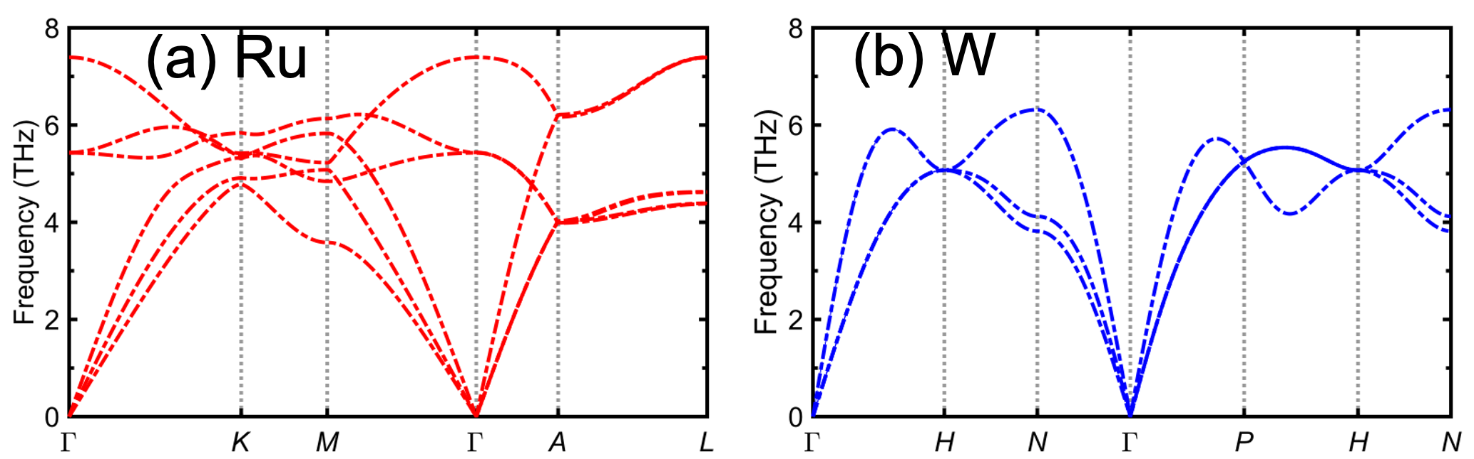
Figure S17: Phonon dispersion curves for (a) Ru (red) and (b) W (blue) along high-symmetry paths in their respective Brillouin zones. The frequency of vibrational modes is plotted as a function of wave vector, showing characteristic dispersion behavior.

Based on the phonon dispersion curves (Figure S17), Ru exhibits both acoustic and optical branches, while W primarily shows acoustic branches without distinct optical modes. In Ru, the optical branches appear above 4 THz, indicating higher-frequency lattice vibrations due to interatomic interactions. In contrast, W's dispersion curves remain within the acoustic regime, suggesting that there is no optical phonon mode, which is attributed to its crystal structure and bonding characteristics.
Comparing the phonon dispersions of the two metals (Figure S17) reveals that W has highly degenerate and isotropic phonon branches. Therefore, given the energy and momentum conservation, W has a much reduced scattering phase space (especially at lower frequencies where the acoustic and longitudinal modes are highly degenerate) as compared to Ru.
Figure S18 further support this interpretation. Ru displays broader and more intense phonon bands, especially in the low- to mid-frequency range (0-6 THz), which is indicative of stronger anharmonic interactions and enhanced phonon-phonon scattering. These broad bands reflect increased mode overlap and phonon population density, which contribute to a larger SPS at low frequencies. In contrast, W shows sharper, well-separated modes with narrower linewidths, reflecting longer phonon lifetimes and reduced scattering opportunities.

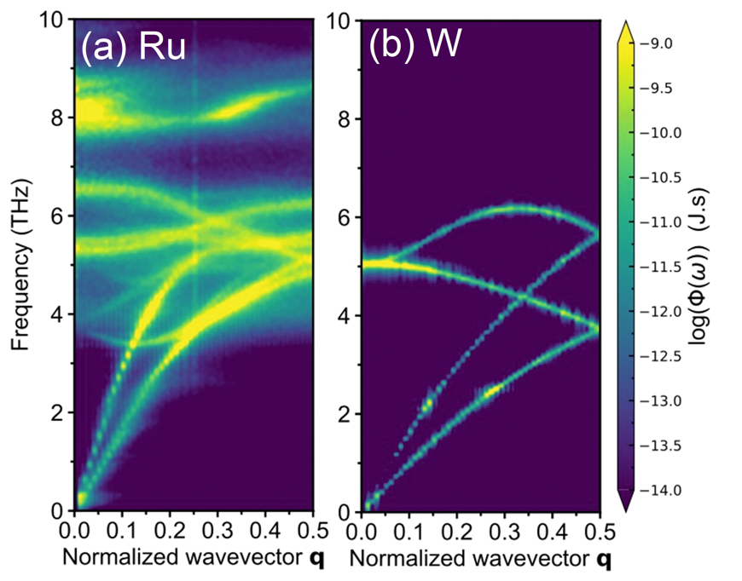
Figure S18: (a, b) Spectral energy density (SED) plots for Ru and W, respectively, illustrating the phonon vibrational intensity as a function of frequency and normalized wavevector q. The color scale represents the logarithm of phonon energy density log(Φ(ω)) in units of J·s.

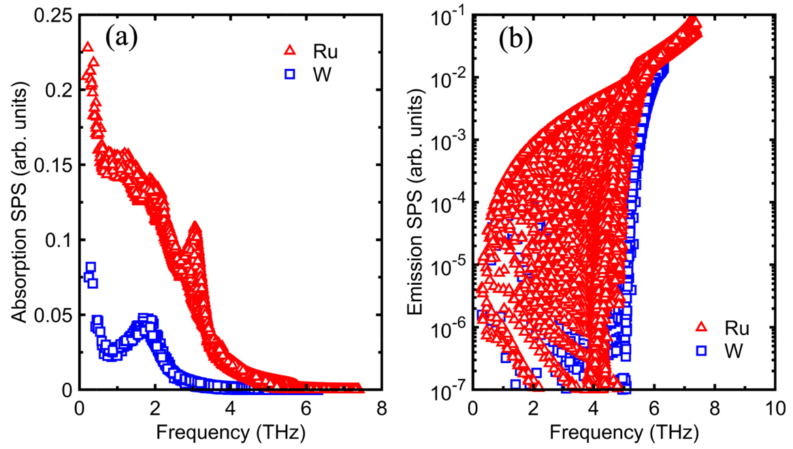
Figure S19: Comparison of the (a) absorption, and (b) emission scattering phase space
Ru exhibits a high absorption SPS at low frequencies, which generally indicates that Ru supports a greater number of phonon-phonon absorption events. This enhances momentum-conserving scattering (Normal processes), contributing to phonon thermalization without necessarily limiting heat conduction^{[24]}. In contrast, a high emission SPS in Ru at certain frequencies reflects a large number of allowed phonon decay processes, which often enhance Umklapp (U) scattering. These resistive processes lead to shorter phonon lifetimes and reduced phonon thermal conductivity. This behavior is evident in Figure S19.
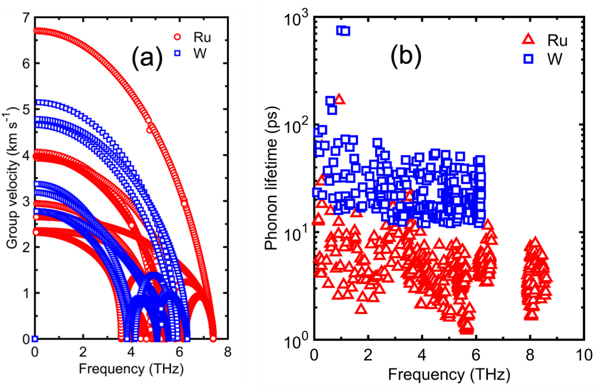
Figure S20: The group velocity and phonon lifetime of Ru and W.

Figure S20 shows the group velocity of Ru and W and Figure S20b shows their phonon lifetimes. For a given frequency the phonon lifetime of W is higher than that of Ru indicating higher phonon-phonon scattering in Ru as discussed earlier.

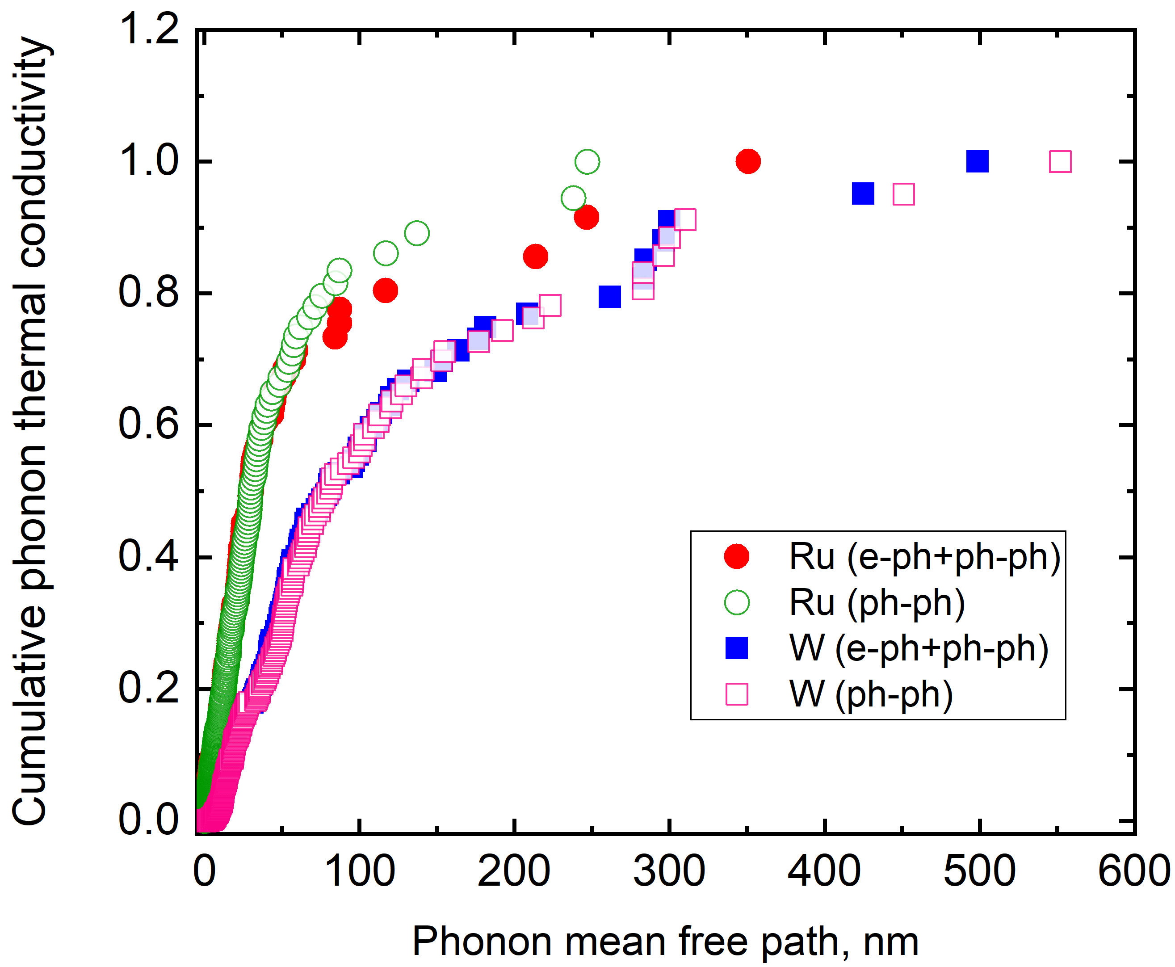

Figure S21: Cumulative phonon thermal conductivity as a function of phonon mean free path for Ru and W thin films. Open symbols represent the analysis based on phonon-phonon (ph-ph) scattering only, while filled symbols incorporate both phonon-phonon and electron-phonon (e-ph) scattering via Matthiessen’s rule. The comparison reveals that inclusion of e-ph scattering has a minimal influence on cumulative thermal conductivity in both Ru and W, indicating that phonon transport in these metals is predominantly governed by ph-ph interactions.

We study the effect of electron-phonon on the phonon thermal transport of Ru and W films. As shown in the Figure S21, the incorporation of electron-phonon scattering leads to only marginal changes in the cumulative phonon thermal conductivity spectra for both Ru and W. This indicates that phonon-phonon interactions remain the dominant scattering mechanism. The phonon lifetimes limited by electron-phonon scattering (Figure 4c) are significantly longer than those from phonon-phonon scattering (Figure S20b), supporting this conclusion. Our SED-based approach, employing a rigorously trained machine-learned potential, fully captures finite-temperature anharmonicity without relying on perturbative assumptions. This allows for direct, mode-resolved extraction of phonon lifetimes from molecular dynamics, inherently accounting for all relevant phonon-phonon scattering processes. As a result, our calculated phonon mean free paths, fully accounting for anharmonicity, demonstrate that phonon-phonon interactions are the primary mechanism limiting phonon lifetimes in Ru and W.

S5: TDTR thickness, sensitivity, uncertainty, and data analysis
To support steady-state thermoreflectance measured in-plane thermal conductivity, we determine various thermophysical properties using time-domain thermoreflectance (TDTR), with details provided elsewhere^{[1,25]}. A Ti:sapphire laser (~808 nm, 80 MHz, Spectra Physics Tsunami) generates a pump and probe beam, with the pump beam modulated via an electro-optic modulator (EOM) to induce a periodic temperature rise, altering the sample's reflectivity. The probe beam detects reflectivity changes using a balanced photodetector and lock-in amplifier. The schemetic for the TDTR set up is shown in Figure S22. To determine the pump and probe beam spot size at 20× magnification, we use an Al-coated fused silica calibration sample (Corning HPFS 7980, 1.36 Wm⁻¹K⁻¹). By fitting the known thermal conductivity in our thermal model, we obtain an effective beam radius of ~2.15 μm. Assuming identical pump and probe beam sizes, we verify the spot size by measuring the thermal conductivity of a sapphire calibration sample

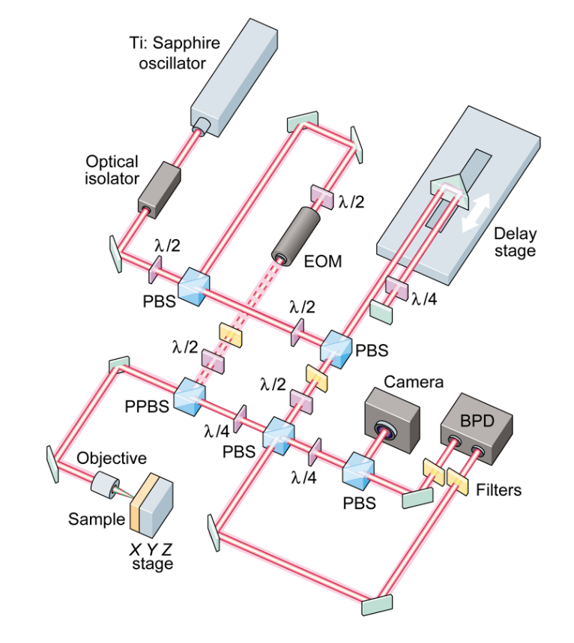
Figure S22: Schematic of the TDTR experimental setup configuration

We evaluate the sensitivity of TDTR measurements to the cross-plane and in-plane thermal conductivities of 102 nm Ru and W films, following the methodology described in our previous work on Cu films.^{[1]} Briefly, a 20 nm Al/60 nm Ti transducer is used to ensure optical opacity and enhance heat spreading within the Ru and W layers relative to the transducer. The sensitivity to cross-plane and in-plane thermal conductivities is calculated at two modulation frequencies and a tightly focused spot size. Notably, a larger spot size results in shallower thermal penetration depth, thereby reducing sensitivity to thermal conductivities.^{[1,26]} These calculations incorporate the thermophysical properties of each layer as listed in Table S5. As shown in Figure S23b and S23d, the sensitivity to the in-plane thermal conductivity of 102 nm Ru and W is higher at 1.2 MHz and a 2.15 μm effective radius, attributed to the greater thermal penetration depth. In contrast, the sensitivity to cross-plane thermal conductivity is comparable at 1.2 MHz and 8.4 MHz but remains lower than the in-plane sensitivity. To minimize the interdependence on in-plane thermal conductivity, we measure the cross-plane component at 8.4 MHz. However, TDTR measurements are limited to cross-plane and in-plane thermal conductivities for 102 nm Ru and W films and lose sensitivity for films with thickness ≤ 50 nm. Note, due to uncertainties in our calculations, we are unable to accurately measure the in-plane thermal conductivity of as-deposited ~102 nm Ru. We can measure the in-plane thermal conductivity of annealed ~102 nm Ru film with TDTR. Moreover, TDTR exhibits higher sensitivity to the thermal conductivity of SiO₂ and Si compared to Ru and W. To ensure accurate fitting of the experimental data, we incorporate accepted literature values for SiO₂ and Si^{[27–31]} in our thermal model.

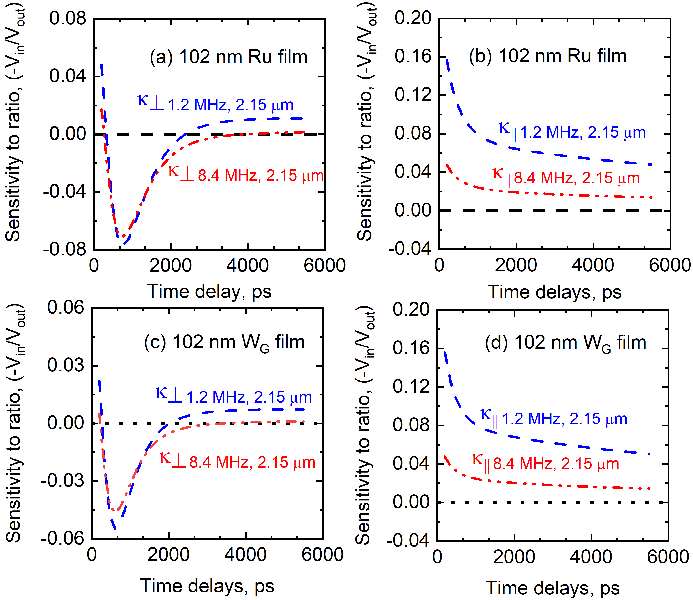

Figure S23: TDTR measurement sensitivities to (a and c) the cross-plane thermal conductivity ${(κ}_{})$ of Al/Ti coated 102 nm Ru and W films at different modulation frequencies and 2.15 μm effective radii of beam. (b and d) The sensitivity to in-plane thermal conductivity ${(κ}_{∥})$ of these films.

We determine the cross-plane and in-plane thermal conductivities of Ru and W films using a five-layer heat diffusion model.^{[32–34]}Figure S24 shows how the best-fit thermal model aligns with the ratio of the in-phase and out-of-phase signals (–V_{in}/V_{out}), demonstrating the fitting process for both thermal conductivities. Table 1 (main manuscript) and Table S5 list the thermophysical properties and thicknesses of the individual layers used in the thermal model. We first measure the cross-plane thermal conductivity of Ru and W and then use it as an input parameter to extract the in-plane thermal conductivity. Table S5 presents the TDTR-measured values for cross-plane and in-plane thermal conductivities along with the thermal boundary resistance. Figure S25 displays the residual contours, comparing the model’s fit to the best-fit values of cross-plane and in-plane thermal conductivities and the thermal boundary resistance at the Ti-film interface. The residual error between the theoretical model and experimental data reaches a maximum of approximately 1.5%, indicating that multiple combinations of thermal conductivity and boundary resistance can achieve a similar fit. Based on this, we set a 1.5% residual threshold, ensuring that the model consistently produces high-quality fits to the experimental data. The strong agreement within this threshold confirms that TDTR effectively detects variations in cross and in-plane thermal conductivities.

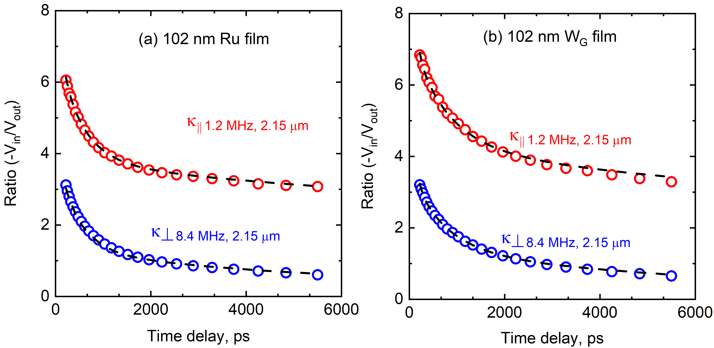

Figure S24: Theoretical fit of experimental data for (a) annealed 102 nm Ru and (b) as-deposited 102 nm W_{G} films.

We incorporate the 1.5% residual uncertainty along with spot-to-spot variations in thermal conductivity, the thermal conductivities of Al, Ti, SiO₂, and Si, and the thermal boundary resistances into our total uncertainty (${}_{i}$) calculation, as defined by the following equation:
Total uncertainty (${}_{i}$),
${}_{i}$= $\sqrt{({σ_{i}}^{2})+\sum_{i}{∆_{i}^{2}})}$ (S08)
Here ${}_{i}$ represents the standard deviations among multiple measurements taken different locations of the samples and $∆_{i}$ denotes the uncertainty associated with each individual parameter in the thermal model^{[28,35]}. Table S5 presents the TDTR-measured thermal conductivities of Ru and W films, along with their corresponding thermal boundary resistances.

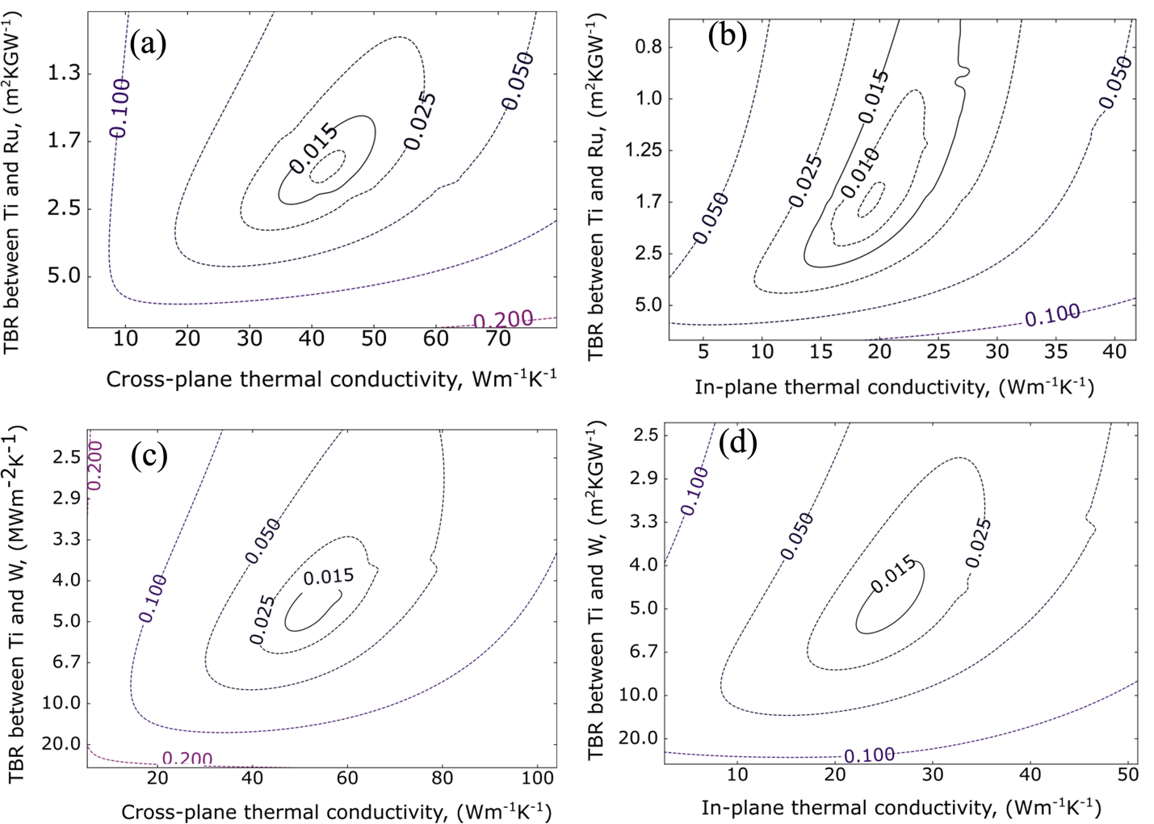

Figure S25: Residual contours of our model’s fit relative to the best fit for annealed 102 nm Ru and as-deposited 102 nm W_{G} films as a function of cross and in-plane thermal conductivity. We choose 1.5% residual threshold within which the thermal model generates the same quality of fit to the experimental data.

Table S5: Parameters used in sensitivity analysis and the thermal model to determine the in-plane and cross-plane thermal conductivities of the Ru and W films.
Materials | Thickness,  nm | Heat capacity,  MJm⁻³K⁻¹ | Thermal conductivity,  W m⁻¹ K⁻¹ | Thermal boundary resistance, (TBR)  m² K GW⁻¹
Al | 20±1 | 2.42^{[27]} | 110-120
Al/Ti | -- | -- | -- | 0.333^{[36–38]}
Ti | 60±2 | 2.36^{[39]} | 16-19
Al₂O₃ |  | 3.06^{[39]} | 34±1.5 ^{[28,40]}
Ti/Al₂O₃ | -- | -- | -- | ~2.5-3.8
Ti/Ru | -- | -- | -- | 0.86 (as-deposited)ª
 |  |  |  | 1.52 (annealed) ª
Ti/W_{G} | -- | -- | -- | 4.52ª
Ti/W_{R} | -- | -- | -- | 1.00^{[36–38]}
Ru | 5 -102 | 2.97^{[41]} | As-deposited 102 nm, ${}_{⊥}=$42.4±11.5 Wm⁻¹K⁻¹
Ru | 5 -102 | 2.97^{[41]} | Annealed 102 nm, ${}_{⊥}=$44.0±10.4 Wm⁻¹K⁻¹  ${}_{∥}=21$.3±11.2 Wm⁻¹K⁻¹
W | 3-102 | 2.56^{[42]} | As-deposited 102 nm W_{G}, ${}_{⊥}=52$.8±12.4 Wm⁻¹K⁻¹  ${}_{∥}=24$.8±13.8 Wm⁻¹K⁻¹
Ru/SiO₂ and W/SiO₂ |  |  |  | 5.00 ^{[30]}
SiO₂ | 100 | 1.62 ^{[28–30]} | 1.45^{[27,28,30,31]}
SiO₂/Si | - | - | - | 4.35 ^{[29,30]}
Si | - | 1.65^{[27–31]} | 140 ^{[28,30]} | -
- We determine the in-plane thermal conductivity using SSTR, employing the TDTR best-fit values for cross-plane thermal conductivity and thermal boundary resistance (TBR) from 102 nm Ru. We assume that the TBR remains unchanged for the 32 nm and 52 nm Ru films. Similarly, for the 102 nm W_{G} film, the TBR between Ti and W_{G} is obtained from TDTR measurements and applied to 31 and 50 nm W_{G} films. In contrast, the TBR between Ti and W_{R} for 20–30 nm thick films is assumed to be 1 m²KGW⁻¹ based on literature values and observations from this study. A 50% uncertainty is propagated for both measured and assumed TBR values.
- We introduce perturbations in the thermal conductivity of Al, Ti, and Si by 5%, and that of SiO₂ by 3%. The measured TDTR cross-plane thermal conductivities of Ru and W is perturbed by 50%, as well as both measured and assumed thermal boundary resistances, are perturbed by 50%.
S6. SSTR sensitivity, uncertainty and data analysis

To evaluate the sensitivity of SSTR measurements to the in-plane thermal conductivity of Ru and W films, we conduct a sensitivity analysis. We compute the SSTR sensitivities (S_{x}​) to various thermal parameters in our samples as a function of Ru and W film thicknesses, employing a tightly focused laser spot. This analysis follows our prior methodology^{[1]} and aligns with the approaches of Braun et al. and Yang et al. ^{[28,43]}

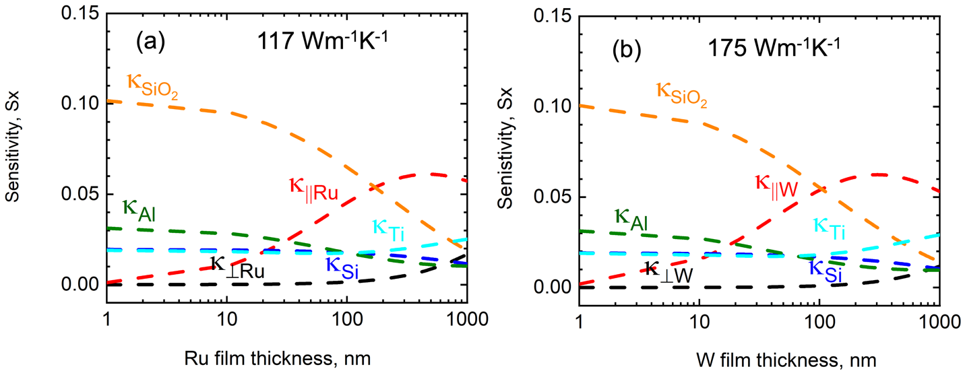

Figure S26: (a) and (b) Typical sample stack of Ru and W films with an Al/Ti transducer as a function of film thickness. The analysis is performed at an effective radius ($\sqrt{r_{0}^{2}+r_{1}^{2}}$) of 2.33 μm. The sensitivity to in-plane thermal conductivity ($κ_{∥})$ of Ru and W films is higher than its cross-plane thermal conductivity ($κ_{⊥})$ . SSTR maintains its sensitivity down to 30 nm Ru and 20 nm W films

The sensitivity is determined using the following equation:

$S_{x}=\frac{{∆T}_{1.1x}\left(thickness\right)-{∆T}_{0.9x}\left(thickness\right)}{{∆T}_{x}\left(thickness\right)}$ (S09)
Here ${∆T}_{x}$ ​ is the temperature rise using the steady-state thermal model based on the given input parameters. In Equation S09, the input variables include x and the thicknesses of the Ru and W films, with values obtained from Table S5. Figure S26(a–b) shows that the sensitivity to in-plane thermal conductivity is greater than that to cross-plane conductivity. This occurs because Ru and W thin films have significantly higher thermal conductivity than SiO₂, causing heat to flow predominantly along the in-plane direction of the Ru and W films.^{[28,44]} As a result, the in-plane temperature gradient is much steeper than the cross-plane gradient. Consequently, in-plane thermal conductivity primarily governs the sensitivity calculations in this study, allowing SSTR to effectively measure in-plane thermal conductivity. We determine the cross-plane thermal conductivity of Ru and W using TDTR (Table S5) and incorporate these values into the thermal model for SSTR analysis. In our SSTR system, we evaluate the sensitivity to in-plane thermal conductivity using an effective spot radius of ~2.33μm, which enhances lateral heat spreading.^{[1]} We generate Figure S26(a-b) by assuming $κ_{⊥Ru}= κ_{∥Ru}$ = 117 W m⁻¹ K⁻¹ and $κ_{⊥W}= κ_{∥W}$ = 175 W m⁻¹ K⁻¹, respectively. However, Figure S26 also indicates that for film thickness up to ~100 nm, the sensitivity to the thermal conductivity of SiO₂ exceeds to in-plane thermal conductivity. To extract in-plane thermal conductivity of Ru and W, we use widely accepted value of $κ_{SiO2}$= 1.45 Wm⁻¹K⁻¹ ^{[27,28,30,31]} in our thermal model. Figure S26 further shows that the sensitivity to the thermal conductivity of Al and Ti is higher than that to the cross-plane thermal conductivity of Ru and W. Specifically, the sensitivity to Ti's thermal conductivity increases for film thicknesses beyond ~100 nm. We also use well-established literature values for the thermal conductivity of Si, as provided in Table S5. We obtain the heat capacity and thermal boundary resistances used in the sensitivity calculations from literature sources, as detailed in Table S5.^{[27–29,39]}

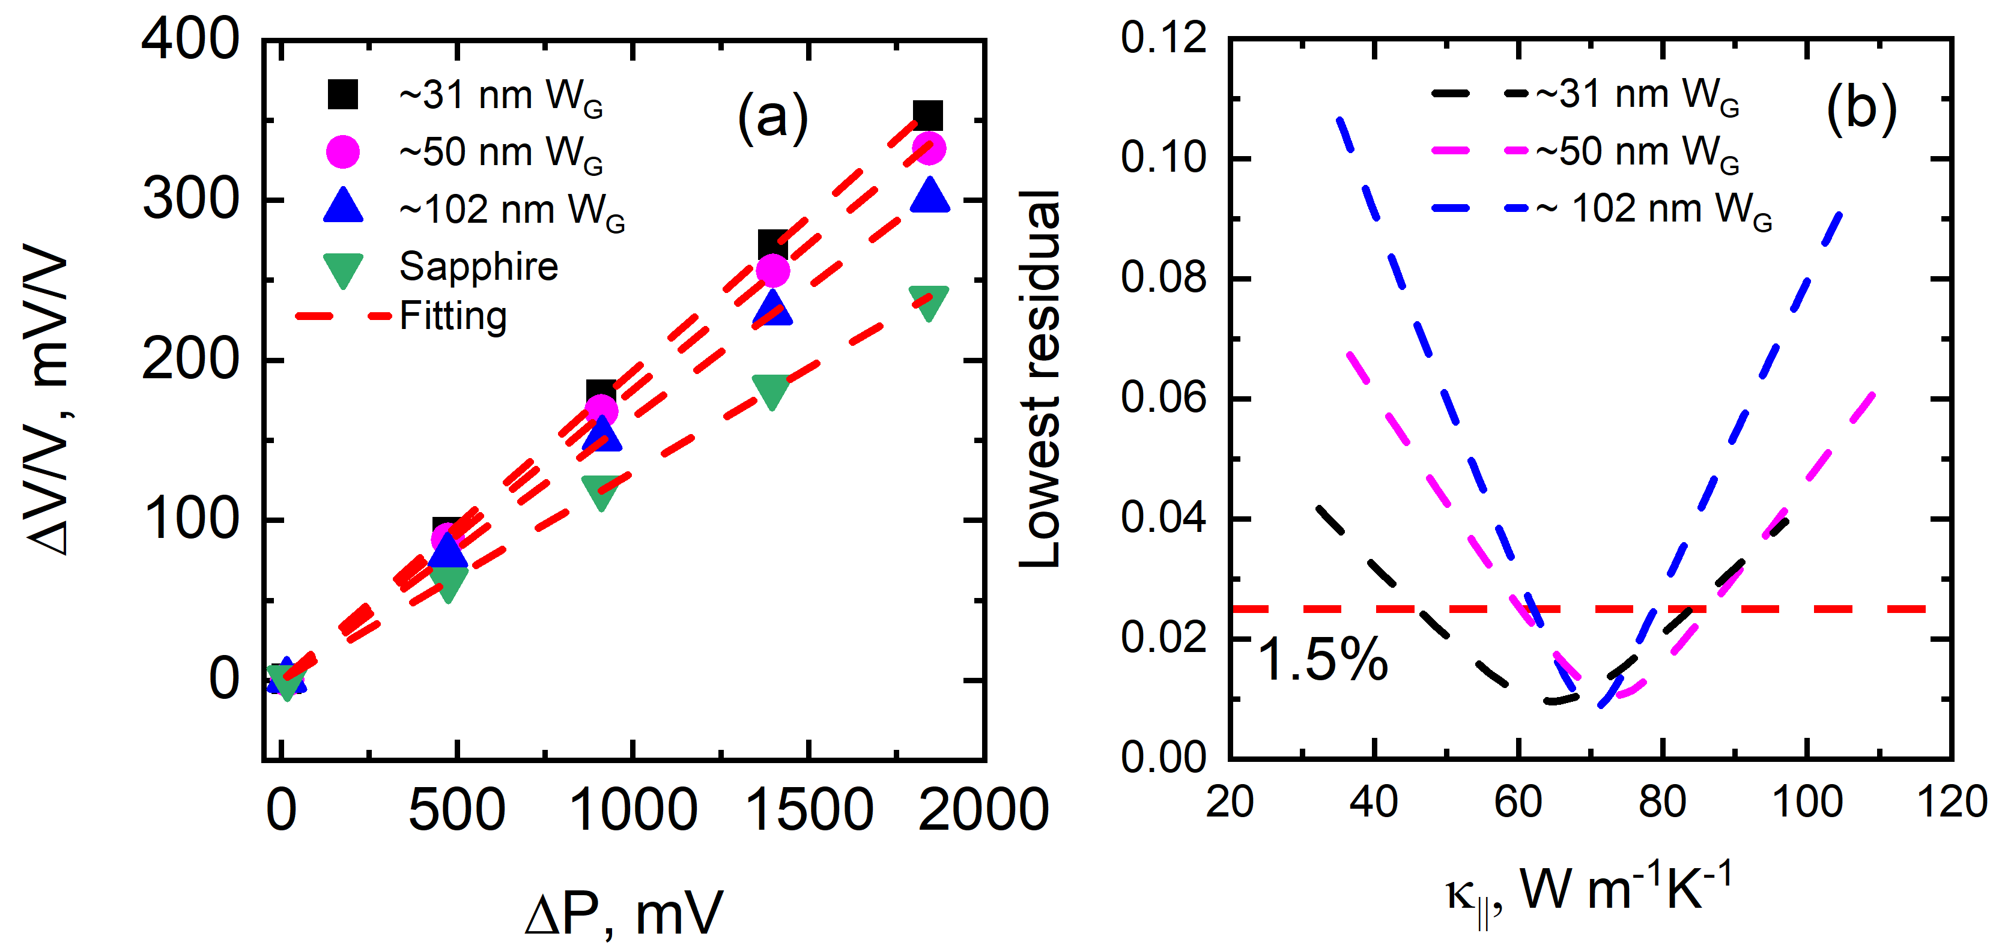

Figure S27: (a) SSTR fitting of ∆V/V as a function of ∆P (proportional to pump power) to extract the thermal conductivities of sapphire and W_{G} films, measured using an effective radius of ~ 2.33 µm. (b) Corresponding 2D contour analysis illustrating the quality of fit between the model parameters and experimental data, where the contour threshold is set to 1.5% based on the observed maximum residual error between the experimental and model data.

SSTR measurements determine the in-plane thermal conductivity of Ru and W films by fitting, while other material properties come from TDTR or literature (Table S5). Figure S27a shows ∆V/V vs. ∆P, used in SSTR fitting to extract the thermal conductivities of sapphire and as-deposited W_{G} films, following established procedures.^{[1,28]} The calibration factor (γ) is derived from a sapphire reference sample with known transducer and sapphire properties (Table S5) and remains constant across samples. Using this calibration, we calculate the thermal conductivity of Al/Ti-coated W_{G} films through a steady-state thermal model, applying a five-layer structure (Al/Ti transducer/W_{G} thin film/SiO₂ /Si substrate) with properties listed in Table 1 and Table S5.
To account for the sensitivity of thermal parameters, we use contour plots to assess the similarity between experimental and model fits, identifying parameter interdependence while extracting the in-plane thermal conductivity of Ru and W_{G}. We compare measured SSTR data with a thermal model, iterating the in-plane thermal conductivity to achieve the best fit. Figure S27b demonstrates a fit quality within a 1.5% residual, confirming SSTR’s capability to measure in-plane thermal conductivity. We set the contour threshold to 1.5% based on the observed maximum residual error between the experimental and model data.^{[35,45]} Error bars in the manuscript, calculated using Equation S08, account for residual uncertainty, spot-to-spot conductivity variations, and perturbations in layer conductivities and thermal boundary resistances (Table S5).
Table S6 compares the in-plane thermal conductivities measured by SSTR and TDTR. TDTR underpredicts thermal conductivity for these thin films due to its higher sensitivity to interface resistances within the film stacks.

Table S6: Comparison of SSTR, and TDTR measured in-plane thermal conductivities of Ru and W films.
Film thickness, nm | TDTR, Wm⁻¹K⁻¹ | SSTR, Wm⁻¹K⁻¹
Annealed ~102 nm Ru | 21.3 ±11.2 | 75.1±9.9
As-deposited ~102 nm W_{G} | 24.8±13.8 | 76.1±8.5

As shown in Figs. S28 and S29, TDTR is comparably sensitive to both $κ_{∥}$ and interfacial resistances at early delay times (up to ~1000 ps). Since Ru and W are electron-dominated systems, the early delay times in TDTR experiments when electrons transfer energy to phonons^{[46,47]} play a critical role in determining the overall thermal conductivity of the films. Therefore, TDTR’s sensitivity to interfacial resistances does not limit its capability but complicates the decoupling of intrinsic $κ_{∥}$.

On the other hand, the SSTR sensitivity plots (Figs. S28 and S29) indicate that the SSTR signal is insensitive to thermal boundary resistances across the entire range of pump powers used in our experiments. Their sensitivity values remain near zero regardless of the pump power, suggesting that changes in these parameters do not significantly influence the signal. In contrast, the signal shows increasing sensitivity to the in-plane thermal conductivity of $κ_{∥}$ of Ru and W with increasing pump power, indicating that SSTR is highly sensitive to their $κ_{∥}$. Moreover, assuming different $κ_{∥}$ values does not substantially alter the sensitivity trend, further validating our modeling approach.

In this analysis, we compute the sensitivity of the TDTR and SSTR signals to each thermal parameter α using a log-log formulation^{[26,38]} :

$S_{α}=\frac{dln(X)}{dln(α)}$ =$\frac{ln⁡[X\left(α+∆α\right)]-ln⁡[X\left(α\right)]}{ln⁡\left(α+∆α\right)-ln⁡\left(α\right)}$ (S10)

where, X is the signal ( TDTR ratio or SSTR magnitude), $∆α$ is a small perturbation (typically 10% of α ). This dimensionless sensitivity indicates the relative influence of each parameter on the measured signal.

For the sensitivity analysis presented in Figs. S28 and S29, the cross-plane thermal conductivity and interfacial resistivity values are taken from either the literature or our own measurements, as listed in Table S5. The in-plane thermal conductivities of Ru and W, which are not directly known, are estimated and used as inputs in the model by summing the electronic contribution (measured via a four-point probe) and the phonon contribution (estimated from molecular dynamics simulations). We also repeat the analysis using bulk thermal conductivity values for Ru and W, and find that the sensitivity to in-plane conductivity does not change significantly. The thermal boundary resistance at the Ti/Ru and Ti/W interfaces is assumed to be 1.0 GW m⁻² K⁻¹, based on previous studies. ^{[36–38]}

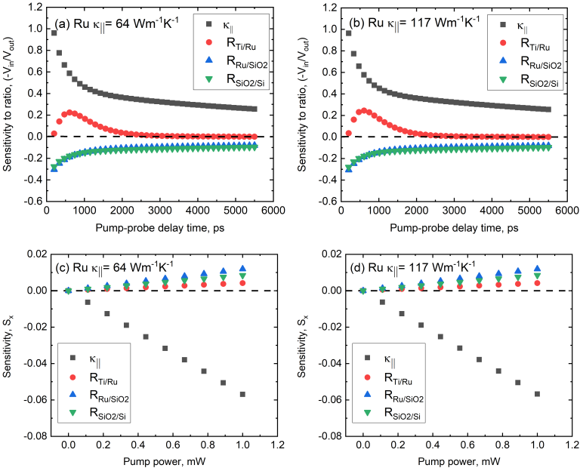

Figure S28: TDTR and SSTR sensitivities to in-plane thermal conductivity ($κ_{∥})$ and various interfacial thermal resistances for 102 nm Ru film. The in-plane thermal conductivity of Ru which is unknown, are used as inputs in the model by summing the electronic contribution measured via a four-point probe and the phonon contribution estimated from molecular dynamics simulations. Also, the sensitivity calculation is performed assuming the bulk thermal conductivity. Note there is no significant difference observed in the sensitivity for assuming different thermal in-plane conductivities
.
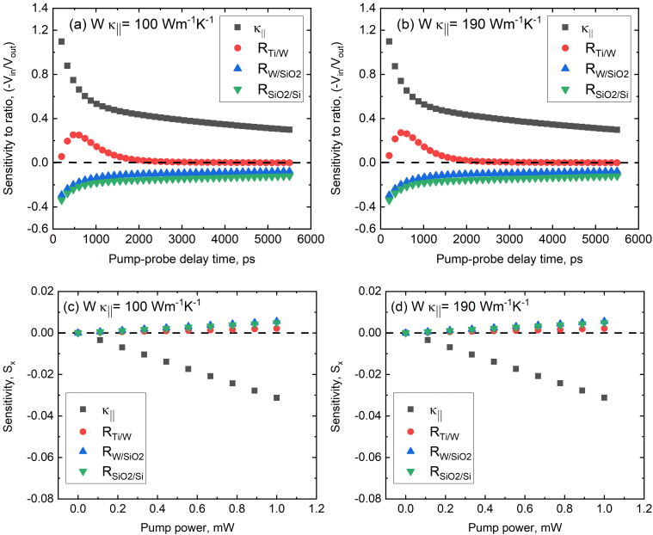

Figure S29: TDTR and SSTR sensitivities to in-plane thermal conductivity ($κ_{∥})$ and various interfacial thermal resistances for 102 nm W film. The approach of sensitivity calculations for W is similar to Ru film.

Overall TDTR is highly sensitive to thermal boundary resistances, whereas SSTR is comparatively less sensitive. These interface resistances are difficult to decouple and accurately determine in TDTR analysis, particularly for thin metal films, and often result in an underestimation of κ∥. Thus, although a reasonable fit is achievable, the extracted κ∥ from TDTR likely reflects an “effective” in-plane conductivity of Ru and W films that is suppressed by interface effects.^{[48]}

This is also consistent with our previous study^{[1]}. TDTR underpredicts in-plane conductivity in thin metal films ($≤$100 nm) due to its sensitivity to interfacial thermal resistance. For thicker films, this artifact becomes less significant. In contrast, SSTR, by design, directly measures the in-plane temperature response and is inherently less affected by interfacial resistances.

Therefore, the lower TDTR value for 102 nm Ru and W results from its sensitivity to interface effects, not from an intrinsic material property, and the higher SSTR value more reflects the intrinsic in-plane thermal conductivity of the films.

To validate the applicability of the steady-state assumption in our multilayer Al/Ti/Ru/SiO2/Si and Al/Ti/W/Ta/SiO2/Si systems, we perform a frequency-dependent analysis using a full multilayer thermal model following Braun et al.^{[28]} As shown in Figure S30, the normalized temperature rise (ΔT/ΔT_{SS}) remains within 0.02% of the steady-state value at 1000 Hz, confirming that the system operates within the steady-state regime at the modulation frequency used in our experiments. The 1000 Hz modulation frequency enables sufficient heat diffusion to reach a quasi-steady state condition. Specifically, the use of a tightly focused spot (2.20 μm effective radius) confines heat laterally, increasing in-plane heat flow. This favors steady-state condition when the modulation frequency is low enough to allow lateral temperature gradients to fully develop.. These conditions collectively support the validity of the steady-state assumption in our multilayer stack.
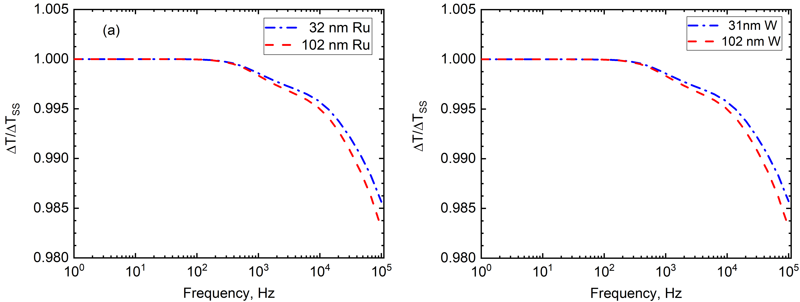
Figure S30: normalized surface temperature rise (ΔT/ΔT_{SS}) vs modulation frequency for the Al/Ti/Ru/SiO₂/Si and Al/Ti/W/Ta/SiO2/Si stack, showing operation within 0.02% of steady-state at 1000 Hz. A tightly focused spot (2.2 μm radius) promotes in-plane heat flow, validating our steady-state assumption.
To evaluate the validity of steady-state assumptions, we extend our multilayer thermal model to compute the absolute temperature rise specifically at the center of Ru and W film. At 1000 Hz, the W and Ru films experience a modest temperature rise (2–3 K). Assuming a conservative temperature coefficient of thermal conductivity (-0.1%/K), based on our previous finding of -0.072%/K for W,^{[49]} this corresponds to a maximum reduction of only ~ 0.2 W m⁻¹ K⁻¹, as shown in Table S7. Thus, the heating effect is minor and does not significantly impact the accuracy of extracted thermal properties

Table S7: The temperature rise and reduction in thermal conductivity in Ru and W films. Based on a conservative estimate of W and Ru ’s thermal conductivity temperature dependence (-0.1%/K), we estimate the reduction in their thermal conductivity.
Film thickness | Temperature rise in the film, ΔT, K | Change in thermal conductivity, Wm⁻¹K⁻¹
~32 nm Ru | 2.69 | -0.16
~102 nm Ru | 2.28 | -0.15
~30 nm W | 2.70 | -0.15
~102 nm W | 2.2 | -0.17

S7. Lorenz number of ruthenium and tungsten thin films

Ruthenium and tungsten thin films exhibit high electrical resistivity due to their grain sizes being smaller than or comparable to the electron mean free path, despite film thicknesses exceeding the mean free path.^{[50,51]} This microstructural feature significantly affects the electron contribution to thermal conductivity, which in turn impacts the Lorenz number.

For Ru films, the Lorenz number varies between as-deposited and annealed samples due to differences in grain size and electron scattering. The annealed ~102 nm Ru film exhibits a Lorenz number of approximately 1.48 × 𝐿₀, whereas the maximum Lorenz number observed in as-deposited Ru films reaches 1.9 × 𝐿₀ . As shown in Figure 2d, the electron thermal conductivity is higher in annealed films due to their larger grain size, while the lower electron thermal conductivity in as-deposited films increases the relative phonon contribution, resulting in higher Lorenz numbers. Table S8 summarizes these findings, showing the average Lorenz number for as-deposited Ru is ~1.9 × 𝐿₀ , while that of annealed Ru films is ~1.5 × 𝐿₀ .

Table S8: Comparison of Lorenz number and phonon contributions in Ru films from SSTR and 4-point probe measurements:

Thickness of the as-deposited Ru films, (nm) | Lorenz number of as-deposited Ru films,  (WΩ K⁻²) | Phonon contributions in as-deposited Ru films, (Wm⁻¹K⁻¹) | Thickness of annealed Ru films, (nm) | Lorenz number of annealed Ru films,  (WΩ K⁻²) | Phonon contributions in annealed Ru,  (Wm⁻¹K⁻¹)
~32 | 2.1 | 31.6 | ~32 | 1.5 | 20.9
~52 | 1.8 | 28.0 | ~52 | 1.6 | 23.7
~102 | 1.7 | 24.9 | ~102 | 1.48 | 23.9

Table S9: Comparison of Lorenz number and phonon contributions in W films from SSTR and 4-point probe measurements:

Thickness of the as-deposited W_{R} films, (nm) | Lorenz number of as-deposited W_{R} films,  (WΩ K⁻²) | Phonon contributions in as-deposited W_{R} films, (Wm⁻¹K⁻¹) | Thickness of as-deposited W_{G} films, (nm) | Lorenz number of as-deposited W_{G} films,  (WΩ K⁻²) | Phonon contributions in as-deposited W_{G} films,  (Wm⁻¹K⁻¹)
~22 | 2.7 | 56.6 | ~31 | 1.8 | 30.3
~26 | 2.7 | 58.5 | ~50 | 1.9 | 37.4
~30 | 2.6 | 63.7 | ~102 | 1.8 | 36.1

In tungsten films, prior literature estimates a phonon thermal conductivity of ~ 60 W m⁻¹ K⁻¹. ^{[52]} Thus, when electron thermal conductivity is reduced due to grain boundary scattering, the total Lorenz number increases accordingly. The W_{R} film demonstrates a Lorenz number of ~2.7 × 𝐿₀ and phonon contribution of ~60 W m⁻¹ K⁻¹. By contrast, the W_{G} (grain-optimized) sample exhibits a lower Lorenz number (~1.8 × 𝐿₀) due to a lower mean total thermal conductivity. These results are summarized in Table S8 and Table S9, emphasizing that variations in microstructure, grain size, and interface quality can lead to differences in Lorenz number and phonon contributions across the film series.

S10: Beam offset technique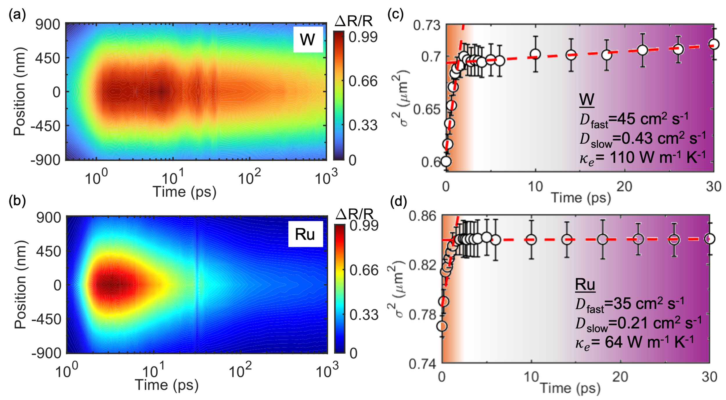
Figure S31: Contours showing the spatiotemporal profiles obtained with nanometric precision for (a) 30 nm W and (b) 100 nm Ru films. The square of the full-width at half maximum ($σ^{2}$) obtained from the gaussian profiles at various pump-probe time delays is plotted for (c) W and (d) Ru.

Experimental set up for beam offset:
The details of our beam offset measurement can be found in the method section and somewhere else^{[53]} The laser pulses, generated by a Ti:Sapphire laser with a central wavelength of 800 nm and operating at 80 MHz, are divided into pump and probe paths using a beam splitter. An electro-optic modulator (Conoptics, 350-160-02) modulates the pump beam at a frequency of 10 MHz, and the pump is frequency-doubled from 1.55 eV to 3.11 eV. A computer-controlled mechanical delay stage (Newport M-360-90) adjusts the arrival time of the probe beam. The probe is further split using a non-polarizing beam splitter to create a reference arm for balanced photodetection. The pump and probe beams are then recombined using a dichroic mirror, which reflects the pump and transmits the probe, and both are directed through the rear aperture of a microscope objective. In the case of the 100x objective, the probe beam remains fixed during measurements, while the pump beam is scanned along the x-axis relative to the probe using a dichroic mirror mounted on a mirror mount (New Focus 8821), controlled by a picomotor controller (Newport Model 8742) with nanometric precision. The 1/e² radii of the pump and probe beams on the sample with the 100x objective are approximately 0.65 μm and 0.55 μm, respectively, measured using a knife-edge method with 20 nm spatial resolution. The electron diffusivity is calculated using the general diffusion model as explained below.

General Diffusion Model:
The slope of the plot of the squared full-width at half maximum ($σ^{2}$) versus time is commonly used to estimate the diffusion coefficient, or diffusivity. The laser energy absorbed by the sample is assumed to follow a Gaussian spatial distribution at time zero, expressed as u(x, t = 0) ∝ exp(−4$\ln{2}$|$x^{2}$|${/σ}^{2}$), where x belongs to Rⁿ (n = 1, 2, or 3 for spatial dimensions).^{[54]} This energy distribution evolves over time according to the heat diffusion equation:
$\frac{∂u\left(x,t\right)}{∂t}=D\left(t\right)∇^{2}u\left(x,t\right).$ (S11)
Alternatively, the heat equation can be expressed with a decay term using a decay rate Γ=1/τ,
$\frac{∂u\left(x,t\right)}{∂t}=D\left(t\right)∇^{2}u\left(x,t\right)-Γu\left(x,t\right).$(S12)
The solutions to both equations (S11 and S12) maintain a Gaussian profile in space and exhibit decay over time. The connection between time-dependent diffusivity and σ² is defined by:
$\frac{∂σ^{2}\left(t\right)}{∂t}=16\ln\left(2\right)D(t)$ (S13)
Equation S13 generalizes the classic relation for a constant diffusion coefficient D, where σ²(t) increases linearly with time as $σ^{2}\left(t\right)=σ^{2}(t)+2Dt$.

Figure S31 shows a typical beam-offset measurement on Ru and W. Figure S31a and S31b shows the electronic temperature dominates the spatiotemporal profile at early time delays while at later times, the profile is dictated by both electronic and phononic temperatures after they coupled with each other. From the spatiotemporal profile we obtain the gaussian profiles at different pump-probe time delays, which gives us an insight into the carrier diffusion processes. The square of the full-width at half maximum ($σ^{2}$) obtained from the gaussian profiles at various pump-probe time delays is plotted in Figure S31c and S31d. The fast diffusion regime at early times related to the equilibration of photo-excited electrons that couple with the cooler lattice leading to a steady slow diffusion regime in the later times after the coupling of electrons with the phonons. The slow diffusion regime is used to back out the thermal conductivity of the metallic films using the diffusivity equations.
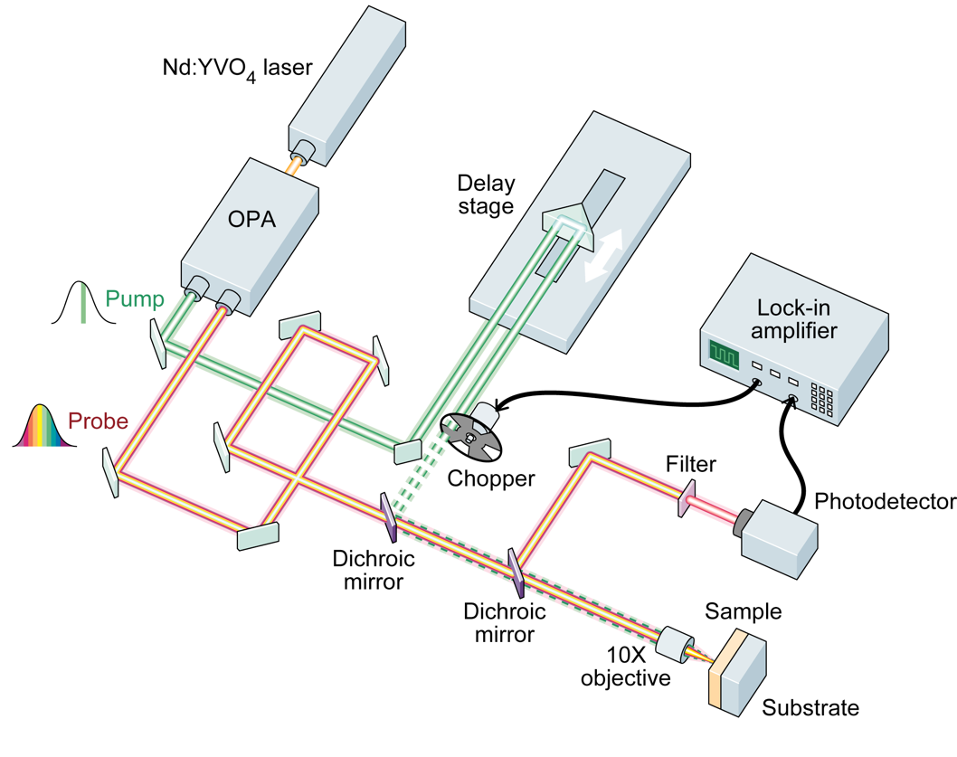
Figure S32: Schematic of transient thermoreflectance pump-probe technique with infrared wavelength tunability.

S9. Details on two temperature model (TTM) and electron-phonon coupling factor determination.
We use an ultrafast pump-probe technique with infrared wavelength tunability to study electron-phonon scattering in Ru and W films by monitoring their intraband transient thermoreflectance response. Figure S32 shows the experimental setup, where a Nd:YVO₄ laser (∼1040 nm, 1 MHz) passes through an OPA, generating a 520 nm pump beam via SHG and a tunable probe (600–2500 nm). We chop the 379 fs pump pulses at 450 Hz and measure their duration by fitting Pt thermoreflectance signals using a sech² function.^{[1]} In this experiment, we excite electrons in Ru and W films with a 2.38 eV pump, driving them out of equilibrium with phonons. We then probe the thermoreflectance at ∼0.53 eV (Ru) and ∼0.56 eV (W), ensuring a nearly free-electron-like reflectivity response by choosing probe energies far from the interband transition thresholds [Ru: 1.74 ± 0.02 eV; W: 0.94 ± 0.05, 1.80 ± 0.015 eV] determined via our ellipsometer (see in the following section). This approach simplifies the extraction of the electron–phonon coupling factor (G) of the films^{[55]}, as the thermoreflectance signal remains linearly proportional to the phonon subsystem temperature,^{[56,57]} while the electron subsystem’s contribution is negligible. We perform measurements at low pump power (fluence ≈ 8.42 J/m²) to prevent nonlinear thermophysical effects,^{[58]} maintaining a linear relationship between electron temperature and material properties (ΔTₑ ≈ 708.8 K). Figure S32 presents the thermoreflectance response of Ru and W films, showing that free electrons transfer energy to phonons within a sub-picosecond timescale. The rise time of the reflectance signals in as-deposited Ru and W films, regardless of thickness and grain size, remains constant, indicating that these factors do not influence electron-phonon energy transfer. However, Figure S33 shows that the thermoreflectance behavior differs between Ru and W films. The rise time in W films is slower within the time regime relevant to electron-phonon interactions compared to that of Ru, suggesting that the electron-phonon coupling factor in Ru is higher than that in W.
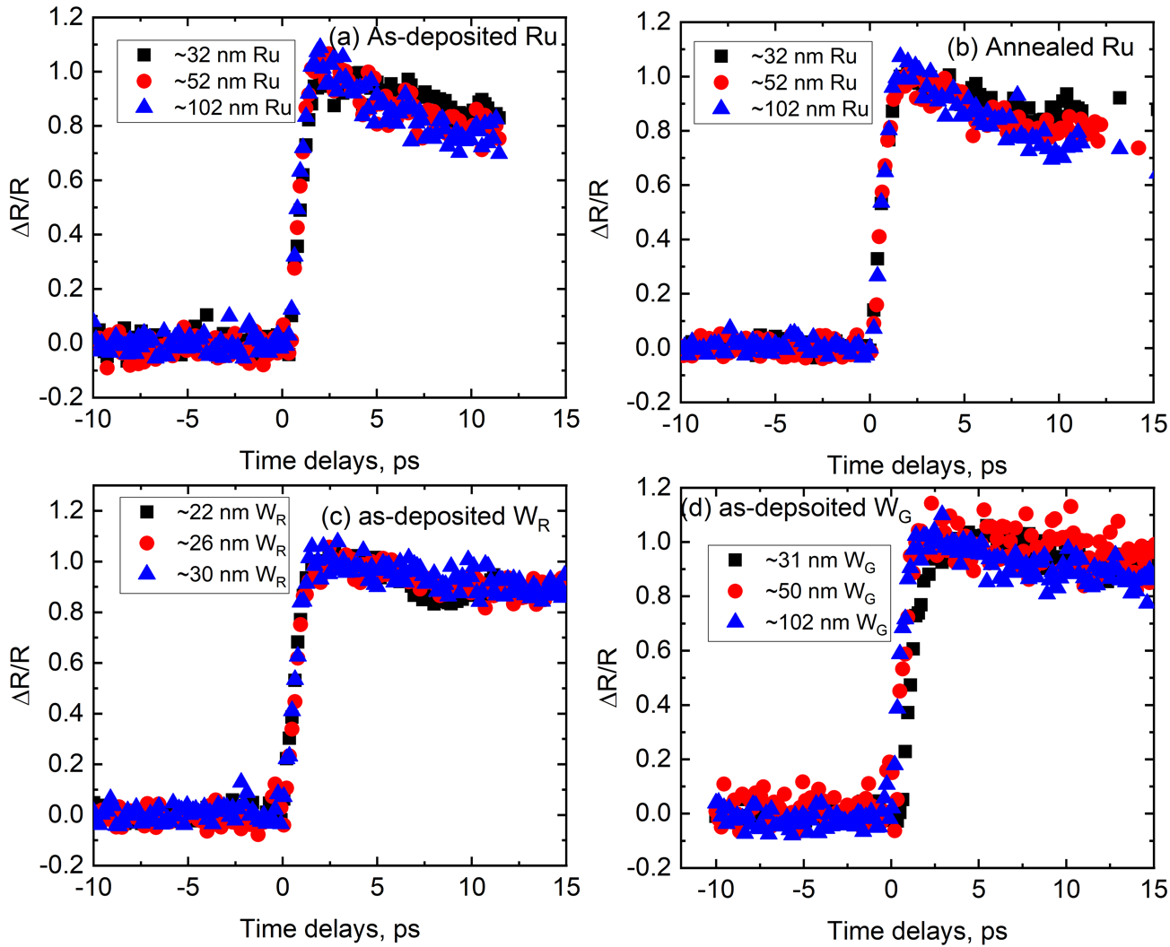

Figure S33: Normalized thermoreflectance as a function of pump-probe delay time for as-deposited Ru and W films.
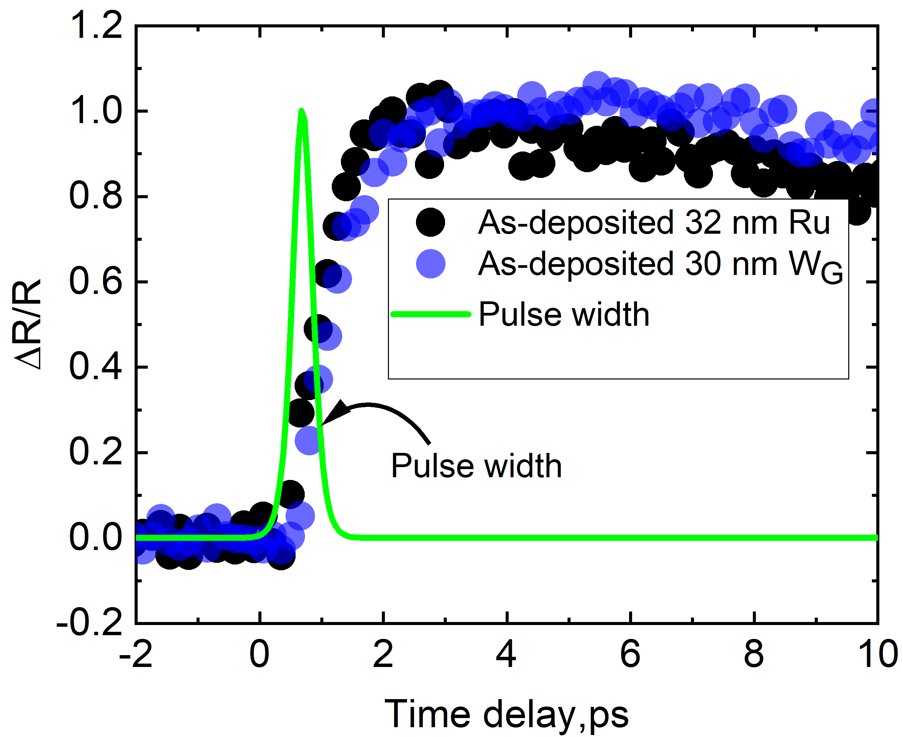
Figure S34: The comparison of the normalized thermoreflectance as a function of pump-probe delay time for as-deposited Ru and W films.

We apply the two-temperature model (TTM) to determine the electron-phonon coupling factors in Ru and W films using the following equations:
$$C_{e}\left(T_{e}\right)\frac{∂T_{e}}{∂t} = ∇ ∙\left(κ_{e} ∇T_{e}\right)-G\left(T_{e}-T_{p}\right)+S\left(x,t\right) (S14)$$
$C_{p}\left(T_{p}\right)\frac{∂T_{p}}{∂t} = ∇ ∙\left(κ_{p} ∇T_{p}\right)+G\left(T_{e}-T_{p}\right)$ (S15)
Here, $C_{e}$ and $C_{p}$ represents the heat capacities of the electrons and phonons, respectively, while $T_{e}$ and $T_{p}$ denote their temperatures. The source term, S (x, t) is given by^{[59]} :

$$S\left(x,t\right)=\left(1-R_{opt}\right)\frac{1.76J}{{2t}_{p}}∙{sech}^{2}\left[\left(\frac{1.76\left(t_{o}-t\right)}{t_{p}}\right)\right]\frac{dI}{dx} (S16)$$

In this equation, $R_{opt}$ denotes the surface reflectivity, J is the incident fluence, $t_{p}$ is pulse width of the pump pulse, $\frac{dI}{dx}$ is the light intensity profile determined using a transfer matrix method based on optical constants at the 520 nm pump wavelength. This profile is computed following the Beer–Lambert law and assumes a sech² pulse shape in the time domain.

We employ the Crank-Nicolson method^{[60]} to solve the coupled differential equations in the two-temperature model (TTM) and determine the electron-phonon coupling factor. To ensure numerical stability, we discretize time (dt = 50 × 10⁻¹⁵ s) and space (dx = 0.5 × 10⁻⁹ m) based on the material parameters listed in Table S10. Using the transfer matrix method, ^{[61]} we calculate the light intensity distribution in the Ru/100 nm SiO₂/Si and W/3nm Ta/100 nm SiO₂/Si systems and model energy deposition into the electronic system through the source term S. We assume the 3 nm Ta layer as the interface between W and 100 nm SiO₂. For films ≤30 nm, we neglect the thermal conductivity terms in the TTM equations (Eq. S14 and Eq. S15) because the film heats homogeneously on timescales relevant to electron-phonon coupling. The optical penetration depth of the pump beam (7.7 ± 0.04 nm for Ru and 13.1 ± 0.3 nm for W) determined via the ellipsometer (see details in the following section) is smaller than 30 nm, ensuring that energy deposition primarily occurs near the surface. However, rapid electron scattering, with mean free paths of 6 nm for Ru^{[6,62]} and 15.5 nm for W^{[6,62]}, facilitates energy redistribution across the film thickness before significant phonon interactions occur. Additionally, ballistic electron transport further enhances energy spreading, allowing the electrons to rapidly thermalize within the film thickness before phonon-driven heat dissipation dominates. For ~50 nm and ~100 nm films, we incorporate the thermal conductivity terms in TTM to determine G, as heat conduction effects become more significant over longer distances. We also assume that the electronic heat capacity varies linearly with electron temperature and that the electron-phonon coupling factor remains constant with temperature.
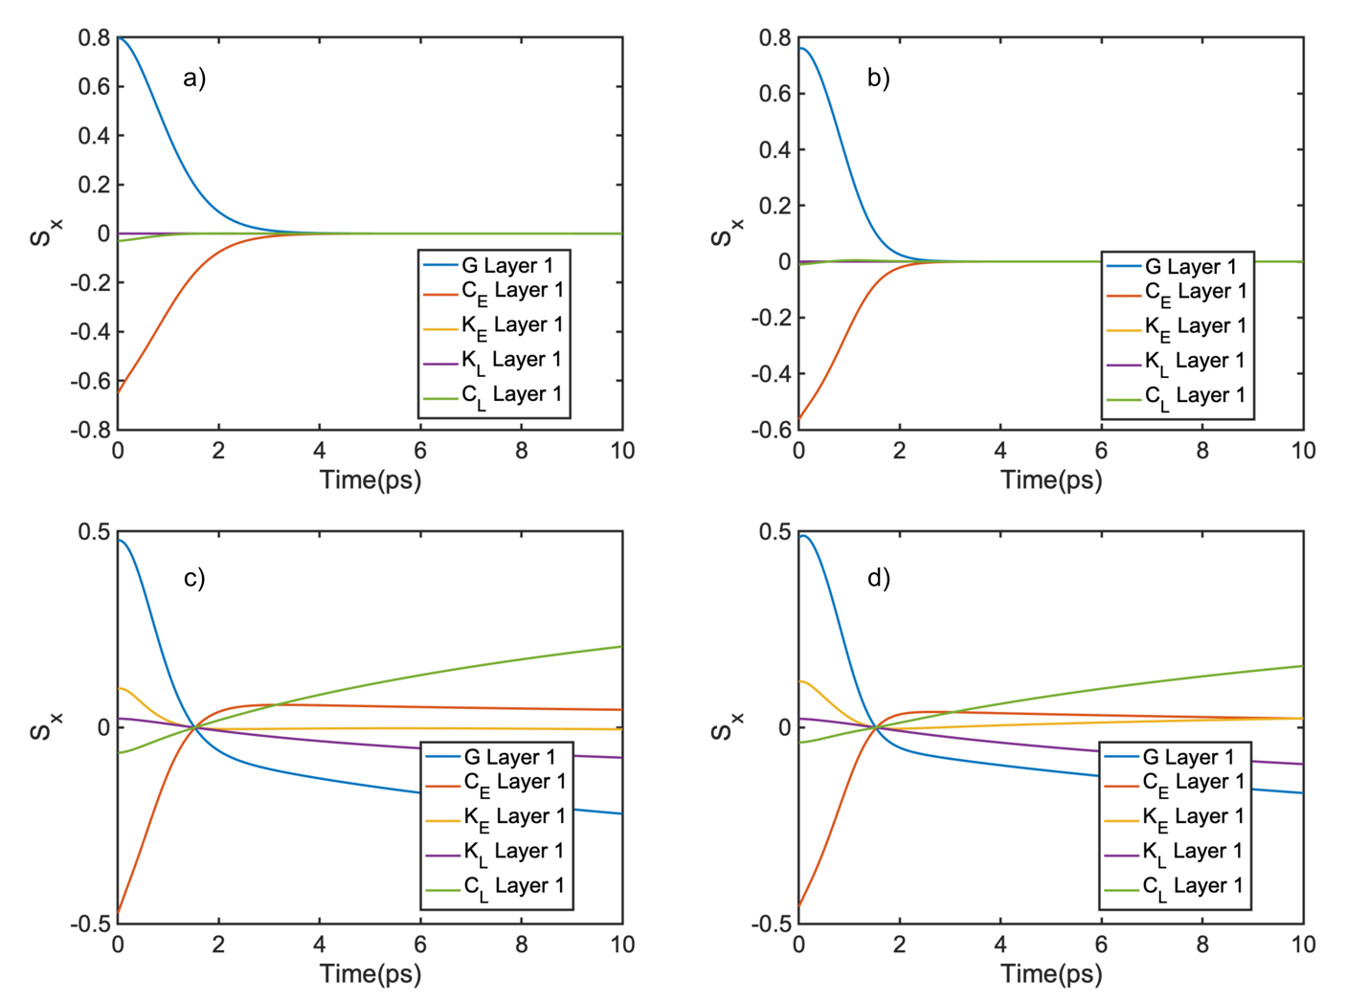
Figure S35: Depiction of the sensitivity for all the parameters contained within the two-temperature model for the case of a) ~32 nm Ru, b) ~30 nm W, c) ~102 nm Ru, and d) ~102 nm W.

We perform the sensitivities for all the parameters involved within the TTM model due to its complexities. Figure S35 shows these sensitivities calculated using the formula $\frac{dlnR}{dlnα}$ for the sensitivity of our model to a parameter $α$.^{[63]} The temperature decay in 30 nm films (Fig. S35a-b) is controlled by the electrons coupling to phonons on these timescales as there is no thermal gradients through the thin film (electron mean free path on order of 15.5 nm for W and 6 nm for Ru). We note significant sensitivity to both the electron-phonon coupling factor, G, and the electronic heat capacity, C_{E}, during the first few picoseconds as the time that the electron and phonons thermalize with one another in the spatially uniform limit $\left(\frac{d^{2}T}{dz^{2}}=0\right)$is described by the time constant ${τ_{e-p}=(\frac{G}{C_{e}}+\frac{G}{C_{p}})}^{-1}$.^{[64]} We also report significant sensitivity to G and C_{E} for the ~102 nm films, (Fig. S35 c-d) within the first few picoseconds as the electrons and phonons initially couple with one another. However, we also see continued sensitivity to a multitude of parameters beyond the first few picoseconds as thermal diffusion occurs within the electron and phonon subsystems. Due to the differing thermal conductivities between the electrons and phonons we see continued sensitivity to the electron-phonon coupling factor beyond the first few picoseconds as heat diffuses through each channel and the temperature is equilibrated between the two respectively. This sensitivity has been reported in previous works.^{[25,65]} We emphasize, however, that the majority of our sensitivity throughout the fitting window arises from the electron-phonon coupling factor, and that the other parameters are either measured values, in the case of K_{e} and K_{p}, or obtained from literature, in the case of C_{e} and C_{p} respectively.
We use TTM simulations to calculate the lattice and electron temperatures based on the thermophysical properties listed in Table S10. Since our probing energy is well above interband transition thresholds, we convert the TTM simulation results into an optical response by normalizing the lattice temperature and comparing it to the normalized reflectivity from thermoreflectance measurements. We normalize the data using the average value of ΔR/R between 1–3 ps and fit for G within the 0–10 ps range. This time window allows sufficient electron-phonon coupling and ensures the lattice temperature reaches its peak (Figure S35)

Table S10: We list the parameters used for the TTM calculations. The temperature-dependent coefficient of the electronic heat capacity,$β, (Ce = { βT}_{e}),$is obtained from our first-principles simulations ( see Section S2) which show good agreement well with the literature, (C_{e} = ${ βT}_{e}$), $C_{p}$ denotes the phonon heat capacity, while $κ_{e}$and $κ_{p}$ represent the thermal conductivity of the electron and phonon subsystems, respectively. These thermal conductivities are determined from 4-pp measurements and SSTR. The electronic thermal boundary resistance is negligible, while the phononic thermal boundary resistances used in the TTM simulations are Ru/SiO₂= 5 m² K GW⁻¹ ^{[30]} ,W/SiO₂=5 m² K GW⁻¹ ^{[30]}, SiO₂/Si=4.35 m² K GW⁻¹ ^{[29,30]} .

Parameters | Ru | W | SiO₂ | Si
Electron heat capacity coefficient, $β$ (J m⁻³ K⁻²) | 371 | 137.3 | 0 | 0
Electron thermal conductivity,  $κ$_{e} (W m⁻¹ k⁻¹) | 29-52 | 35-40 | 0 | 0
Phonon thermal conductivity, $κ$_{p} (W m⁻¹ k⁻¹) | 25-32 | 30-64 | 1.45 ^{[27,28,30,31]} | 140 ^{[28,30]}
Phonon heat capacity,  $C_{p}$ (MJ m⁻³K⁻¹) | 2.85 | 2.52 | 1.62^{[28–30]} | 1.65^{[27–31]}

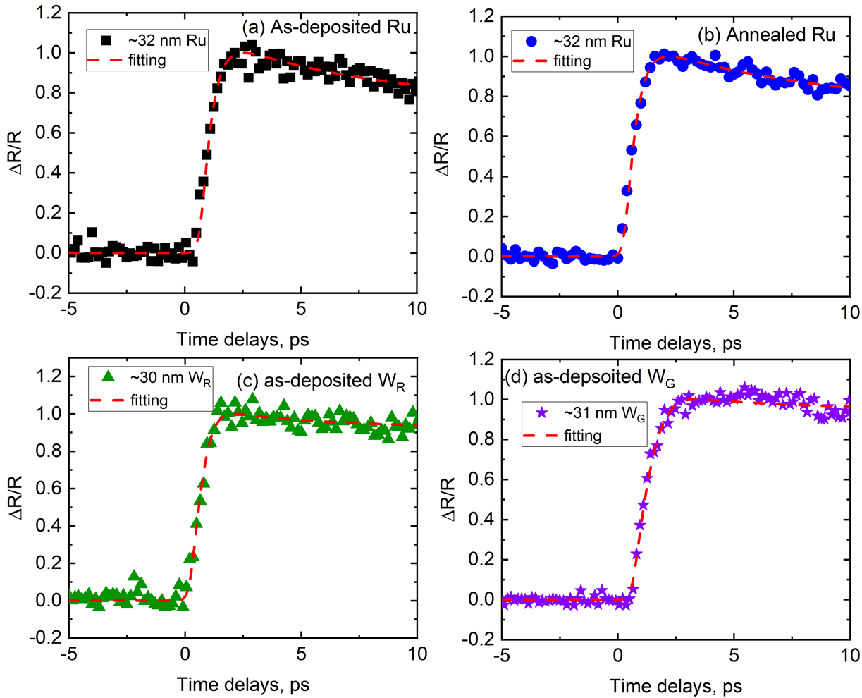

Figure S36: Experimental data for as-deposited Ru and W films. The orange dashed line is the best fit to experimental data.

During the electron-phonon coupling factor (G) analysis, we assess whether the fitting parameters in the TTM exhibit sufficient sensitivity to determine G accurately. While the characteristic response within the 0–10 ps time regime primarily arises from electron-phonon coupling, variations in G exist for Ru and W films due to experimental noise, leading to multiple acceptable fits to the data. To quantify this uncertainty, we employ contour plots that evaluate the similarity between different fits of the experimental and model data. We generate the optical response curve using TTM with the best-fit set of material properties (Table S10) and perturb G by re-fitting. In this process, we fit only for the time at which the pulse interacts with the sample: an arbitrary parameter in our TTM. The degree of similarity between the perturbed curve and the experimental data, relative to the best-fit curve, establishes the uncertainty bounds. To quantify this, we apply the metric defined by Feser et al.:^{[35]}

Z(G) $≡{(\frac{\sum{{[reflectivity\left(t;G_{exact}\right)-reflectivity(t; G_{perturbed})] }^{2}} }{\sum{reflectivity{(t; G_{exact})}^{2}}})}^{\frac{1}{2}}$ (S17)

The contour of Z(G) characterizes the least-squares similarity between different fits, where the curvature around the best-fit value (global minimum) defines the uncertainty. Based on the quality of our experimental data, we adopt a 0.5% residual threshold, within which the TTM produces fits of comparable quality to the experimental data, as illustrated in Figure S37. We incorporate this 0.5% residual uncertainty into the overall uncertainty in our G calculations.

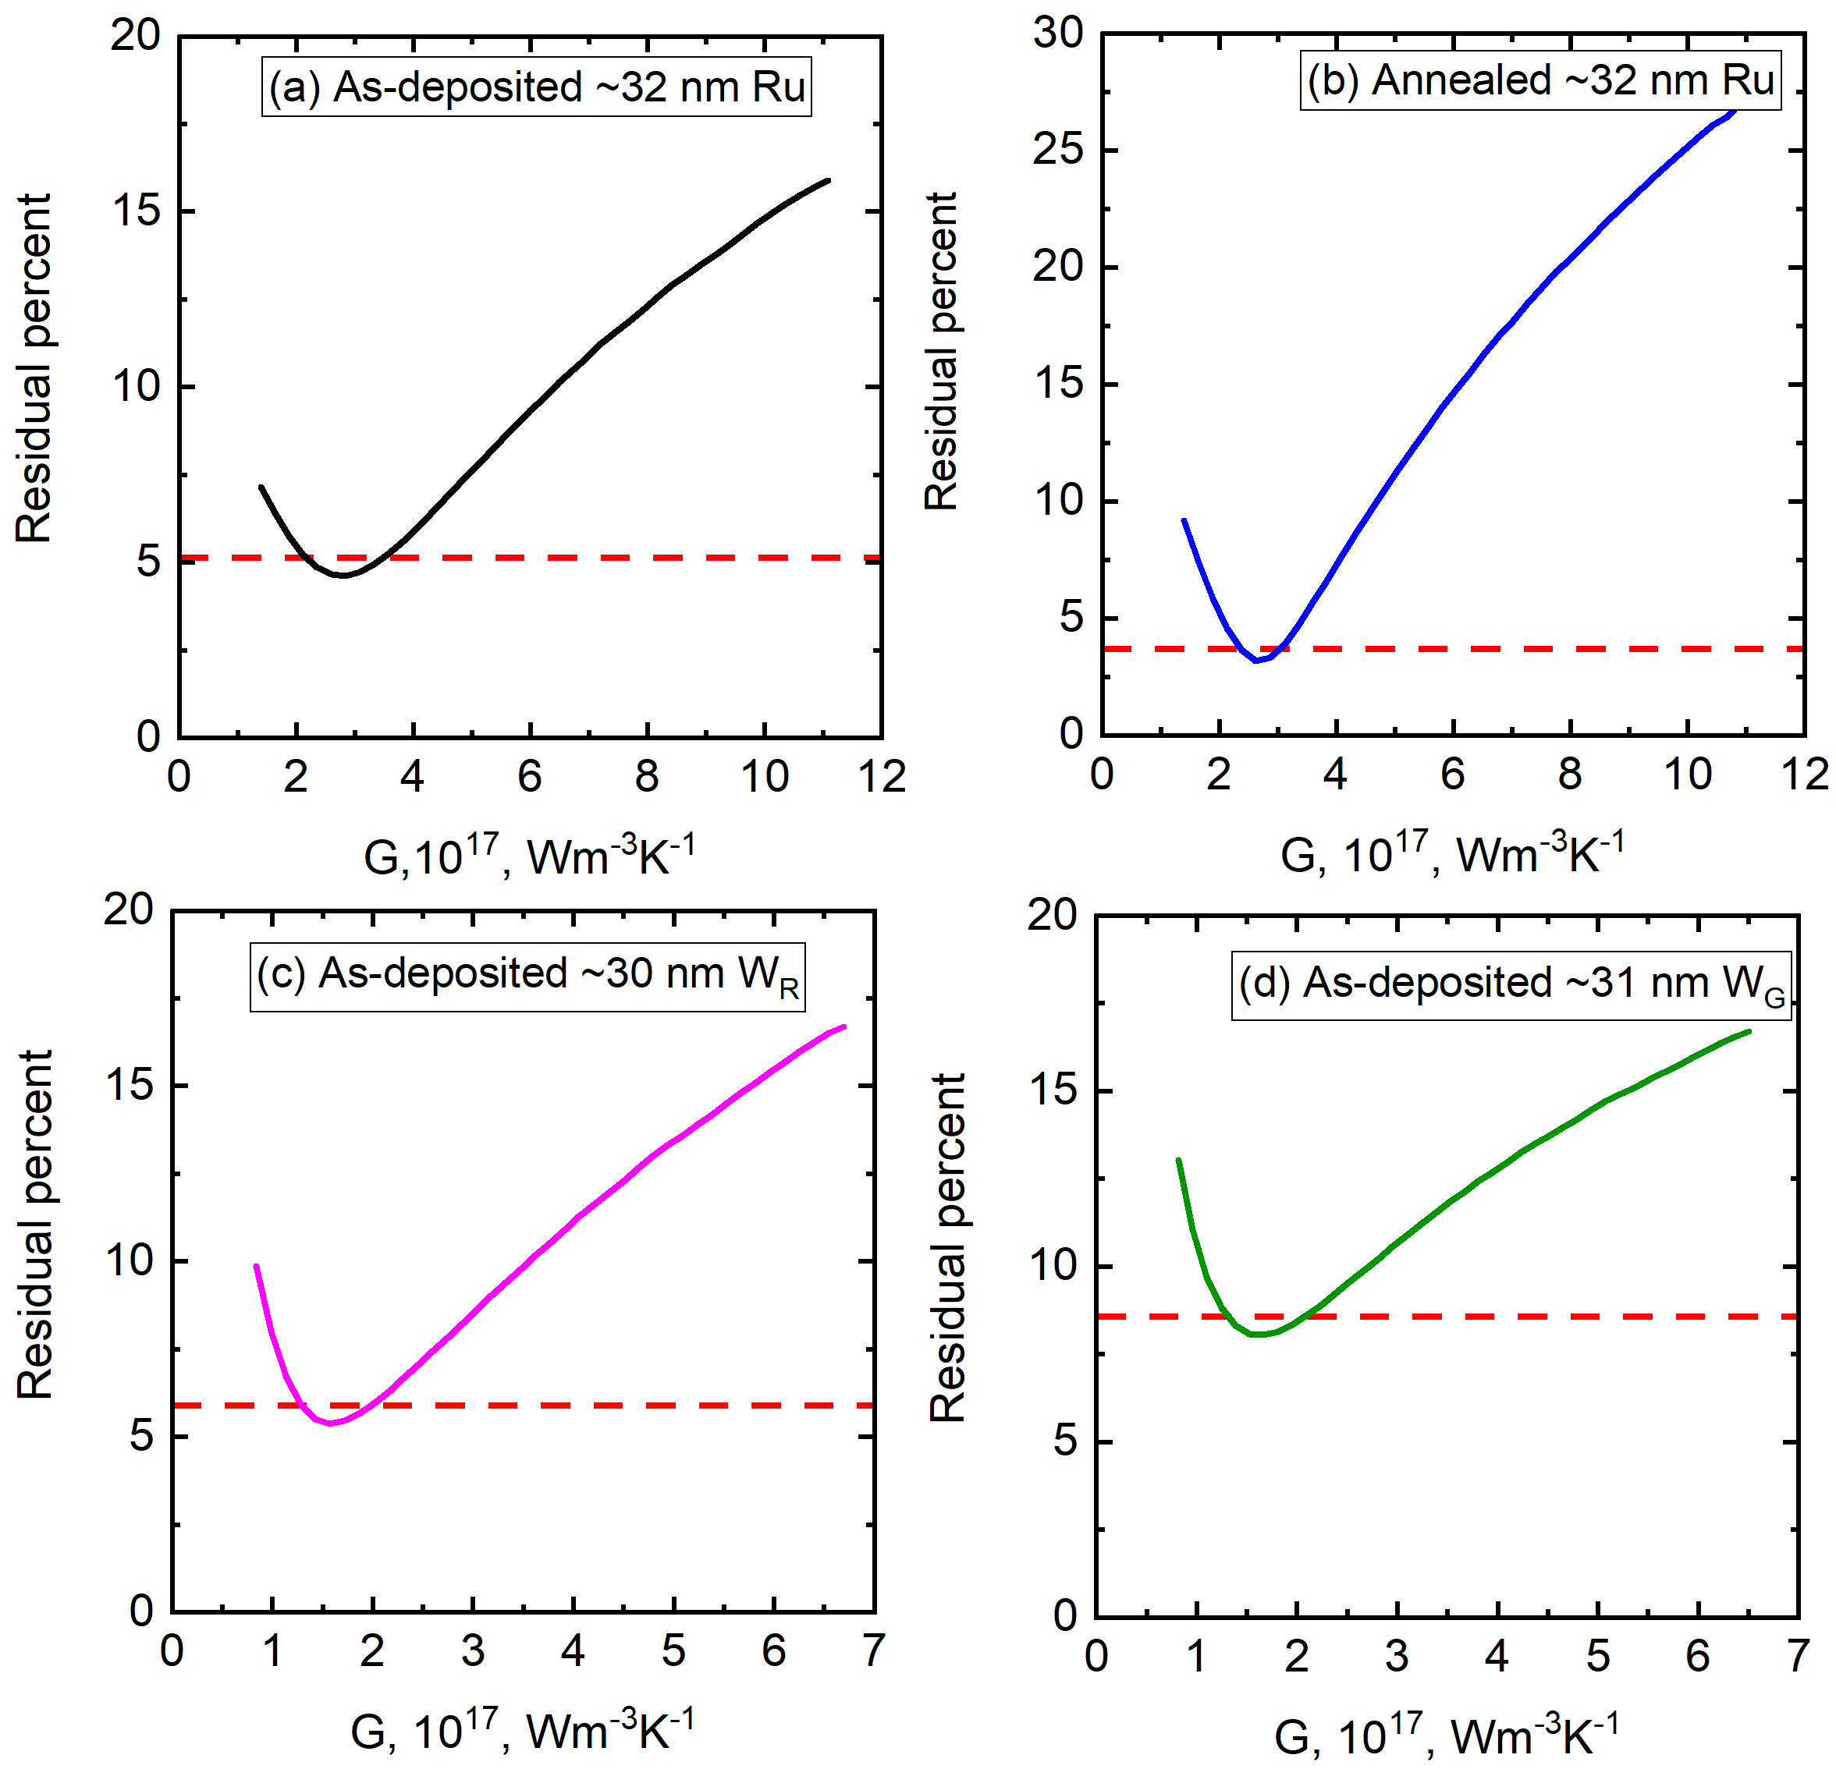
Figure S37: 2D contour analysis of G for as-deposited Cu films assuming the quality of fit based on the TTM model parameters and experimental data is within 0.5% threshold value.

S10. Effective electron relaxation time, interband transitions and optical penetration depth determination with ellipsometer

We determine the optical penetration depth of Ru and W using a visible ellipsometer (M2000, J.A. Woollam Company) at a wavelength of 520 nm (2.3842 eV). Figure S38 presents the optical response of Ru films of varying thicknesses, characterized by their dielectric functions ($ε_{1}$ and $ε_{2}$).

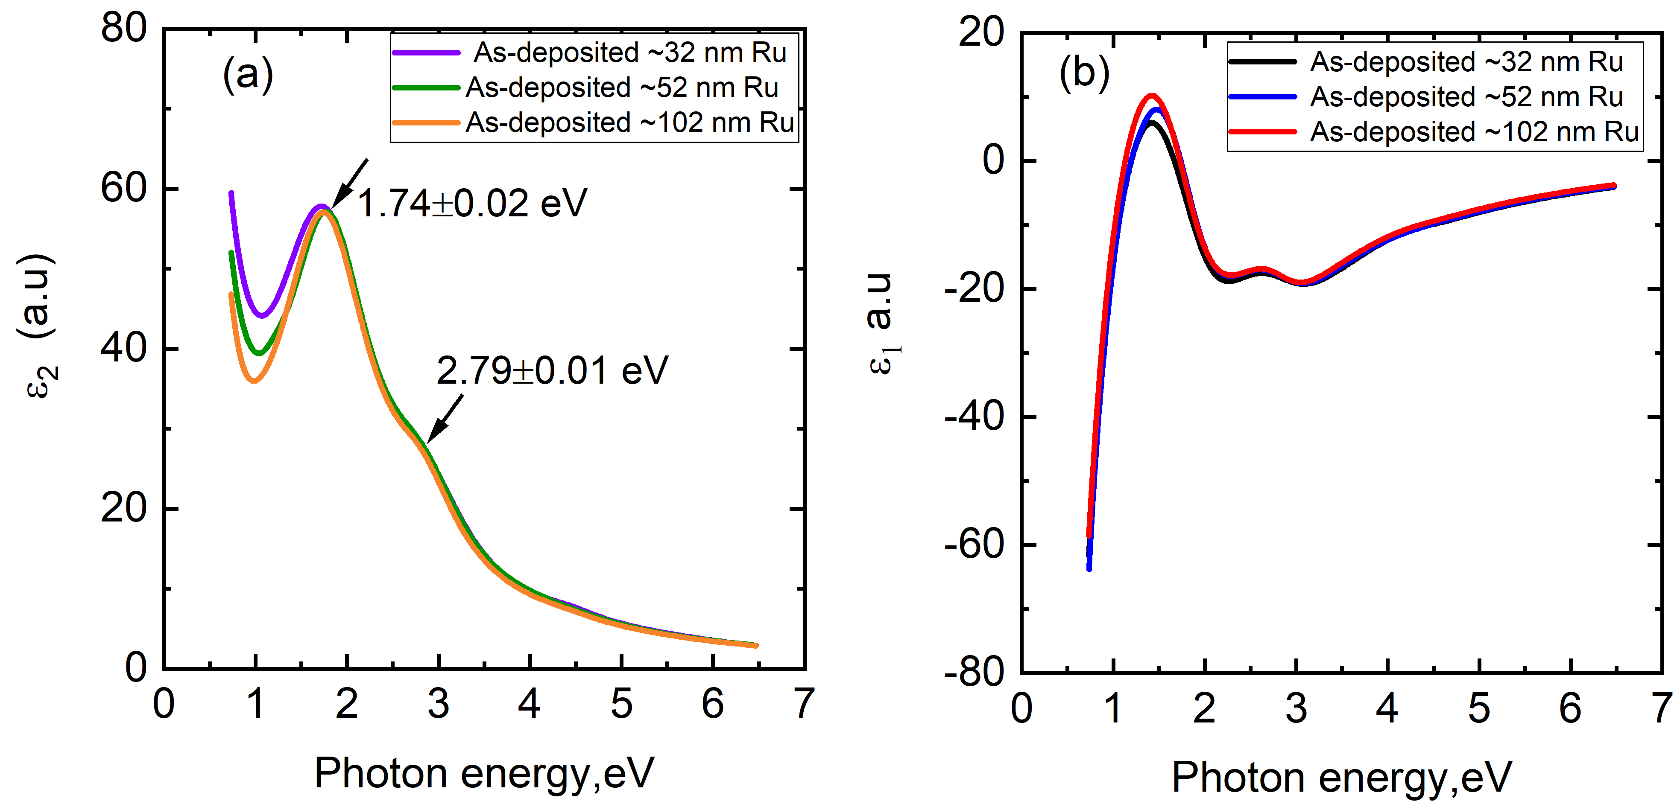
Figure S38: The optical response of as-deposited Ru films as a function of photon energy (0.73eV-6.53eV). The interband transitions in Ru happen at 1.74±0.02 eV and 2.79± 0.01 eV. No interband transitions are observed below ~0.73 eV photon energy.

Figure S38 shows the optical response of different thick Ru films in terms of dielectric functions ($ε_{1}$ and $ε_{2}$ ). We identify the interband transition for Ru at 1.74±0.02 eV and 2.79± 0.01 eV. Similarly for the W, the interband transitions occur at 0.94 ± 0.05 and 1.80 ± 0.015 eV. The optical penetration depths for Ru and W are calculated as 7.7 ± 0.04 nm and 13.1 ± 0.3 nm, respectively, using following relation, penetration depth: $δ=\frac{λ}{4π\sqrt{Im(ϵ)}}$ (S18)

where λ is the incident light wavelength, and Im(ε) represents the imaginary part of the dielectric function, which incorporates the material’s absorption coefficient.
We use infrared variable-angle spectroscopic ellipsometry (IR-VASE) to determine the effective electron relaxation time in materials by analyzing their optical properties in the infrared spectrum. By fitting oscillator models to complex, frequency-dependent ellipsometric data, we extract the effective electron relaxation time for Ru and W films. Ellipsometry measures the change in polarization state of the light upon reflection from the sample, capturing the amplitude ratio (Ψ) and phase difference (Δ). These parameters relate to the complex reflection coefficients ($r_{p}$ and $r_{s}$) of the sample for p- and s-polarized light as:
$ρ=\frac{r_{p}}{r_{s}}=\tan{Ψ}e^{iΔ}$ (S19)

We collect ellipsometric data for Ru and W films over the spectral range of 500-3500 cm⁻¹ (0.06-0.433 eV) using an infrared ellipsometer (IR-VASE Mark II, J.A. Woollam Company). We perform the measurements at ncident angles of 60° and 70°, with a spectral resolution of 16 cm⁻¹ (~2 meV). Figure S39 presents the measured ellipsometric data for as-deposited Ru films with thicknesses ranging from 5 nm to 102 nm.

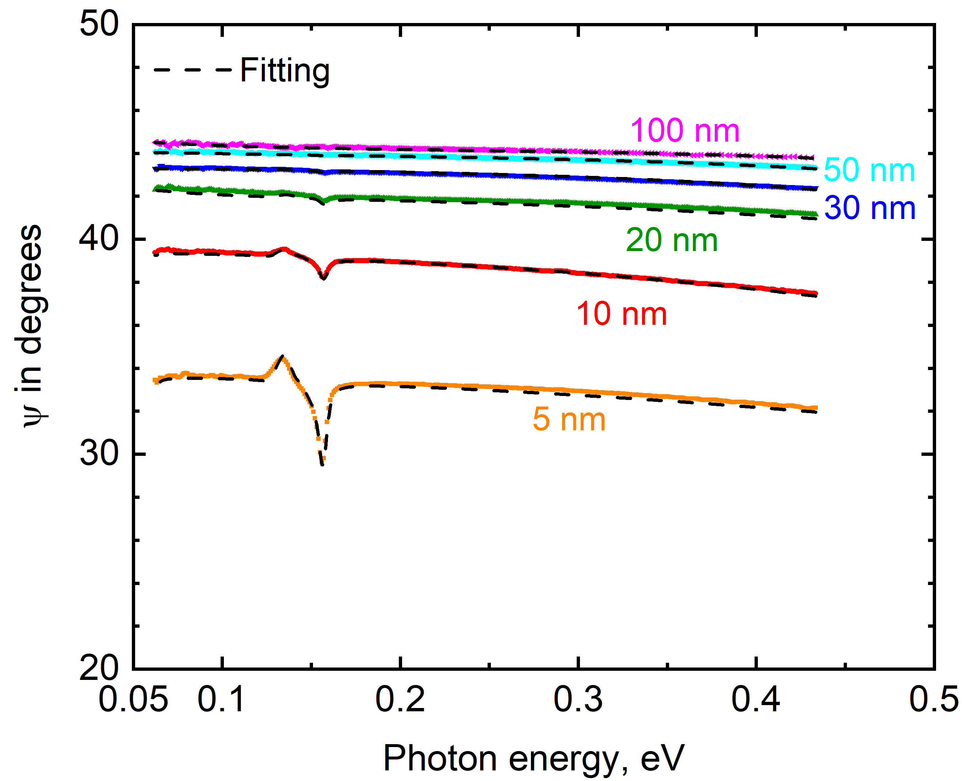
Figure S39: (a) Measured ellipsometry data at the incidence angle of 60° for as-deposited Ru films with various thicknesses and their comparison of measured ellipsometry data for with modeling results (black lines) fitted on the measured data.

We develop an isotropic multi-layer optical model based on this measured ellipsometric data to extract the complex, frequency-dependent dielectric function of the Ru and W film. For the dielectric functions of the silicon substrate and thermal SiO₂ layer,^{[66]} we use literature-reported values. In the infrared regime, the optical properties of the Ru and W films are primarily dominated by the free-electron contribution. Therefore, we apply the Drude-Lorentz model to determine the optical behavior as follows: ^{[67]}

$ε_{Drude-Lorentz}\left(ω\right)=ε_{1}\left(ω\right)+iε_{2}\left(ω\right)=ε_{∞}-\frac{ω_{p}^{2}}{ω^{2}+iΓω}+\sum_{i}{\frac{f_{i}}{ω_{i}^{2}-ω^{2}-iΓ_{i}ω}}$ (S20)

In this expression, $ε_{∞}$ is the high-frequency dielectric constant, the second term on the right side describes free-electron contribution^{[67]} where $ω_{p}$ is the plasma frequency, and Γ is the scattering rate. The third term on the right side describes the effect of electronic transition modes to the near-infrared excited response. These transitions are modeled using the Lorentz function^{[67]}, where f_{i} is the oscillator strength, ω_{i} the resonance frequency, and Γi the broadening parameter of the i-th oscillator.
We refine the parameters of the Drude-Lorentz model by minimizing the mean square error to achieve optimal agreement between the modeled and measured ellipsometric data. Note we use one Drude mode and one Lorentz oscillator to fit the ellipsometry data of Ru and W films. Figure S39 presents a comparison between the fitted modeling results and the measured data for as-deposited Ru films at the incidence angle of 60°. The mean squared errors for the fits across different film thicknesses remain 0.3, indicating a high level of accuracy. Finally, we determine the effective relaxation time of electron ($τ$) from the fitted scattering rate in the Drude model, where $τ=Γ^{-1}$.

Reference

[1] M. R. Islam, P. Karna, J. A. Tomko, E. R. Hoglund, D. M. Hirt, M. S. B. Hoque, S. Zare, K. Aryana, T. W. Pfeifer, C. Jezewski, A. Giri, C. D. Landon, S. W. King, P. E. Hopkins, Nat Commun 2024, 15, 9167.
[2] E. A. Riesel, T. Mackey, H. Nilforoshan, M. Xu, C. K. Badding, A. B. Altman, J. Leskovec, D. E. Freedman, J. Am. Chem. Soc. 2024, 146, 30340.
[3] A. Malizia, R. Rossi, I. Cacciotti, Review of Scientific Instruments 2018, 89, 083306.
[4] P. Karna, A. Giri, Phys. Rev. B 2023, 107, 094301.
[5] P. Karna, A. Giri, J. Phys.: Condens. Matter 2024, 36, 345701.
[6] P. Karna, M. R. Islam, E. R. Hoglund, P. E. Hopkins, A. Giri, Materials Today Chemistry 2024, 37, 101991.
[7] D. Pines, Theory Of Quantum Liquids: Normal Fermi Liquids, CRC Press, 2018.
[8] W. S. Fann, R. Storz, H. W. K. Tom, J. Bokor, Phys. Rev. B 1992, 46, 13592.
[9] P. Karna, A. Giri, J. Phys.: Condens. Matter 2024, 36, 345701.
[10] C. Kittel, Introduction to solid state physics, 8th ed., Wiley, Hoboken, NJ, 2005.
[11] P. E. Hopkins, J. R. Serrano, L. M. Phinney, H. Li, A. Misra, Journal of Applied Physics 2011, 109, 13524.
[12] X. He, S. Nomoto, T. Komatsu, T. Katase, T. Tadano, S. Kitani, H. Yoshida, T. Yamamoto, H. Mizoguchi, K. Ide, H. Hiramatsu, H. Kawaji, H. Hosono, T. Kamiya, Advanced Functional Materials 2023, 33, 2213144.
[13] P. G. Klemens, Proc. Phys. Soc. A 1955, 68, 1113.
[14] I.-T. Lu, M. Bernardi, Sci Rep 2017, 7, 3403.
[15] M. Nakagawa, W. Mansel, K. Böning, P. Rosner, G. Vogl, Phys. Rev. B 1979, 19, 742.
[16] P. Giannozzi, S. Baroni, N. Bonini, M. Calandra, R. Car, C. Cavazzoni, D. Ceresoli, G. L. Chiarotti, M. Cococcioni, I. Dabo, A. Dal Corso, S. de Gironcoli, S. Fabris, G. Fratesi, R. Gebauer, U. Gerstmann, C. Gougoussis, A. Kokalj, M. Lazzeri, L. Martin-Samos, N. Marzari, F. Mauri, R. Mazzarello, S. Paolini, A. Pasquarello, L. Paulatto, C. Sbraccia, S. Scandolo, G. Sclauzero, A. P. Seitsonen, A. Smogunov, P. Umari, R. M. Wentzcovitch, J. Phys.: Condens. Matter 2009, 21, 395502.
[17] R. Martoňák, A. Laio, M. Parrinello, Phys. Rev. Lett. 2003, 90, 075503.
[18] T. Developers, Zenodo 2021.
[19] A. P. Thompson, H. M. Aktulga, R. Berger, D. S. Bolintineanu, W. M. Brown, P. S. Crozier, P. J. in ’t Veld, A. Kohlmeyer, S. G. Moore, T. D. Nguyen, R. Shan, M. J. Stevens, J. Tranchida, C. Trott, S. J. Plimpton, Computer Physics Communications 2022, 271, 108171.
[20] K. He, X. Zhang, S. Ren, J. Sun, 2016, pp. 770–778.
[21] J. A. Thomas, J. E. Turney, R. M. Iutzi, C. H. Amon, A. J. H. McGaughey, Phys. Rev. B 2010, 81, 081411.
[22] T. Feng, B. Qiu, X. Ruan, Journal of Applied Physics 2015, 117, 195102.
[23] W. G. Hoover, Phys. Rev. A 1985, 31, 1695.
[24] J. Callaway, Phys. Rev. 1959, 113, 1046.
[25] D. Hirt, Md. R. Islam, Md. S. B. Hoque, W. Hutchins, S. Makarem, M. K. Lenox, W. T. Riffe, J. F. Ihlefeld, E. A. Scott, G. Esteves, P. E. Hopkins, Applied Physics Letters 2024, 124, 202202.
[26] A. J. Schmidt, R. Cheaito, M. Chiesa, Review of Scientific Instruments 2009, 80, 94901.
[27] C. Cancellieri, E. A. Scott, J. Braun, S. W. King, R. Oviedo, C. Jezewski, J. Richards, F. L. Mattina, L. P. H. Jeurgens, P. E. Hopkins, Journal of Applied Physics 2020, 128.
[28] J. L. Braun, D. H. Olson, J. T. Gaskins, P. E. Hopkins, Review of Scientific Instruments 2019, 90, 24905.
[29] J. L. Braun, C. H. Baker, A. Giri, M. Elahi, K. Artyushkova, T. E. Beechem, P. M. Norris, Z. C. Leseman, J. T. Gaskins, P. E. Hopkins, Physical Review B 2016, 93, 140201.
[30] M. S. B. Hoque, Y. R. Koh, K. Aryana, E. R. Hoglund, J. L. Braun, D. H. Olson, J. T. Gaskins, H. Ahmad, M. M. M. Elahi, J. K. Hite, Z. C. Leseman, W. A. Doolittle, P. E. Hopkins, Review of Scientific Instruments 2021, 92, 64906.
[31] E. A. Scott, S. W. Smith, M. D. Henry, C. M. Rost, A. Giri, J. T. Gaskins, S. S. Fields, S. T. Jaszewski, J. F. Ihlefeld, P. E. Hopkins, Applied Physics Letters 2018, 113, 192901.
[32] D. G. Cahill, K. Goodson, A. Majumdar, Journal of Heat Transfer 2002, 124, 223.
[33] P. E. Hopkins, J. R. Serrano, L. M. Phinney, S. P. Kearney, T. W. Grasser, C. T. Harris, Journal of Heat Transfer 2010, 132, 1.
[34] D. G. Cahill, Review of Scientific Instruments 2004, 75, 5119.
[35] J. P. Feser, D. G. Cahill, Review of Scientific Instruments 2012, 83, 104901.
[36] R. B. Wilson, D. G. Cahill, 2012, 255901.
[37] R. Cheaito, K. Hattar, J. T. Gaskins, A. K. Yadav, J. C. Duda, T. E. Beechem, J. F. Ihlefeld, E. S. Piekos, J. K. Baldwin, A. Misra, P. E. Hopkins, Applied Physics Letters 2015, 106, 93114.
[38] B. C. Gundrum, D. G. Cahill, R. S. Averback, .
[39] D. H. Olson, M. G. Sales, J. A. Tomko, T. F. Lu, O. V. Prezhdo, S. J. McDonnell, P. E. Hopkins, Applied Physics Letters 2021, 118, 163503.
[40] R. B. Wilson, D. G. Cahill, Appl. Phys. Lett 2015, 107, 203112.
[41] H. Jang, J. Kimling, D. G. Cahill, Phys. Rev. B 2020, 101, 064304.
[42] V. Yu. Bodryakov, High Temp 2015, 53, 643.
[43] J. Yang, C. Maragliano, A. J. Schmidt, Review of Scientific Instruments 2013, 84, 104904.
[44] M. S. B. Hoque, Y. R. Koh, J. L. Braun, A. Mamun, Z. Liu, K. Huynh, M. E. Liao, K. Hussain, Z. Cheng, E. R. Hoglund, D. H. Olson, J. A. Tomko, K. Aryana, R. Galib, J. T. Gaskins, M. M. M. Elahi, Z. C. Leseman, J. M. Howe, T. Luo, S. Graham, M. S. Goorsky, A. Khan, P. E. Hopkins, ACS Nano 2021, 15, 9588.
[45] T. W. Pfeifer, J. A. Tomko, E. Hoglund, E. A. Scott, K. Hattar, K. Huynh, M. Liao, M. Goorsky, P. E. Hopkins, Journal of Applied Physics 2022, 132.
[46] C.-K. Sun, F. Vallée, L. Acioli, E. P. Ippen, J. G. Fujimoto, Phys. Rev. B 1993, 48, 12365.
[47] J. Hohlfeld, S.-S. Wellershoff, J. Güdde, U. Conrad, V. Jähnke, E. Matthias, Chemical Physics 2000, 251, 237.
[48] T. Zeng, G. Chen, Journal of Heat Transfer 2001, 123, 340.
[49] M. Milich, H. B. Schonfeld, K. Boboridis, D. Robba, L. Vlahovic, R. J. M. Konings, J. L. Braun, J. T. Gaskins, N. Bhatt, A. Giri, P. E. Hopkins, Phys. Rev. Lett. 2024, 132, 146303.
[50] W. Lee, K. D. Kihm, H. G. Kim, S. Shin, C. Lee, J. S. Park, S. Cheon, O. M. Kwon, G. Lim, W. Lee, Nano Letters 2017, 17, 2361.
[51] J. Anaya, S. Rossi, M. Alomari, E. Kohn, L. Tóth, B. Pécz, K. D. Hobart, T. J. Anderson, T. I. Feygelson, B. B. Pate, M. Kuball, Acta Materialia 2016, 103, 141.
[52] N. Bhatt, P. Karna, S. Thakur, A. Giri, Phys. Rev. Mater. 2023, 7, 115001.
[53] P. Karna, M. S. B. Hoque, S. Thakur, P. E. Hopkins, A. Giri, Nano Lett. 2023, 23, 491.
[54] J. Crank, The Mathematics of Diffusion, Clarendon Press, 1979.
[55] J. A. Tomko, S. Kumar, R. Sundararaman, P. E. Hopkins, Journal of Applied Physics 2021, 129, 193104.
[56] T. Heilpern, M. Manjare, A. O. Govorov, G. P. Wiederrecht, S. K. Gray, H. Harutyunyan, Nature Communications 2018 9:1 2018, 9, 1.
[57] R. W. Schoenlein, W. Z. Lin, J. G. Fujimoto, G. L. Eesley, Physical Review Letters 1987, 58, 1680.
[58] Z. Lin, L. V. Zhigilei, V. Celli, Physical Review B - Condensed Matter and Materials Physics 2008, 77, 075133.
[59] J. Sotrop, A. Kersch, M. Domke, G. Heise, H. P. Huber, Applied Physics A: Materials Science and Processing 2013, 113, 397.
[60] M. N. Özışık, M. J. Colaco, H. R. B. Orlande, R. M. Cotta, Finite Difference Methods in Heat Transfer, Taylor & Francis, CRC Press, 2017.
[61] A. B. Bhatia, P. C. Clemmow, D. Gabor, A. R. Stokes, A. M. Taylor, P. A. Wayman, W. L. Wilcock, .
[62] D. Gall, Journal of Applied Physics 2016, 119.
[63] B. C. Gundrum, D. G. Cahill, R. S. Averback, Physical Review B 2005, 72, 245426.
[64] R. B. Wilson, J. P. Feser, G. T. Hohensee, D. G. Cahill, Phys. Rev. B 2013, 88, 144305.
[65] G.-M. Choi, R. B. Wilson, D. G. Cahill, Phys. Rev. B 2014, 89, 064307.
[66] C. M. Herzinger, B. Johs, W. A. McGahan, J. A. Woollam, W. Paulson, Journal of Applied Physics 1998, 83, 3323.
[67] G. R. Fowles, Introduction to modern optics, 1989.

