Supplementary material

HEAS publication trend

Web of Science was used as a search engine to explore the publication trend of HEAs. The HEA subgroup of irradiated materials plus nuclear application was additionally assessed. The 3 search conditions examined included abstract and title fields, and any of the following terms in singular and plural form:
- “High entropy alloy”, “multi principal element”, “compositionally complex alloy”, “complex concentrated alloy”
- A condition and “refractory”
- A condition and “nuclear”, “irradiation”, “fission”, “fusion reactor”
Only documents in English were considered, early access was excluded and only the following document types were filtered: articles, review article, proceeding paper and Letter.

Elements used in the ASAP code

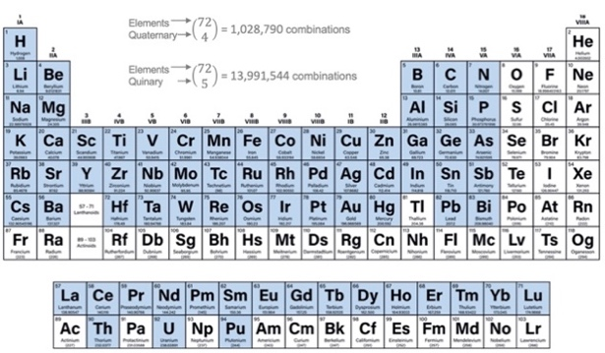
Fig. S1. Elements selected for HEA screening by the ASAP code.

