SUPPORTING INFORMATION
Temperature invariant, nearly zero temperature coefficient of
resistivity in Si-doped titanium nitrides
S. Novia Berriel,¹ Corbin Feit,¹ Md. Rafiqul Islam,² Jia Shi,³ Somilkumar J. Rathi,⁴ Ajit Dhamdhere,⁴ Hae Young Kim,⁴ Patrick E. Hopkins,^{2,5,6} Talat Rahman,^{3,7} Duy Le,^{3,7} Parag Banerjee^{* 1,7,8,9}
¹Department of Materials Science and Engineering, University of Central Florida, Orlando, FL 32816 USA.
²Department of Mechanical Engineering and Aerospace Engineering, University of Virginia, Charlottesville, VA 22904 USA.
³Department of Physics, University of Central Florida, Orlando, FL 32816 USA.
⁴Eugenus, Inc., 677 River Oaks Parkway, San Jose, CA, 95134, USA.,
⁵Department of Materials Science and Engineering, University of Virginia, Charlottesville, Virginia 22904 USA.
⁶Department of Physics, University of Virginia, Charlottesville, Virginia 22904 USA.
⁷REACT Faculty Cluster, University of Central Florida, Orlando, Florida 32816 USA.
⁸Nano Science and Technology Center, University of Central Florida, Orlando, Florida 32816 USA.
⁹ Florida Solar Energy Center, University of Central Florida, Orlando, Florida 32816 USA.

*Corresponding authors: parag.banerjee@ucf.edu

Supporting Information S1: Density functional theory (DFT) calculations of potential effects of Si and O in the Ti-Si-N lattice
Density functional theory calculations were conducted to search possible Si placement in TiN lattice which would significantly affect the electronic properties of TiN. In the trial configurations considered, a Si atom was either placed on a Ti or N lattice site, replacing a Ti or N, respectively. Additionally, since it was known that the films had O, one or two O atoms were placed either interstitially or by replacing a N from its lattice site. All calculations were performed with either a (2×2×2) or (3×3×3) TiN supercell. These various permutations of Si and O placement resulted in a total of 21 different configurations. The structures are graphically summarized here in Figure S1.
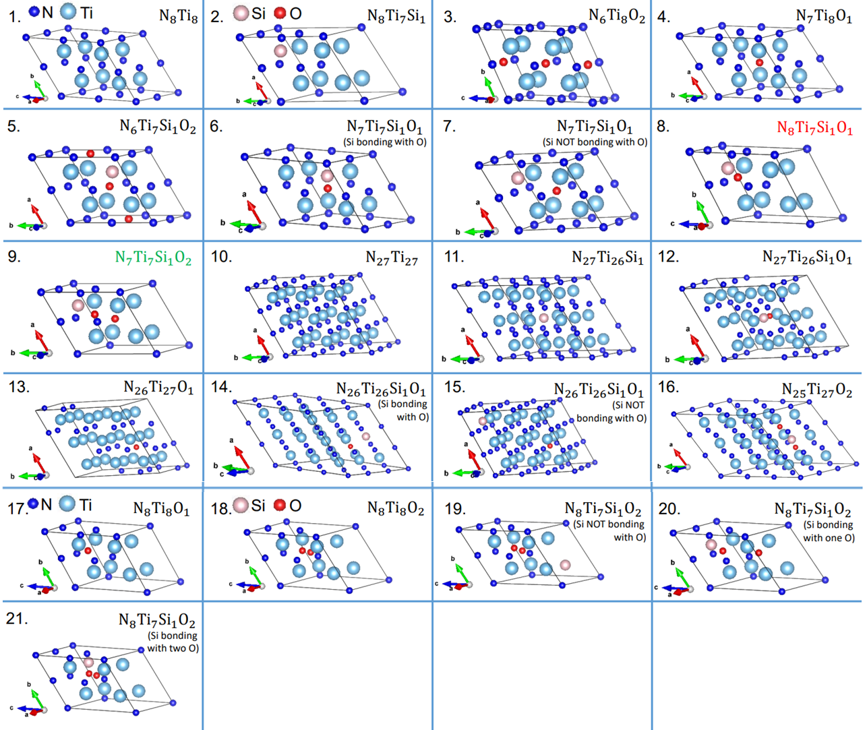
Figure S1. Structural unit of 21 supercells used for calculating the band structure of Ti-Si-N-O system.

In Table S1, we show results of the electronic structure calculations, using GGA and GGA+U approaches, for the 21 structures considered in this work. First, it was verified that TiN (i.e., Ti₈N₈) band structure calculations yield results corresponding to those reported in literature.^{[1]} Owing to the strong Coulomb repulsion between 3d electrons of transition metal Ti, GGA + U method is capable of providing a more accurate description of electronic properties compared to GGA.^{[2-3]} Here, the U value is adopted as 4.4 eV, which has been proven to successfully correct the local states of 3d electron in Ti.^{[4-5]} The band structure for TiN indicates that TiN behaves as a metal i.e., with no band gap.
In total, 17 band structure calculations yielded metallic behavior with no band gap formation. Only one structure (structure # 20, N₈Ti₇Si₁O₂) predicted a semiconductor with a definite band gap opening. Two configurations resulted in band gap opening while maintaining a finite DOS at the Fermi level. These correspond to structure # 8, N₈Ti₇SiO, structure # 9 N₇Ti₇SiO₂ in Table S1, and collectively the above three configurations, their DOS and band structures are shown in Figure S2.
Specifically in these cases, a Si atom substitutes a Ti atom and one, or two, O atoms are located interstitially or substitute in the neighboring N site. The structures have a commonality, in that a Si-O bond exists in the unit cell. We also importantly note that the presence of a Si-O bond does not necessarily produce a gap / semiconductor behavior.

# | Structure Unit | GGA | GGA+ U
1 | N₈Ti₈ | Metal | Metal
2 | N₈Ti₇Si₁ | Metal | -
3 | N₆Ti₈O₂ | Metal | Metal
4 | N₇Ti₈O₁ | Metal | Metal
5 | N₆Ti₇Si₁O₂ | Metal | Metal
6 | N₇Ti₇Si₁O₁ (Si bonding with O) | Metal | Metal
7 | N₇Ti₇Si₁O₁ (Si NOT bonding with O) | Metal | -
8 | N₈Ti₇Si₁O₁ | Metal | Metal
9 | N₇Ti₇Si₁O₂ | Metal | Metal
10 | N₂₇Ti₂₇ | Metal | -
11 | N₂₇Ti₂₆Si₁ | Metal | -
12 | N₂₇Ti₂₆Si₁O₁ | Metal | -
13 | N₂₆Ti₂₇O₁ | Metal | -
14 | N₂₆Ti₂₆Si₁O₁ (Si bonding with O) | Metal | -
15 | N₂₆Ti₂₆Si₁O₁ (Si NOT bonding with O) | Metal | -
16 | N₂₅Ti₂₆Si₁O₂ | Metal | -
17 | N₈Ti₈O₁ | Metal | -
18 | N₈Ti₈O₂ | Metal | -
19 | N₈Ti₇Si₁O₂ (Si NOT bonding with O) | Metal | -
20 | N₈Ti₇Si₁O₂ (Si bonding with one O) | Semiconductor | -
21 | N₈Ti₇Si₁O₂ (Si bonding with two O) | Metal | -

Table S1. Formula unit used for DFT and calculation results using GGA and GGA + U. Calculations from the bolded structures show band gap opening, though the bolded “metal” categorization indicates a finite density of states at the Fermi level as shown in Figure S2.

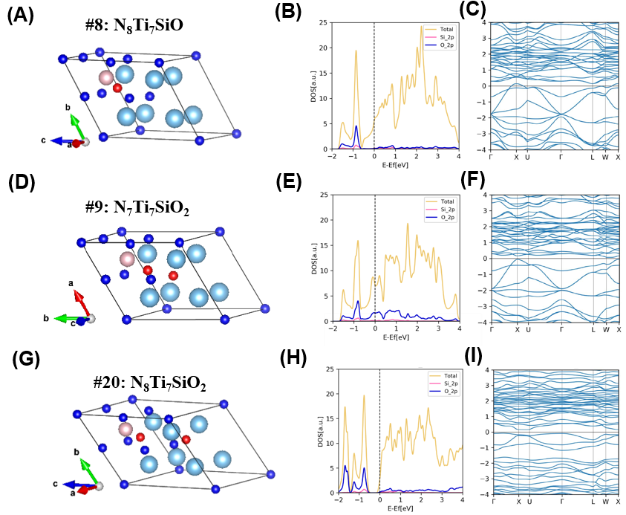
Figure S2. (A) – (C) Structure unit, DOS and E vs. k for N₈Ti₇SiO, respectively. (D) – (F) Structure unit, DOS and E vs. k for N₇Ti₇SiO₂, respectively and (G) – (I) Structure unit, DOS and E vs. k for N₈Ti₇SiO₂, respectively.

Supporting Information S2: Thermal Conductivity Analysis
The temperature-dependent thermal conductivities of Ti_{1-x}Si_{x}N films were measured using a time-domain thermoreflectance (TDTR) technique. To verify TDTR measurements are sensitive to cross-plane thermal conductivity of Ti_{1-x}Si_{x}N films, a sensitivity analysis was performed. TDTR sensitivity was calculated to cross-plane thermal conductivity of each film stack. Various thermophysical properties of each layer are listed in Table S2 below.
Material | Thickness  (nm) | Room temperature heat capacity,  MJm⁻³K⁻¹ | Thermal conductivity,  W m⁻¹ K⁻¹ | Thermal boundary resistance, (TBR)  m² K GW⁻¹
Al | 80 | 2.42 [2] | 144
Al/Ti_{1-x}Si_{x}N | -- | -- | -- | TDTR best fit values^{b}
TiN | 142.3 | 2.95 [11,12]
Ti_{0.98}Si_{0.2}N | 119.1 | 3.05 [11–14]
Ti_{0.914}Si_{0.086}N | 139 | 3.42 [11–14]
Ti_{0.758}Si_{0.242}N | 136 | 3.29 [11–14]
Ti_{1-x}Si_{x}N/SiO₂ |  |  |  | 10.00 [4]
SiO₂ | 100 | 1.62 [1,3,4] | 1.35 [1,2,4,5]
SiO₂/Si | - | - | - | 4.35 [3,4]
Si | - | 1.65 [1–5] | 130 [1,4] | -

Table S2: Parameters used in sensitivity analysis and thermal model to determine the cross-plane thermal conductivity of Ti_{1-x}Si_{x}N films for room temperature measurements. Here, we derived the electrical thermal conductivity of Al from the 4 point-probe measured electrical resistivity applying Wiedemann-Franz Law assuming the low temperature value of the Lorenz number (2.44x10⁻⁸ $ΩWK^{-2}$). The thickness of Al is 80 nm determined by picosecond ultrasonic measurements.^{[6-7]} The heat capacity at different temperatures for Ti_{1-x}Si_{x}N was determined using rule of mixtures applied on the heat capacity^{[8-11]} of TiN and Si₃N₄. The temperature-dependent thermal conductivity and heat capacity of Al, SiO₂, and Si as a function of temperature were taken from the literature^{[12-13]}.
Figure S3 shows that our measurement has sufficient sensitivity to the cross-plane thermal conductivity of Ti_{1-x}Si_{x}N films, provided knowledge of the thermal conductivity of the SiO₂ layer in the substrate. Therefore, the accepted literature values^{[14-18]} for SiO₂ could be used in our thermal model to fit the experimental data and perform uncertainty calculations on this assumption as discussed in the following section. To determine the thermal conductivity of Ti_{1-x}Si_{x}N films, we employ a four-layer heat diffusion model^{[19-21]}. Figure 1b exhibits the best-fit thermal model to the ratio of the in-phase and out-of-phase signal (–V_{in}/V_{out}) fitting for the thermal conductivity of Ti_{1-x}Si_{x}N films and thermal boundary resistance of Al/ Ti_{1-x}Si_{x}N. To fit the experimental data with the model we use the thermophysical properties of Al, Ti_{1-x}Si_{x}N, SiO₂ and Si listed in Table S2.

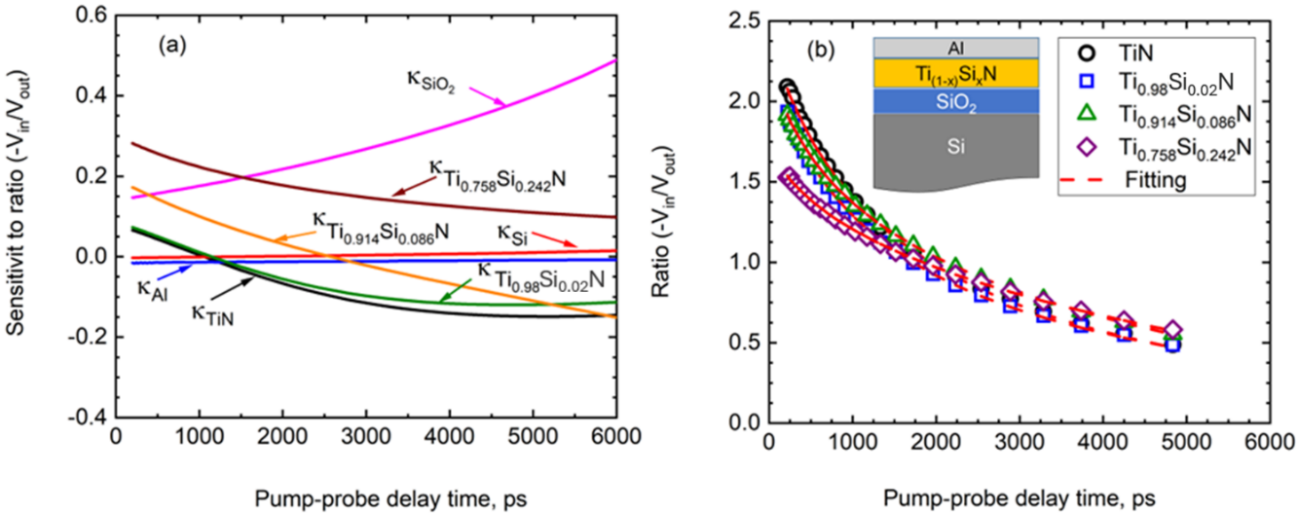
Figure S3: (a) Sensitivity of TDTR measurements to the ratio of in-phase to out-of-phase signal (-V_{in}/V_{out}) for the cross-plane thermal conductivities ($κ)$. (b) Theoretical fit of TDTR experimental data for TiN, Ti_{0.98}Si_{0.02}N, Ti_{0.914}Si_{0.086}N and Ti_{0.758}Si_{0.242}N films obtained at room temperature.

We calculate the total uncertainty (${}_{i}$) using the following equation^{[14, 22]},
${}_{i}$= $\sqrt{({σ_{i}}^{2})+\sum_{i}{∆_{i}^{2}})}$ Eq. S1
Here ${}_{i}$ represents the standard deviations among multiple measurements across various spots and $∆_{i}$ is the uncertainty associated with an individual parameter of the thermal model. The uncertainty of TDTR measurements include the thermal conductivity variations at different spots for multiple measurements, the thickness of Al, Ti_{1-x}Si_{x}N and SiO₂ ($±$ 3%) and volumetric heat capacity of Ti_{1-x}Si_{x}N ($±$ 5%), the thermal conductivity of Al and SiO₂ ($±$10%) and thermal boundary resistance of Ti_{1-x}Si_{x}N/SiO₂ ($±$ 900%).

References
[1] M. Marlo, V. Milman, Phys. Rev. B 2000, 62, 2899.
[2] B. Himmetoglu, A. Floris, S. de Gironcoli, M. Cococcioni, International Journal of Quantum Chemistry 2014, 114, 14.
[3] E. R. Ylvisaker, W. E. Pickett, K. Koepernik, Phys Rev B 2009, 79, 035103.
[4] B. J. Morgan, G. W. Watson, Surface Science 2007, 601, 5034.
[5] E. Finazzi, C. Di Valentin, G. Pacchioni, A. Selloni, The Journal of Chemical Physics 2008, 129, 154113.
[6] C. Thomsen, H. J. Maris, J. Tauc, Thin Solid Films 1987, 154, 217.
[7] C. Thomsen, J. Strait, Z. Vardeny, H. J. Maris, J. Tauc, J. J. Hauser, Physical Review Letters 1984, 53, 989.
[8] W. Lengauer, S. Binder, K. Aigner, P. Ettmayer, A. Guillou, J. Debuigne, G. Groboth, Journal of Alloys and Compounds 1995, 217, 137.
[9] A. Seifitokaldani, A. E. Gheribi, M. Dollé, P. Chartrand, Journal of Alloys and Compounds 2016, 662, 240.
[10] A. Kuwabara, K. Matsunaga, I. Tanaka, Phys Rev B 2008, 78.
[11] N. Nishiyama, S. Kitani, Y. Ohta, E. Kulik, Z. Netriová, A. Holzheid, Z. Lenčéš, H. Kawaji, F. Wakai, Journal of the European Ceramic Society 2020, 40, 6309.
[12] Y. S. Touloukian, E. Buyco, Specific heat - metallic elements and alloys. (Reannouncement). Data book, Vol. 4, United States.
[13] Y. S. Touloukian, R. W. Powell, C. Y. Ho, P. Klemens, Thermal conductivity - metallic elements and alloys. (Reannouncement). Data book, Vol. 1, United States.
[14] J. L. Braun, D. H. Olson, J. T. Gaskins, P. E. Hopkins, Review of Scientific Instruments 2019, 90, 024905.
[15] C. Cancellieri, E. A. Scott, J. Braun, S. W. King, R. Oviedo, C. Jezewski, J. Richards, F. La Mattina, L. P. H. Jeurgens, P. E. Hopkins, Journal of Applied Physics 2020, 128, 195302.
[16] J. L. Braun, C. H. Baker, A. Giri, M. Elahi, K. Artyushkova, T. E. Beechem, P. M. Norris, Z. C. Leseman, J. T. Gaskins, P. E. Hopkins, Phys Rev B 2016, 93, 140201.
[17] M. S. B. Hoque, Y. R. Koh, K. Aryana, E. R. Hoglund, J. L. Braun, D. H. Olson, J. T. Gaskins, H. Ahmad, M. M. M. Elahi, J. K. Hite, Z. C. Leseman, W. A. Doolittle, P. E. Hopkins, Review of Scientific Instruments 2021, 92, 064906.
[18] E. A. Scott, S. W. Smith, M. D. Henry, C. M. Rost, A. Giri, J. T. Gaskins, S. S. Fields, S. T. Jaszewski, J. F. Ihlefeld, P. E. Hopkins, Applied Physics Letters 2018, 113, 192901.
[19] D. G. Cahill, K. Goodson, A. Majumdar, Journal of Heat Transfer 2002, 124, 223.
[20] P. E. Hopkins, J. R. Serrano, L. M. Phinney, S. P. Kearney, T. W. Grasser, C. T. Harris, Journal of Heat Transfer 2010, 132, 081302.
[21] D. G. Cahill, Review of Scientific Instruments 2004, 75, 5119.
[22] J. P. Feser, D. G. Cahill, Review of Scientific Instruments 2012, 83, 104901.

